**Visualization with matplotlib**

1. We’ll now take an in-depth look at the Matplotlib tool for visualization in Python. Matplotlib is a multiplatform data visualization library built on NumPy arrays, and designed to work with the broader SciPy stack.
2. One of Matplotlib’s most important features is its ability to play well with many operating systems and graphics backends. Matplotlib supports dozens of backends and output types, which means you can count on it to work regardless of which operating system you are using or which output format you wish. This cross-platform, everything-to-everyone approach has been one of the great strengths of Matplotlib.
3. In recent years, however, the interface and style of Matplotlib have begun to show their age. Newer tools like ggplot and ggvis in the R language, along with web visualization toolkits based on D3js and HTML5 canvas, often make Matplotlib feel clunky and old-fashioned. Still, I’m of the opinion that we cannot ignore Matplotlib’s strength as a well-tested, cross-platform graphics engine. Recent Matplotlib versions make it relatively easy to set new global plotting styles and people have been developing new packages that build on its powerful internals to drive Matplotlib via cleaner, more modern APIs-for example seaborn ggplot, HoloViews, Altair, and even Pandas itself can be used as wrappers around Matplotlib’s API. Even with wrappers like these, it is still often useful to dive into Matplotlib’s syntax to adjust the final plot output. For this reason, I believe that Matplotlib itself will remain a vital piece of the data visualization stack, even if new tools mean the community gradually moves away from using the Matplotlib API directly.
4. **General Matplotlib Tips**

🡪Before we dive into the details of creating visualizations with Matplotlib, there are a

few useful things you should know about using the package.

1. **Importing Matplotlib**

🡪Just as we use the np shorthand for NumPy and the pd shorthand for Pandas, we will use some standard short hands for Matplotlib imports:

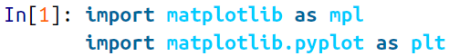

1. **Setting Styles**

🡪We will use the plt.style directive to choose appropriate aesthetic styles for our figures. Here we will set the classic style, which ensures that the plots we create use the classic Matplotlib style:



🡪Throughout this section, we will adjust this style as needed.

1. **show() or No show()? How to Display Your Plots**

🡪A visualization you can’t see won’t be of much use, but just how you view your Matplotlib plots depends on the context. The best use of Matplotlib differs depending on how you are using it; roughly, the three applicable contexts are using Matplotlib in a script, in an IPython terminal, or in an IPython notebook.

**🡺Plotting from a script**

🡪If you are using Matplotlib from within a script, the function plt.show() is your friend. plt.show() starts an event loop, looks for all currently active figure objects, and opens one or more interactive windows that display your figure or figures.

🡪So, for example, you may have a file called myplot.py containing the following:

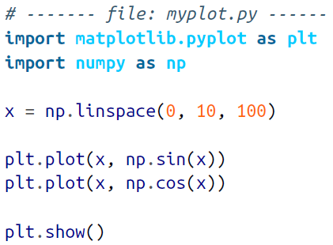

🡪You can then run this script from the command-line prompt, which will result in a window opening with your figure displayed:

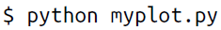

🡪The plt.show() command does a lot under the hood, as it must interact with your system’s interactive graphical backend. The details of this operation can vary greatly from system to system and even installation to installation, but Matplotlib does its best to hide all these details from you.

🡪One thing to be aware of: the plt.show() command should be used only once per Python session, and is most often seen at the very end of the script.

🡪**Multiple show() commands can lead to unpredictable backend-dependent behaviour, and should mostly be avoided.**

**🡺Plotting from an IPython shell**

🡪It can be very convenient to use Matplotlib interactively within an IPython shell. IPython is built to work well with Matplotlib if you specify Matplotlib mode. To enable this mode, you can use the %matplotlib magic command after starting ipython:

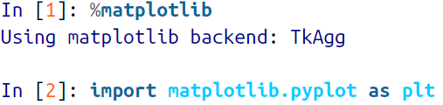

🡪At this point, any plt plot command will cause a figure window to open, and further commands can be run to update the plot. Some changes (such as modifying properties of lines that are already drawn) will not draw automatically; to force an update, use plt.draw(). Using plt.show() in Matplotlib mode is not required.

**🡺Plotting from an IPython notebook**

🡪The IPython notebook is a browser-based interactive data analysis tool that can combined narrative, code, graphics, HTML elements, and much more into a single executable document

🡪Plotting interactively within an IPython notebook can be done with the %matplotlib command, and works in a similar way to the IPython shell. In the IPython notebook, you also have the option of embedding graphics directly in the notebook, with two possible options:

* **%matplotlib notebook will lead to interactive plots embedded within the notebook**
* **%matplotlib inline will lead to static images of your plot embedded in the notebook**

🡪For this chapter, we will generally opt for %matplotlib inline:

  
🡪After you run this command (it needs to be done only once per kernel/session), any cell within the notebook that creates a plot will embed a PNG image of the resulting graphic as shown in figure below:

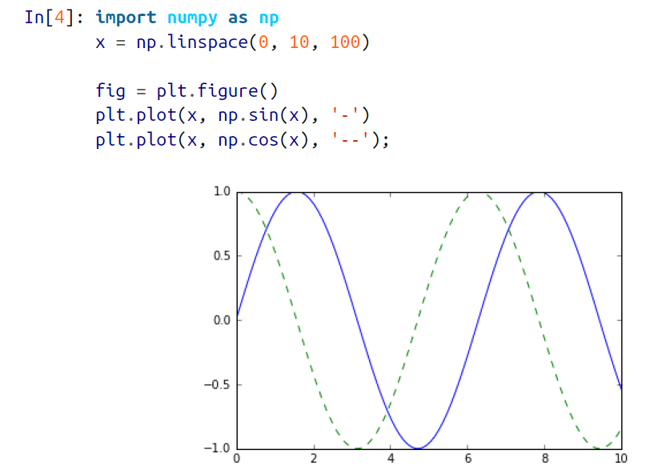

**🡺Saving Figures to File**

🡪One nice feature of Matplotlib is the ability to save figures in a wide variety of formats. You can save a figure using the savefig() command. For example, to save the previous figure as a PNG file, you can run this:



🡪We now have a file called my_figure.png in the current working directory:

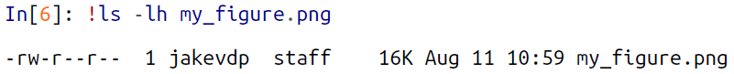

🡪To confirm that it contains what we think it contains, let’s use the IPython Image object to display the contents of this file:

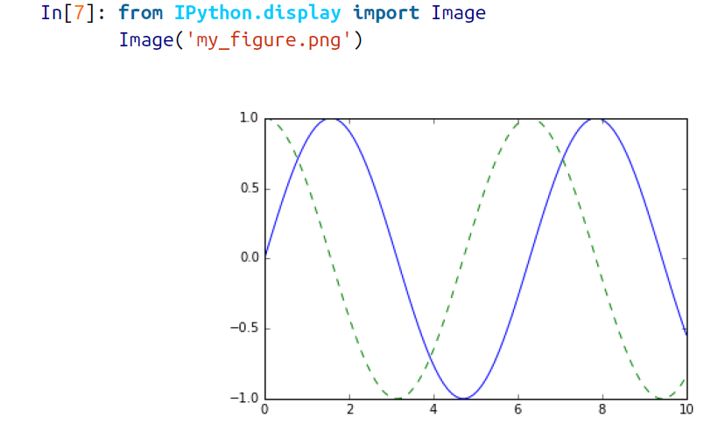

🡪In savefig(), the file format is inferred from the extension of the given filename. Depending on what backends you have installed, many different file formats are available. You can find the list of supported file types for your system by using the following method of the figure canvas object:

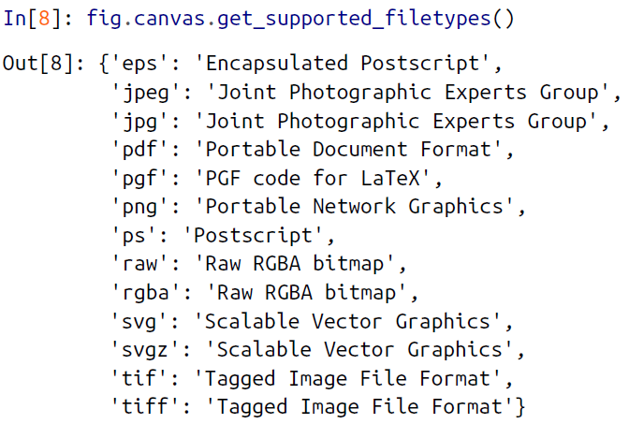

**🡪Note that when saving your figure, it’s not necessary to use plt.show() or related commands discussed earlier.**

1. **Two Interfaces for the price of one**

🡪A potentially confusing feature of Matplotlib is its dual interfaces: a convenient MATLAB-style state-based interface, and a more powerful object-oriented interface. We’ll quickly highlight the differences between the two here.

**🡺MATLAB-style interface**

🡪Matplotlib was originally written as a Python alternative for MATLAB users, and much of its syntax reflects that fact. The MATLAB-style tools are contained in the pyplot (plt) interface. For example, the following code will probably look quite familiar to MATLAB users:

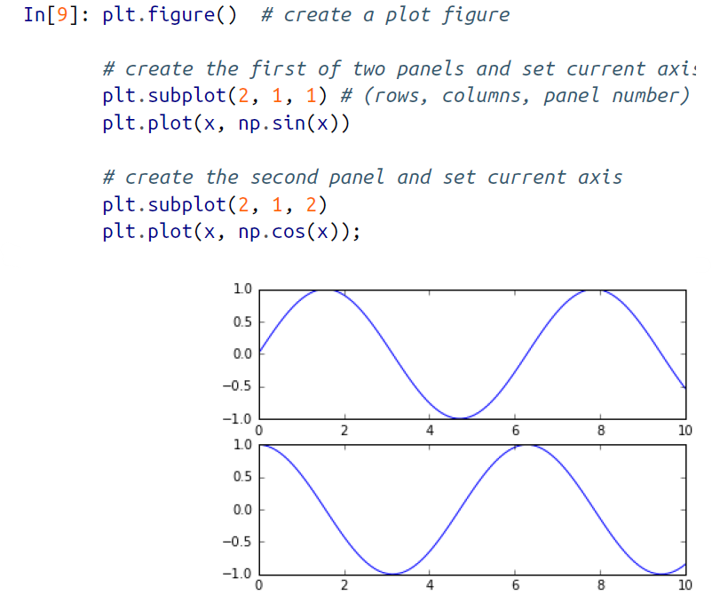

🡪It’s important to note that this interface is stateful: it keeps track of the “current” figure and axes, which are where all plt commands are applied. You can get a reference to these using the plt.gcf() (get current figure) and plt.gca() (get current axes) routines.

🡪While this stateful interface is fast and convenient for simple plots, it is easy to run into problems. For example, once the second panel is created, how can we go back and add something to the first? This is possible within the MATLAB-style interface, but a bit clunky. Fortunately, there is a better way.

**🡺Object-oriented interface**

🡪The object-oriented interface is available for these more complicated situations, and for when you want more control over your figure. Rather than depending on some notion of an “active” figure or axes, in the object-oriented interface the plotting functions are methods of explicit Figure and Axes objects. To re-create the previous plot using this style of plotting, you might do the following:

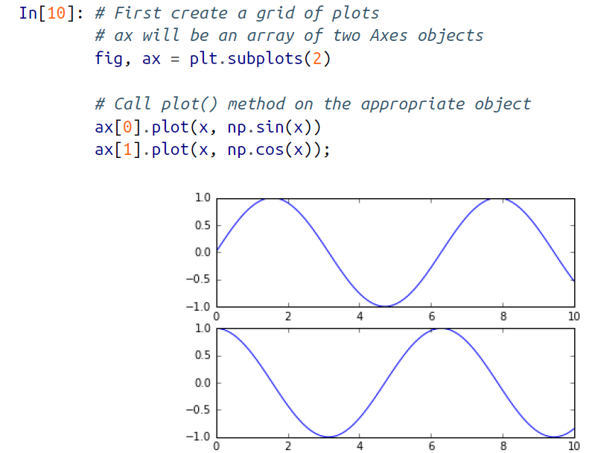

🡪For more simple plots, the choice of which style to use is largely a matter of preference, but the object-oriented approach can become a necessity as plots become more complicated. Throughout this chapter, we will switch between the MATLAB-style and object-oriented interfaces, depending on what is most convenient. In most cases, the difference is as small as switching plt.plot() to ax.plot(), but there are a few gotchas that we will highlight as they come up in the following sections.

1. **Simple Line Plots**

🡪Perhaps the simplest of all plots is the visualization of a single function y = f x . Here we will take a first look at creating a simple plot of this type. As with all the following sections, we’ll start by setting up the notebook for plotting and importing the functions we will use:

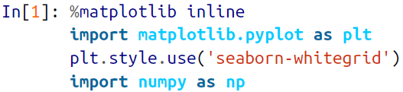

🡪For all Matplotlib plots, we start by creating a figure and an axes. In their simplest form, a figure and axes can be created as follows:

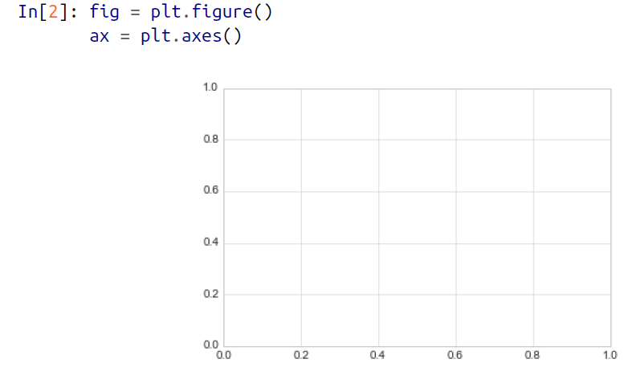

🡪In Matplotlib, the figure (an instance of the class plt.Figure) can be thought of as a single container that contains all the objects representing axes, graphics, text, and labels. The axes (an instance of the class plt.Axes) is what we see above: a bounding box with ticks and labels, which will eventually contain the plot elements that make up our visualization. Throughout this book, we’ll commonly use the variable name fig to refer to a figure instance, and ax to refer to an axes instance or group of axes instances.

🡪Once we have created an axes, we can use the ax.plot function to plot some data. Let’s start with a simple sinusoid

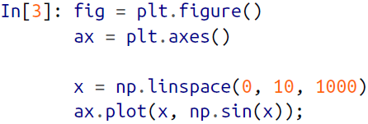

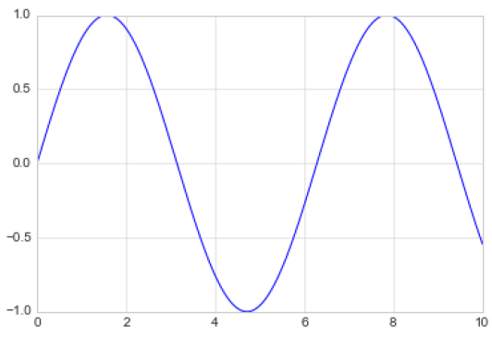

🡪Alternatively, we can use the pylab interface and let the figure and axes be created for us in the background

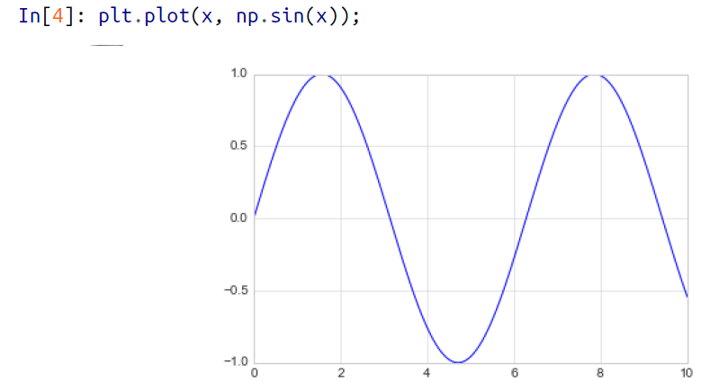

🡪If we want to create a single figure with multiple lines, we can simply call the plot function multiple times:

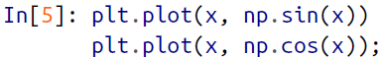

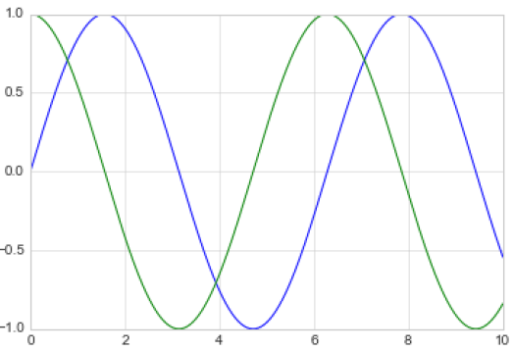

🡪That’s all there is to plotting simple functions in Matplotlib! We’ll now dive into some more details about how to control the appearance of the axes and lines.

1. **Adjusting the Plot: Line Colors and Styles**

🡪The first adjustment you might wish to make to a plot is to control the line colors and styles. The plt.plot() function takes additional arguments that can be used to specify these. To adjust the color, you can use the color keyword, which accepts a string argument representing virtually any imaginable color. The color can be specified in a variety of ways as shown in figure below:

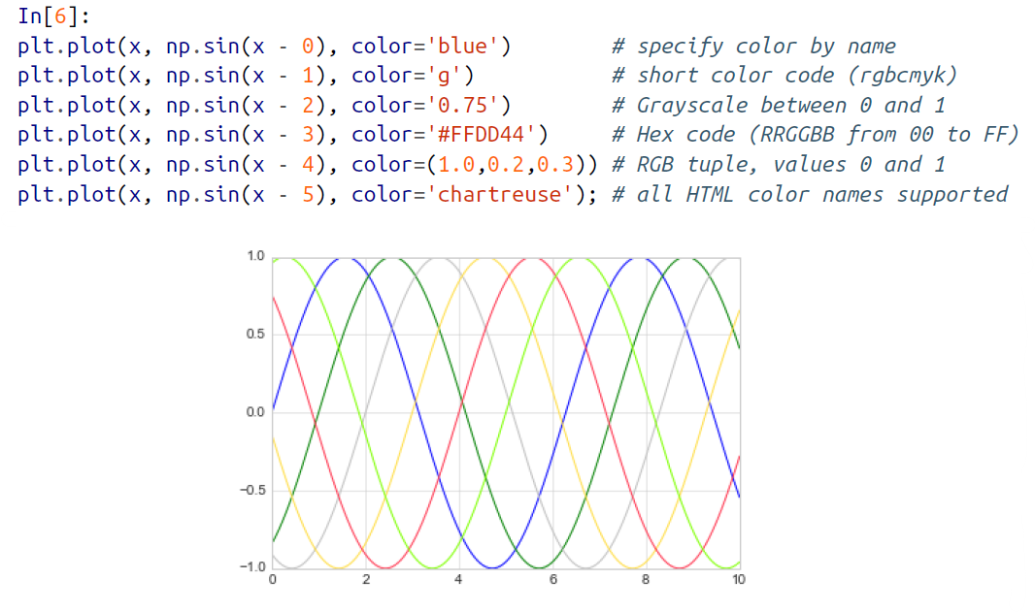  
🡪If no color is specified, Matplotlib will automatically cycle through a set of default colors for multiple lines.

🡪Similarly, you can adjust the line style using the linestyle keyword as shown in figure below:

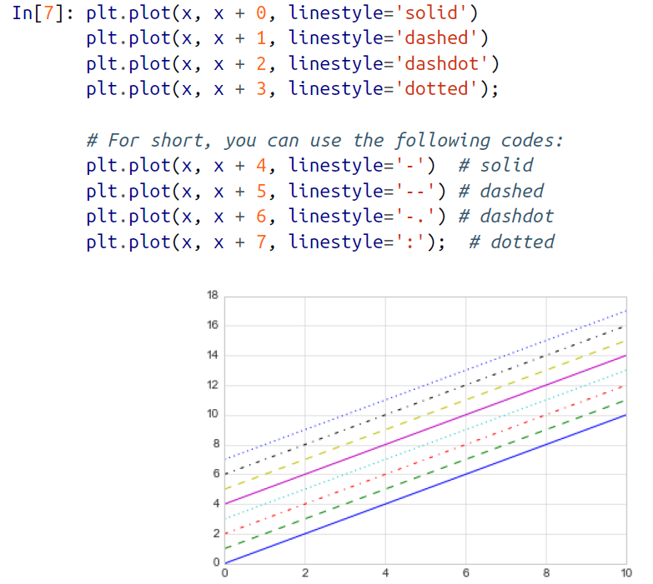

🡪If you would like to be extremely terse, these linestyle and color codes can be combined into a single nonkeyword argument to the plt.plot() function as shown below:

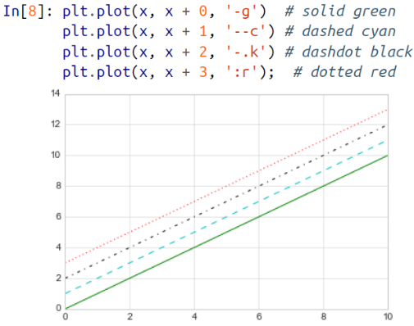

🡪These single-character color codes reflect the standard abbreviations in the RGB (Red/Green/Blue) and CMYK (Cyan/Magenta/Yellow/blacK) color systems, commonly used for digital color graphics.

🡪There are many other keyword arguments that can be used to fine-tune the appearance of the plot; for more details, I’d suggest viewing the docstring of the plt.plot() function using IPython’s help tools

1. **Adjusting the plot: Axes Limits**

🡪Matplotlib does a decent job of choosing default axes limits for your plot, but sometimes it’s nice to have finer control. The most basic way to adjust axis limits is to use the plt.xlim() and plt.ylim() methods as shown in figure below:

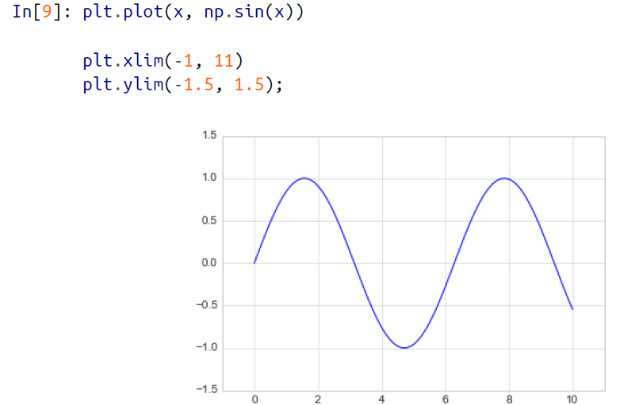

🡪If for some reason you’d like either axis to be displayed in reverse, you can simply reverse the order of the arguments

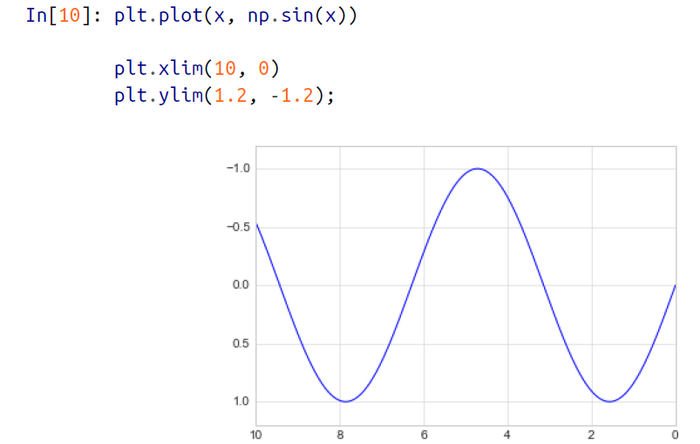

🡪A useful related method is plt.axis() (note here the potential confusion between axes with an e, and axis with an i). The plt.axis() method allows you to set the x and y limits with a single call, by passing a list that specifies [xmin, xmax, ymin, ymax]

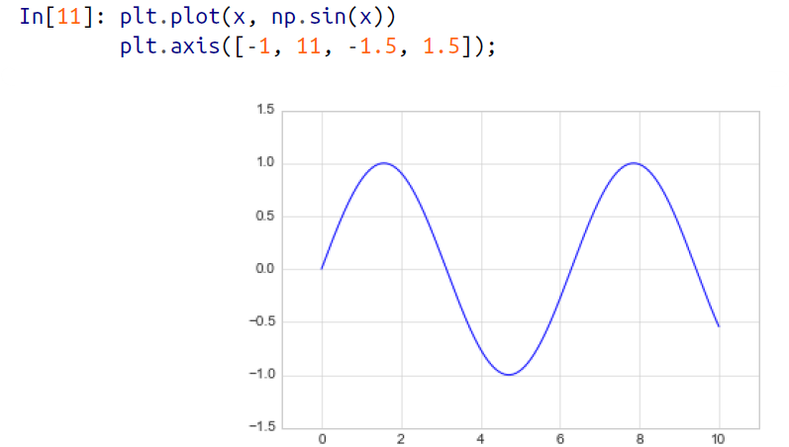

🡪It allows even higher-level specifications, such as ensuring an equal aspect ratio so that on your screen, one unit in x is equal to one unit in y

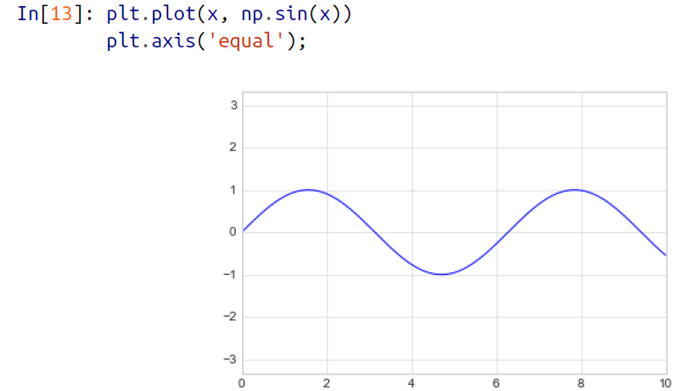

🡪For more information on axis limits and the other capabilities of the plt.axis() method, refer to the plt.axis() docstring.

1. **Labelling Plots**

🡪As the last piece of this section, we’ll briefly look at the labeling of plots: titles, axis

labels, and simple legends.

🡪Titles and axis labels are the simplest such labels—there are methods that can be used

to quickly set them as shown in figure below:

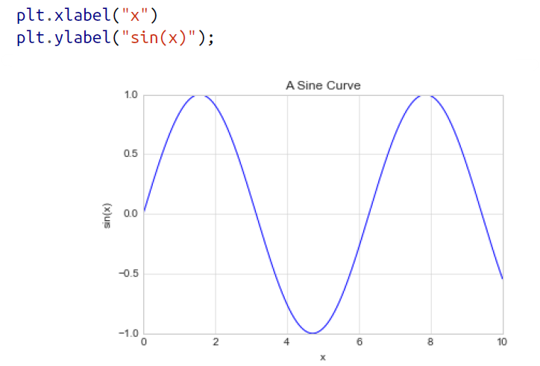

🡪You can adjust the position, size, and style of these labels using optional arguments to the function. For more information, see the Matplotlib documentation and the docstrings of each of these functions.

🡪When multiple lines are being shown within a single axes, it can be useful to create a plot legend that labels each line type. Again, Matplotlib has a built-in way of quickly creating such a legend. It is done via the (you guessed it) plt.legend() method. Though there are several valid ways of using this, I find it easiest to specify the label of each line using the label keyword of the plot function.

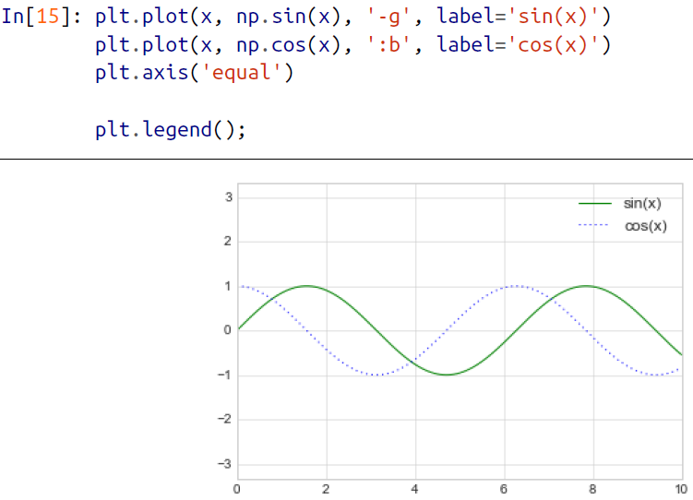

🡪As you can see, the plt.legend() function keeps track of the line style and color, and matches these with the correct label. More information on specifying and formatting plot legends can be found in the plt.legend() docstring.

**I.M.P.** 🡪In the object-oriented interface to plotting, rather than calling these functions individually, it is often more convenient to use the ax.set() method to set all these properties at once as shown in figure below:

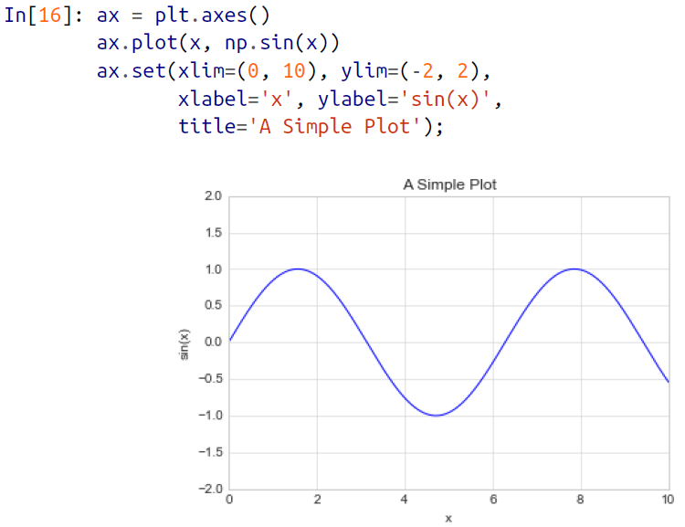

1. **Simple Scatter Plots**

🡪Another commonly used plot type is the simple scatter plot, a close cousin of the line plot. Instead of points being joined by line segments, here the points are represented individually with a dot, circle, or other shape. We’ll start by setting up the notebook for plotting and importing the functions we will use:

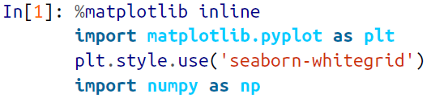

**🡺Scatter Plots with plt.plot**

🡪In the previous section, we looked at plt.plot/ax.plot to produce line plots. It turns out that this same function can produce scatter plots as well

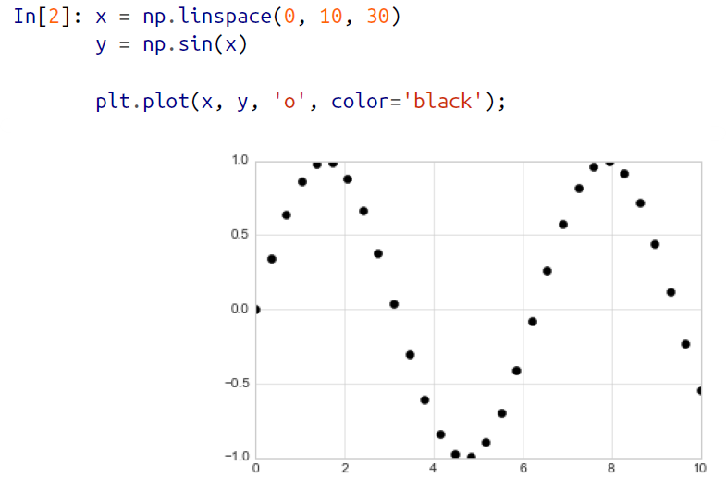

🡪The third argument in the function call is a character that represents the type of symbol used for the plotting. Just as you can specify options such as '-' and '--' to control the line style, the marker style has its own set of short string codes. The full list of available symbols can be seen in the documentation of plt.plot, or in Matplotlib’s online documentation. Most of the possibilities are fairly intuitive, and we’ll show a number of the more common ones here as shown in figure below:

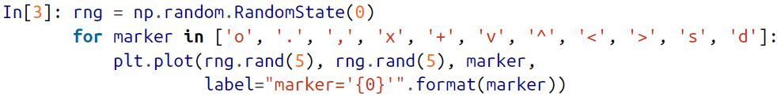

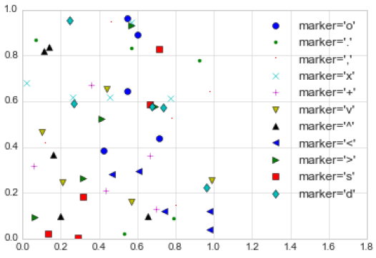

🡪For even more possibilities, these character codes can be used together with line and color codes to plot points along with a line connecting them as shown in figure below:

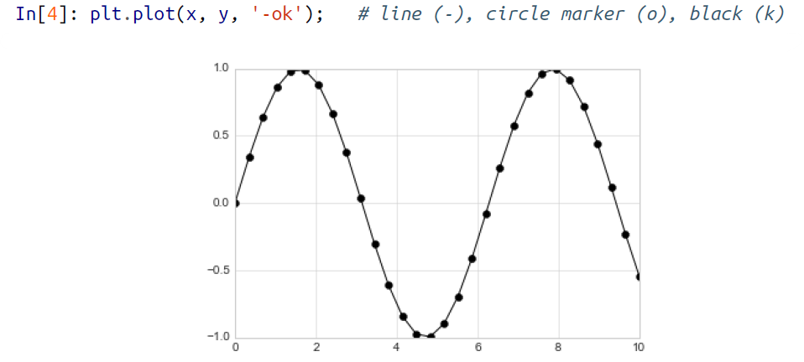

🡪Additional keyword arguments to plt.plot specify a wide range of properties of the lines and markers as shown in figure below:

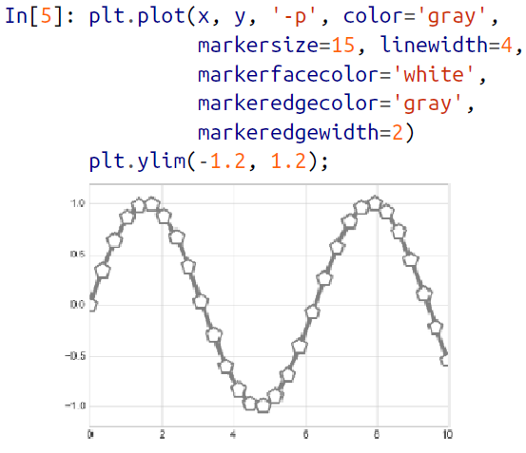

🡪This type of flexibility in the plt.plot function allows for a wide variety of possible visualization options. For a full description of the options available, refer to the plt.plot documentation.

1. **Scatter Plots with plt.scatter**

🡪A second, more powerful method of creating scatter plots is the plt.scatter function, which can be used very similarly to the plt.plot function which is as shown below:

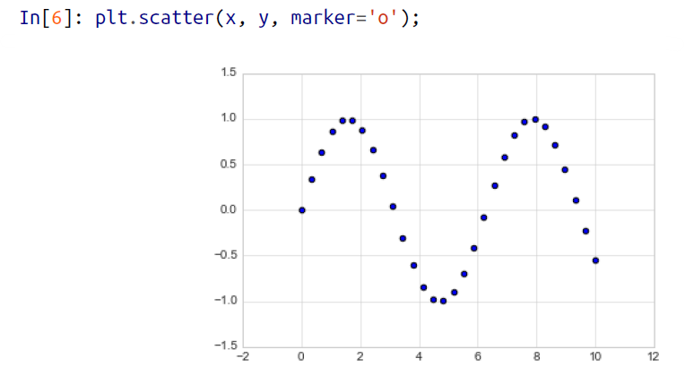

🡪The primary difference of plt.scatter from plt.plot is that it can be used to create scatter plots where the properties of each individual point (size, face color, edge color, etc.) can be individually controlled or mapped to data.

🡪Let’s show this by creating a random scatter plot with points of many colors and sizes. In order to better see the overlapping results, we’ll also use the alpha keyword to adjust the transparency level as shown in figure below:

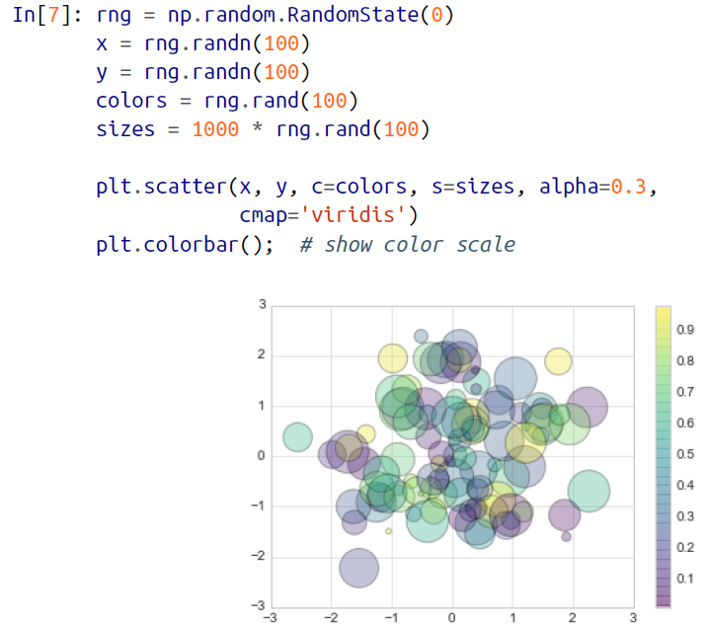

🡪Notice that the color argument is automatically mapped to a color scale (shown here by the colorbar() command), and the size argument is given in pixels. In this way, the color and size of points can be used to convey information in the visualization, in order to illustrate multidimensional data.

🡪For example, we might use the Iris data from Scikit-Learn, where each sample is one of three types of flowers that has had the size of its petals and sepals carefully measured

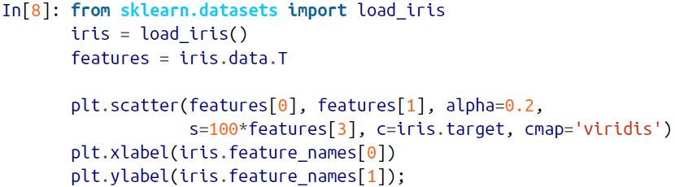

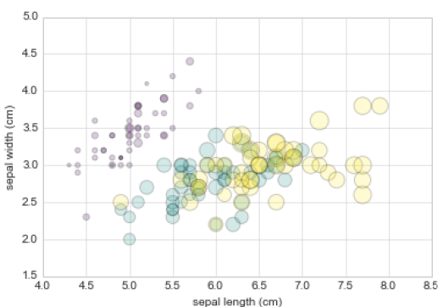

🡪We can see that this scatter plot has given us the ability to simultaneously explore four different dimensions of the data: the (x, y) location of each point corresponds to the sepal length and width, the size of the point is related to the petal width, and the color is related to the particular species of flower. Multicolor and multifeature scatter plots like this can be useful for both exploration and presentation of data.

1. **Plot Versus Scatter: A Note On Efficiency**

🡪Aside from the different features available in plt.plot and plt.scatter, why might you choose to use one over the other? While it doesn’t matter as much for small amounts of data, as datasets get larger than a few thousand points, plt.plot can be noticeably more efficient than plt.scatter.

🡪The reason is that plt.scatter has the capability to render a different size and/or color for each point, so the renderer must do the extra work of constructing each point individually. In plt.plot, on the other hand, the points are always essentially clones of each other, so the work of determining the appearance of the points is done only once for the entire set of data.

🡪For large datasets, the difference between these two can lead to vastly different performance, and for this reason, plt.plot should be preferred over plt.scatter for large

datasets.

1. **Visualizing Errors**

🡪For any scientific measurement, accurate accounting for errors is nearly as important, if not more important, than accurate reporting of the number itself. For example, imagine that I am using some astrophysical observations to estimate the Hubble Constant, the local measurement of the expansion rate of the universe. I know that the current literature suggests a value of around 71 (km/s)/Mpc, and I measure a value of 74 (km/s)/Mpc with my method. Are the values consistent? The only correct answer, given this information, is this: there is no way to know.

🡪Suppose I augment this information with reported uncertainties: the current literature suggests a value of around 71 ± 2.5 (km/s)/Mpc, and my method has measured a value of 74 ± 5 (km/s)/Mpc. Now are the values consistent? That is a question that can be quantitatively answered.

🡪In visualization of data and results, showing these errors effectively can make a plot convey much more complete information.

**🡺Basic Error Bars**

🡪A basic errorbar can be created with a single Matplotlib function call as shown in figure below:

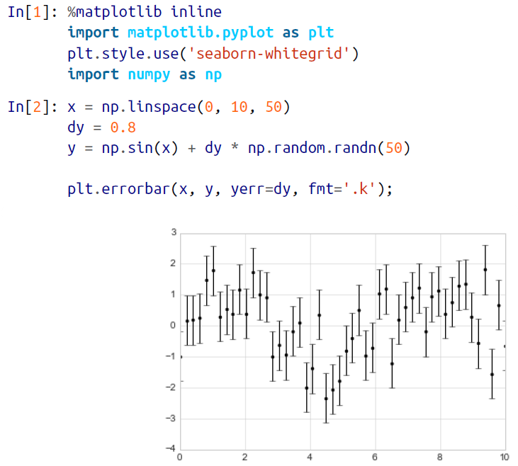

🡪Here the fmt is a format code controlling the appearance of lines and points, and has the same syntax as the shorthand used in plt.plot

🡪In addition to these basic options, the errorbar function has many options to finetune the outputs. Using these additional options you can easily customize the aesthetics of your errorbar plot. I often find it helpful, especially in crowded plots, to make the errorbars lighter than the points themselves as shown in figure below:



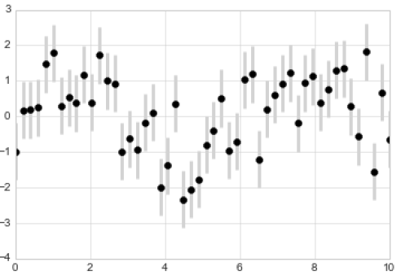

🡪In addition to these options, you can also specify horizontal errorbars (xerr), one sided error bars, and many other variants. For more information on the options available, refer to the docstring of plt.errorbar.

1. **Continue Errors**

🡪In addition to these options, you can also specify horizontal errorbars (xerr), onesided errorbars, and many other variants. For more information on the options available, refer to the docstring of plt.errorbar.

🡪Here we’ll perform a simple Gaussian process regression (GPR), using the Scikit-Learn API. This is a method of fitting a very flexible nonparametric function to data with a continuous measure of the uncertainty. We won’t delve into the details of Gaussian process regression at this point, but will focus instead on how you might visualize such a continuous error measurement:

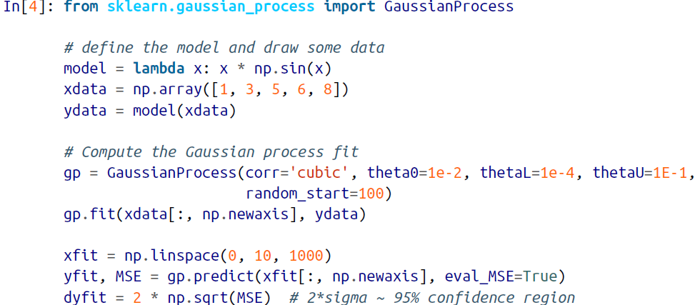

🡪We now have xfit, yfit, and dyfit, which sample the continuous fit to our data. We could pass these to the plt.errorbar function as above, but we don’t really want to plot 1,000 points with 1,000 errorbars. Instead, we can use the plt.fill_between function with a light color to visualize this continuous error as shown in figure below:

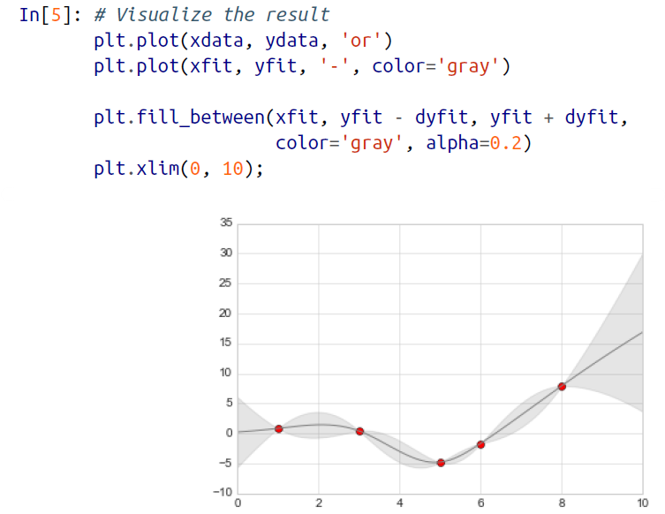

🡪Note what we’ve done here with the fill_between function: we pass an x value, then the lower y-bound, then the upper y-bound, and the result is that the area between these regions is filled.

🡪The resulting figure gives a very intuitive view into what the Gaussian process regression algorithm is doing: in regions near a measured data point, the model is strongly constrained and this is reflected in the small model errors. In regions far from a measured data point, the model is not strongly constrained, and the model errors increase.

🡪For more information on the options available in plt.fill_between() (and the closely related plt.fill() function), see the function docstring or the Matplotlib documentation.

1. **Density and Contour Plots**

🡪Sometimes it is useful to display three-dimensional data in two dimensions using contours or color-coded regions. There are three Matplotlib functions that can be helpful for this task: plt.contour for contour plots, plt.contourf for filled contour plots, and plt.imshow for showing images. This section looks at several examples of using these. We’ll start by setting up the notebook for plotting and importing the functions we will use:

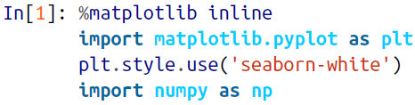

**🡺Visualizing a Three-Dimensional Function**

🡪We’ll start by demonstrating a contour plot using a function z = f(x, y), using the following particular choice for f:



🡪A contour plot can be created with the plt.contour function. It takes three arguments: a grid of x values, a grid of y values, and a grid of z values. The x and y values represent positions on the plot, and the z values will be represented by the contour levels. Perhaps the most straight forward way to prepare such data is to use the np.meshgrid function, which builds two-dimensional grids from one-dimensional

arrays:

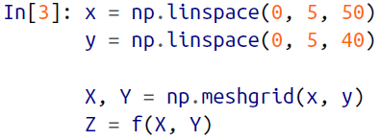

🡪Now let’s look at this with a standard line-only contour plot as shown in figure below:



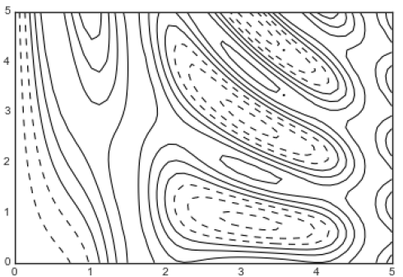

🡪Notice that by default when a single color is used, negative values are represented by dashed lines, and positive values by solid lines. Alternatively, you can color-code the lines by specifying a colormap with the cmap argument. Here, we’ll also specify that we want more lines to be drawn—20 equally spaced intervals within the data range as shown in figure:

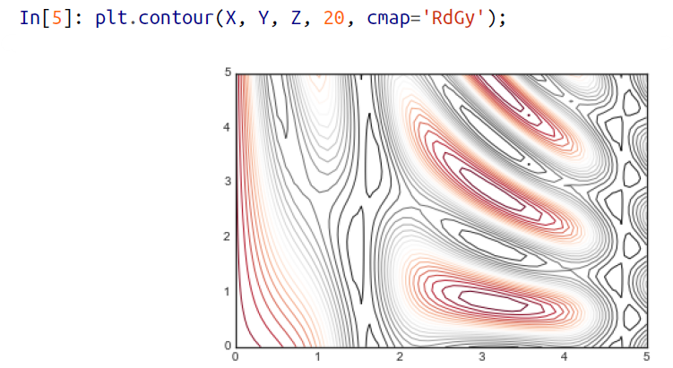

🡪Here we chose the RdGy (short for Red-Gray) colormap, which is a good choice for centered data. Matplotlib has a wide range of colormaps available, which you can easily browse in IPython by doing a tab completion on the plt.cm module:



🡪Our plot is looking nicer, but the spaces between the lines may be a bit distracting. We can change this by switching to a filled contour plot using the plt.contourf() function (notice the f at the end), which uses largely the same syntax as plt.contour().

🡪Additionally, we’ll add a plt.colorbar() command, which automatically creates an

additional axis with labeled color information for the plot as shown in figure below:

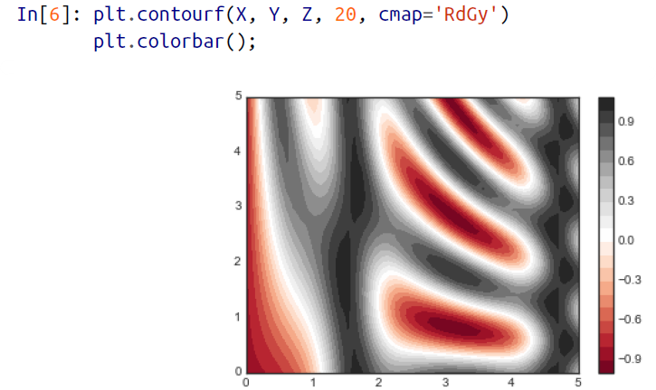

🡪The colorbar makes it clear that the black regions are “peaks,” while the red regions are “valleys.”

🡪One potential issue with this plot is that it is a bit “splotchy.” That is, the color steps are discrete rather than continuous, which is not always what is desired. You could remedy this by setting the number of contours to a very high number, but this results in a rather inefficient plot: Matplotlib must render a new polygon for each step in the level. A better way to handle this is to use the plt.imshow() function, which interprets a two-dimensional grid of data as an image.

🡪Figure below shows the result of the following code:

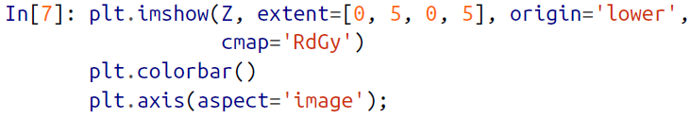

🡪There are a few potential gotchas with imshow(), however:

* plt.imshow() doesn’t accept an *x* and *y* grid, so you must manually specify the *extent* [*xmin*, *xmax*, *ymin*, *ymax*] of the image on the plot.
* plt.imshow() by default follows the standard image array definition where the origin is in the upper left, not in the lower left as in most contour plots. This must be changed when showing gridded data.
* plt.imshow() will automatically adjust the axis aspect ratio to match the input data; you can change this by setting, for example, plt.axis(aspect='image') to make *x* and *y* units match.

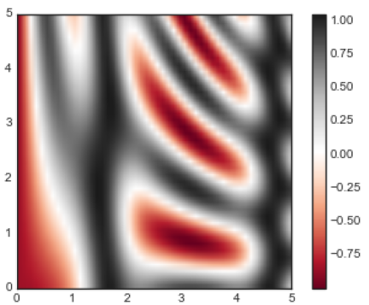

🡪Finally, it can sometimes be useful to combine contour plots and image plots. For example, to create the effect shown in Figure below, we’ll use a partially transparent background image (with transparency set via the alpha parameter) and over-plot contours with labels on the contours themselves (using the plt.clabel() function):

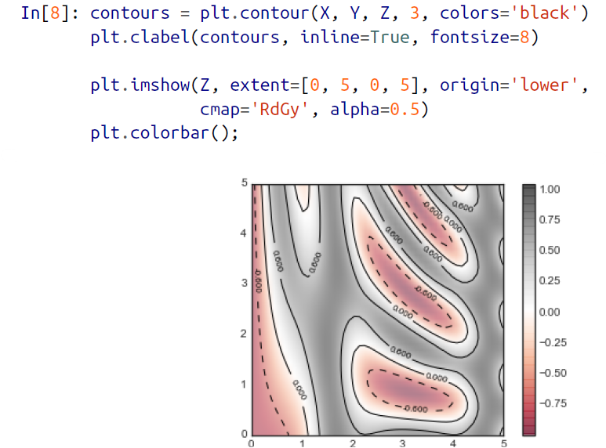

🡪The combination of these three functions—plt.contour, plt.contourf, and plt.imshow—gives nearly limitless possibilities for displaying this sort of threedimensional data within a two-dimensional plot. For more information on the options available in these functions, refer to their docstrings

1. **Histograms, Binnings, and Density**

🡪A simple histogram can be a great first step in understanding a dataset. Earlier, we

saw a preview of Matplotlib’s histogram function which creates a basic histogram in one line, once the normal boilerplate imports are done as shown in figure below:

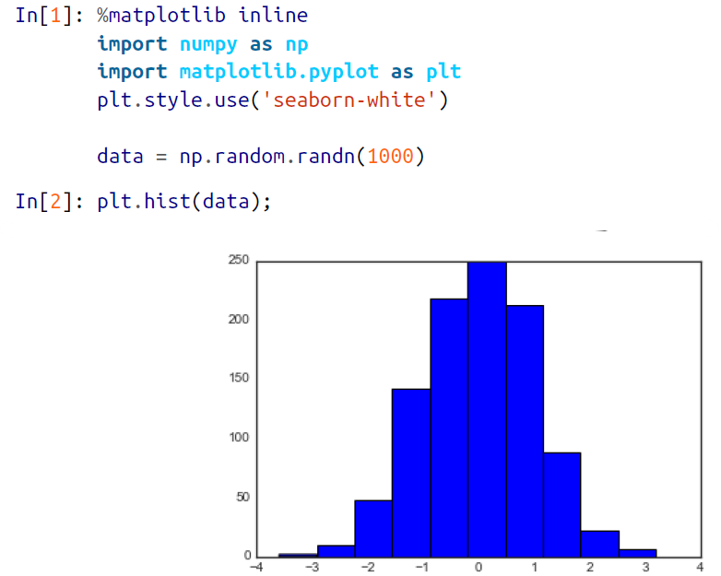

🡪The hist() function has many options to tune both the calculation and the display; here’s an example of a more customized histogram as shown below:

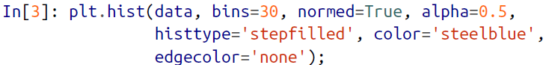

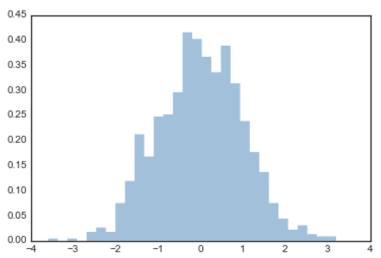

🡪The plt.hist docstring has more information on other customization options available. I find this combination of histtype='stepfilled' along with some transparency alpha to be very useful when comparing histograms of several distributions as shown in figure below:

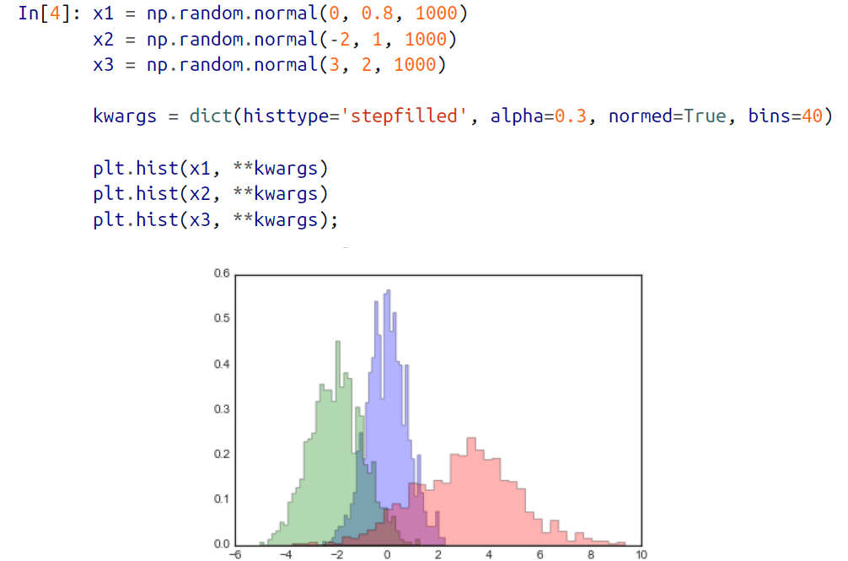

*Here the dict is used to store the data values and than that dict is given as reference in the .hist instead of writing them individually

*The towers or bars of a histogram are called bins. **The height of each bin shows how many values from that data fall into that range. The default value of the number of bins to be created in a histogram is 10. However, we can change the size of bins using the parameter bins in matplotlib.**

🡪If you would like to simply compute the histogram (that is, count the number of points in a given bin) and not display it, the np.histogram() function is available:

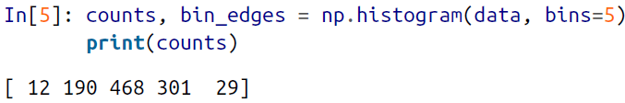

1. **Two-Dimensional Histograms and Binnings**

🡪Just as we create histograms in one dimension by dividing the number line into bins, we can also create histograms in two dimensions by dividing points among two dimensional bins. We’ll take a brief look at several ways to do this here. We’ll start by defining some data—an x and y array drawn from a multivariate Gaussian distribution:

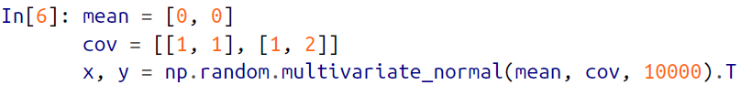

**🡺plt.hist2d: Two-dimensional histogram**

🡪One straightforward way to plot a two-dimensional histogram is to use Matplotlib’s plt.hist2d function as shown in figure below:

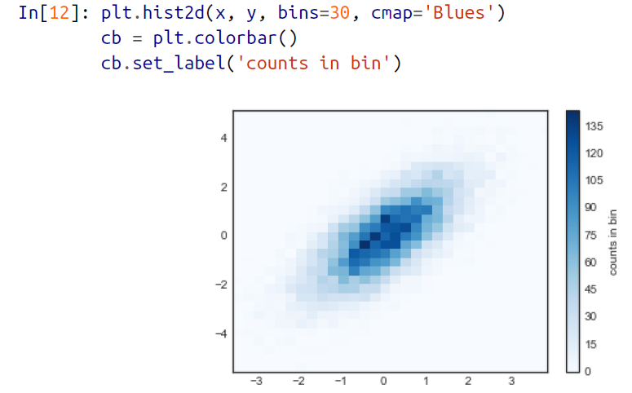

🡪Just as with plt.hist, plt.hist2d has a number of extra options to fine-tune the plot and the binning, which are nicely outlined in the function docstring. Further, just as plt.hist has a counterpart in np.histogram, plt.hist2d has a counterpart in np.histogram2d, which can be used as follows:



**🡪For the generalization of this histogram binning in dimensions higher than two, see the np.histogramdd function.**

**🡺plt.hexbin: Hexagonal binning**

*A tessellation or tiling is the covering of a surface, often a plane, using one or more geometric shapes, called tiles, with no overlaps and no gaps.

🡪The two-dimensional histogram creates a tessellation of squares across the axes. Another natural shape for such a tessellation is the regular hexagon. For this purpose, Matplotlib provides the plt.hexbin routine, which represents a two-dimensional dataset binned within a grid of hexagons as shown in figure:

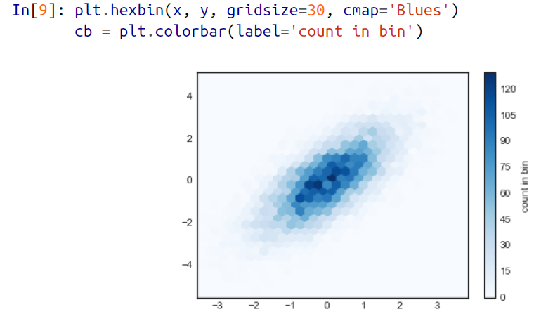

🡪plt.hexbin has a number of interesting options, including the ability to specify weights for each point, and to change the output in each bin to any NumPy aggregate (mean of weights, standard deviation of weights, etc.).

**🡺Kernel density estimation**

**\*The numpy.meshgrid function is used to create a rectangular grid out of two given one-dimensional arrays representing the Cartesian indexing or Matrix indexing.**

**\***The numpy module of Python provides a function called numpy**.**ravel, which is used **to change a 2-dimensional array or a multi-dimensional array into a contiguous flattened array**. The returned array has the same data type as the source array or input array.

🡪Another common method of evaluating densities in multiple dimensions is kernel

density estimation (KDE). This will be discussed more in further chapters, but for now we’ll simply mention that KDE can be thought of as a way to “smear out” the points in space and add up the result to obtain a smooth function. One extremely quick and simple KDE implementation exists in the scipy.stats package. Here is a quick example of using the KDE on this data is as shown below:

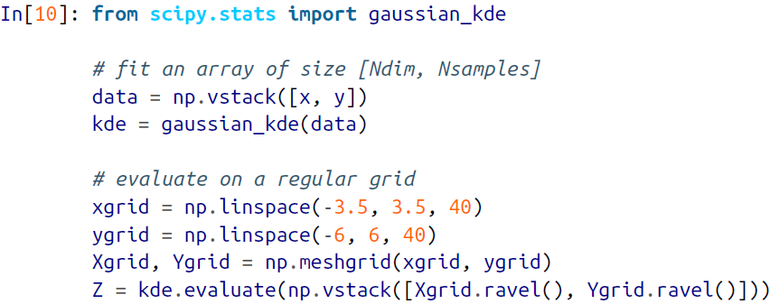

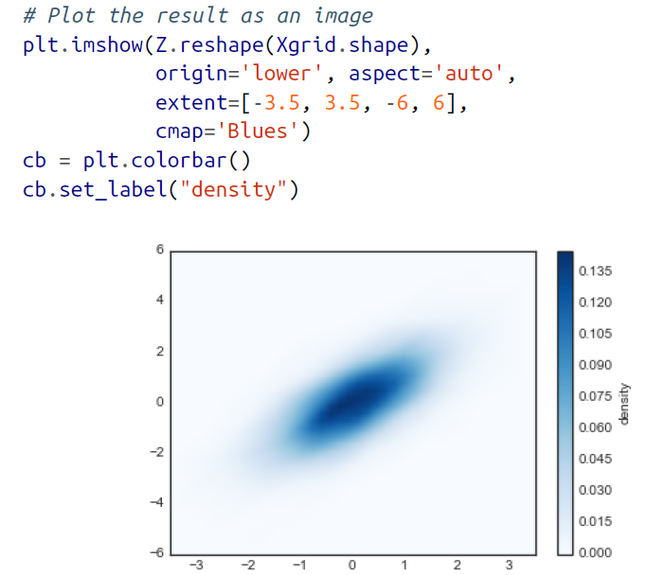

🡪KDE has a smoothing length that effectively slides the knob between detail and smoothness (one example of the ubiquitous bias–variance trade-off). The literature on choosing an appropriate smoothing length is vast: gaussian_kde uses a rule of thumb to attempt to find a nearly optimal smoothing length for the input data.

🡪Other KDE implementations are available within the SciPy ecosystem, each with its own various strengths and weaknesses; see, for example, sklearn.neighbors. Kernel Density and statsmodels.nonparametric.kernel_density.KDEMultivariate. For

visualizations based on KDE, using Matplotlib tends to be overly verbose.

1. Customizing Plot Legends

🡪Plot legends give meaning to a visualization, assigning labels to the various plot elements. We previously saw how to create a simple legend; here we’ll take a look at customizing the placement and aesthetics of the legend in Matplotlib.

🡪The simplest legend can be created with the plt.legend() command, which automatically

creates a legend for any labeled plot elements as shown in figure below:

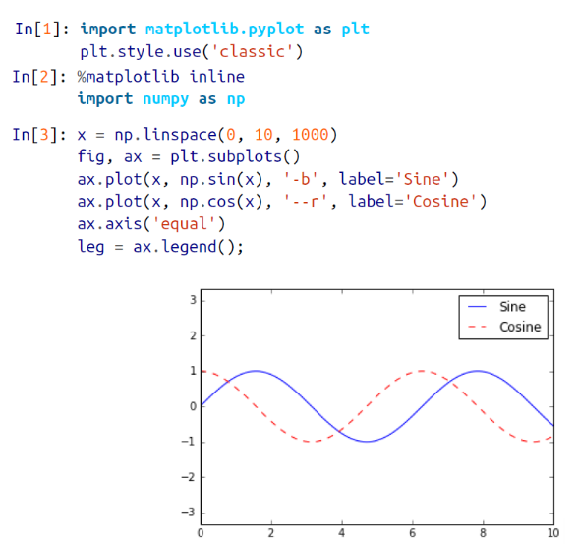

🡪But there are many ways we might want to customize such a legend. For example, we can specify the location and turn off the frame as shown in figure:

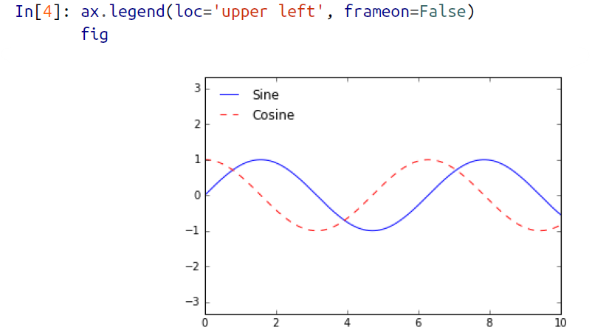

🡪We can use the ncol command to specify the number of columns in the legend as shown in the figure:

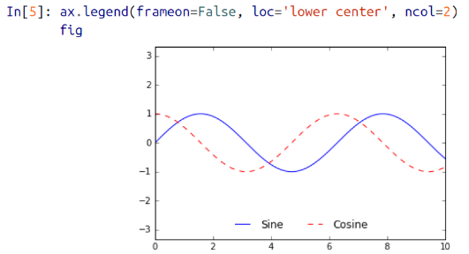

🡪We can use a rounded box (fancybox) or add a shadow, change the transparency (alpha value) of the frame, or change the padding around the text as shown below:

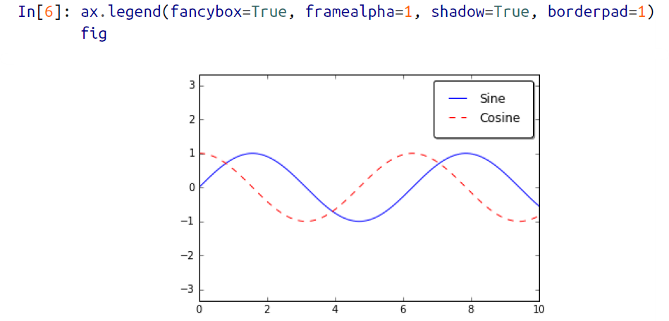

🡪For more information on available legend options, see the plt.legend docstring.

**🡺Choosing Elements for the Legend**

🡪As we’ve already seen, the legend includes all labeled elements by default. If this is not what is desired, we can fine-tune which elements and labels appear in the legend by using the objects returned by plot commands. The plt.plot() command is able to create multiple lines at once, and returns a list of created line instances. Passing any of these to plt.legend() will tell it which to identify, along with the labels we’d like to specify as shown in figure below:

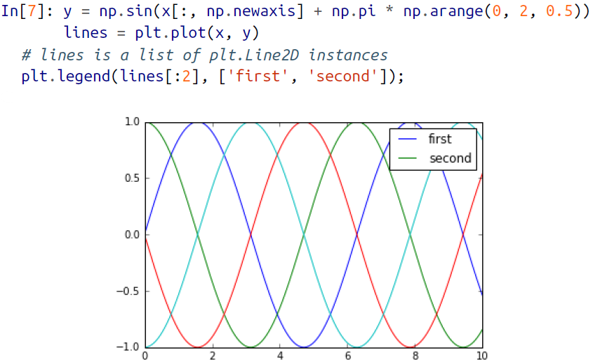

🡪I generally find in practice that it is clearer to use the first method, applying labels to the plot elements you’d like to show on the legend as shown in figure:

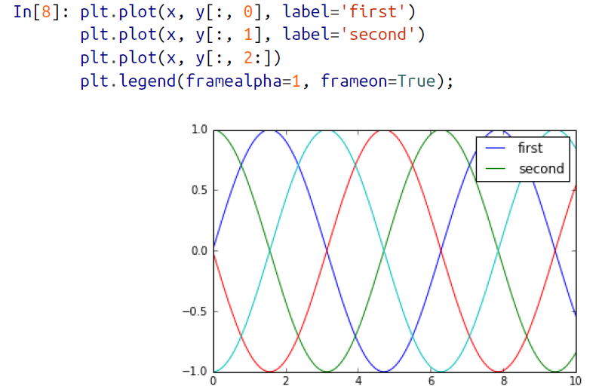

🡪Notice that by default, the legends ignores all elements without a label attribute set.

**🡺Legend For Size Of Points**

🡪Sometimes the legend defaults are not sufficient for the given visualization. For example, perhaps you’re using the size of points to mark certain features of the data, and want to create a legend reflecting this. Here is an example where we’ll use the size of points to indicate populations of California cities. We’d like a legend that specifies the scale of the sizes of the points, and we’ll accomplish this by plotting some labelled data with no entries as shown in the figure:

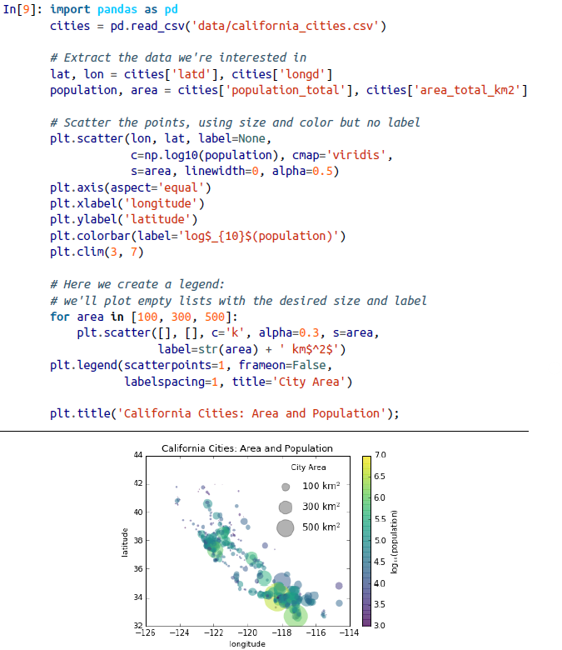

**🡪The legend will always reference some object that is on the plot, so if we’d like to display a particular shape we need to plot it. In this case, the objects we want (gray circles) are not on the plot, so we fake them by plotting empty lists. Notice too that the legend only lists plot elements that have a label specified.**

🡪By plotting empty lists, we create labelled plot objects that are picked up by the legend, and now our legend tells us some useful information. This strategy can be useful for creating more sophisticated visualizations.

🡪Finally, note that for geographic data like this, it would be clearer if we could show state boundaries or other map-specific elements. For this, an excellent choice of tool is Matplotlib’s Basemap add-on toolkit, which we’ll explore later in this chapter.

**🡺Multiple Legends**

🡪Sometimes when designing a plot you’d like to add multiple legends to the same axes. Unfortunately, Matplotlib does not make this easy: via the standard legend interface, it is only possible to create a single legend for the entire plot. If you try to create a second legend using plt.legend() or ax.legend(), it will simply override the first one. We can work around this by creating a new legend artist from scratch, and then using the lower-level ax.add_artist() method to manually add the second artist to the plot as shown in the figure below:

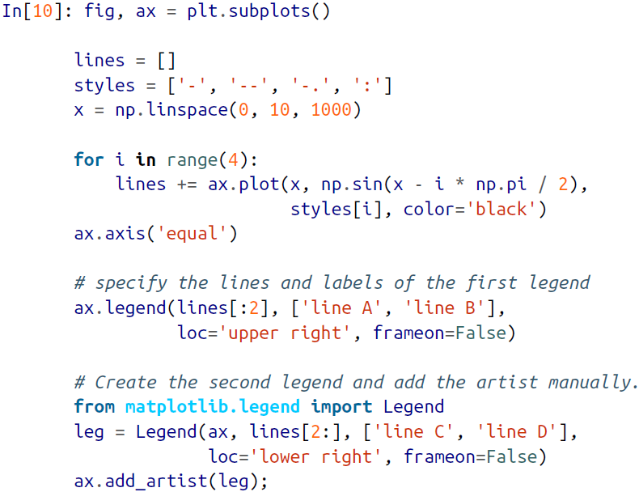

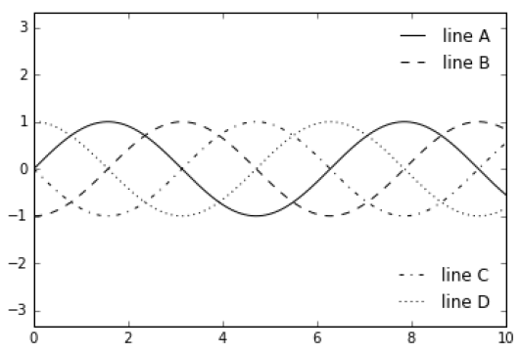

🡪This is a peek into the low-level artist objects that compose any Matplotlib plot. If you examine the source code of ax.legend() (recall that you can do this within the IPython notebook using ax.legend??) you’ll see that the function simply consists of some logic to create a suitable Legend artist which is then saved in the legend_attribute and added to the figure when the plot is drawn.

1. **Customizing Colorbars**

🡪Plot legends identify discrete labels of discrete points. For continuous labels based on the color of points, lines, or regions, a labeled colorbar can be a great tool. In Matplotlib, a colorbar is a separate axes that can provide a key for the meaning of colors in a plot. We’ll start by setting up the notebook for plotting and importing the functions we will use:

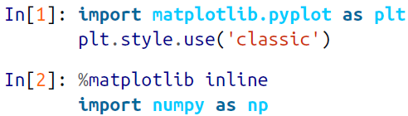

🡪As we have seen several times throughout this section, the simplest colorbar can be created with the plt.colorbar function as shown in figure:

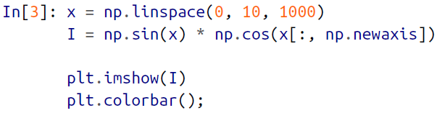

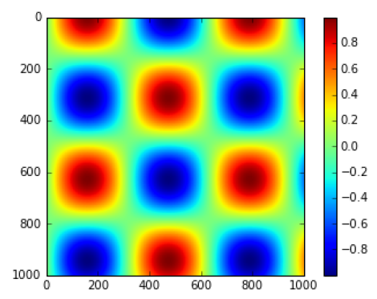

🡪We’ll now discuss a few ideas for customizing these colorbars and using them effectively in various situations.

**🡺Customizing Colorbars**

🡪We can specify the colormap using the cmap argument to the plotting function that is creating the visualization as shown in the figure below:

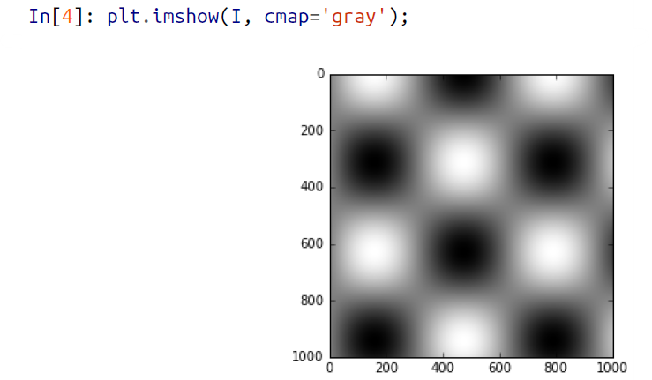

🡪All the available colormaps are in the plt.cm namespace; using IPython’s tabcompletion feature will give you a full list of built-in possibilities:

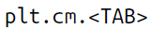

🡪But being able to choose a colormap is just the first step: more important is how to decide among the possibilities! The choice turns out to be much more subtle than you might initially expect.

**🡺Choosing the colormap**

🡪A full treatment of color choice within visualization is beyond the scope of this book, but for entertaining reading on this subject and others, see the article “Ten Simple Rules for Better Figures”. Matplotlib’s online documentation also has an interesting discussion of colormap choice.

🡪Broadly, you should be aware of three different categories of colormaps:

1. **Sequential Colormaps**

These consist of one continuous sequence of colors (e.g., binary or viridis).

1. **Divergent Colormaps**

These usually contain two distinct colors, which show positive and negative deviations from a mean (e.g., RdBu or PuOr).

1. **Qualitative Colormaps**

These mix colors with no particular sequence (e.g., rainbow or jet).

🡪The jet colormap, which was the default in Matplotlib prior to version 2.0, is an example of a qualitative colormap. Its status as the default was quite unfortunate, because qualitative maps are often a poor choice for representing quantitative data.

**🡪Among the problems is the fact that qualitative maps usually do not display any uniform progression in brightness as the scale increases.**

🡪We can see this by converting the jet colorbar into black and white

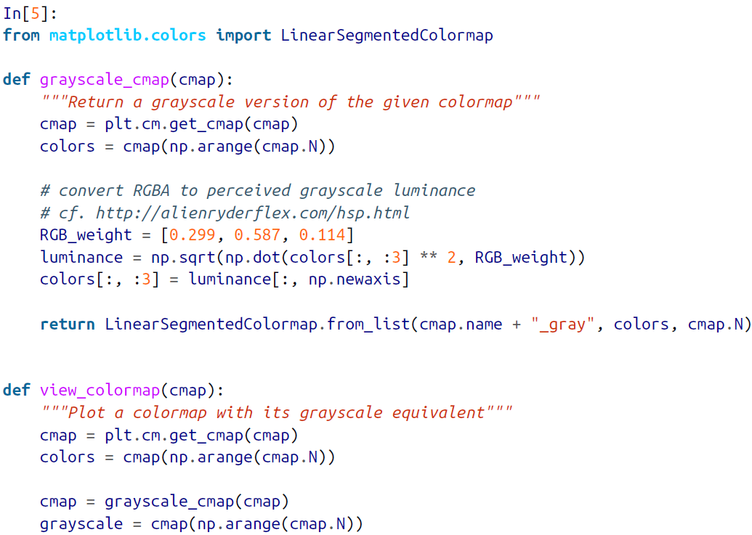

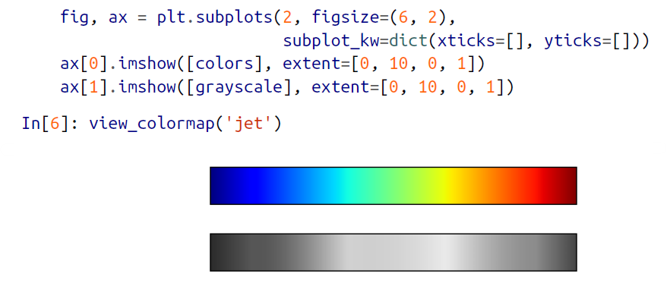

🡪Notice the bright stripes in the grayscale image. Even in full color, this uneven brightness means that the eye will be drawn to certain portions of the color range, which will potentially emphasize unimportant parts of the dataset. It’s better to use a colormap such as viridis (the default as of Matplotlib 2.0), which is specifically constructed to have an even brightness variation across the range. Thus, it not only plays well with our color perception, but also will translate well to grayscale printing as shown in the figure below:

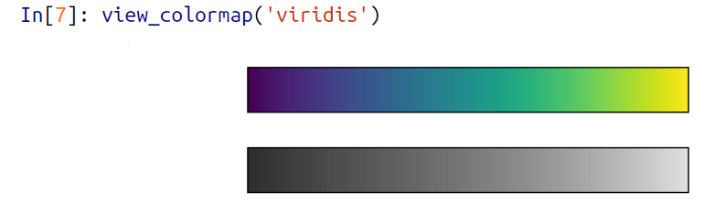

🡪If you favor rainbow schemes, another good option for continuous data is the cubehelix colormap

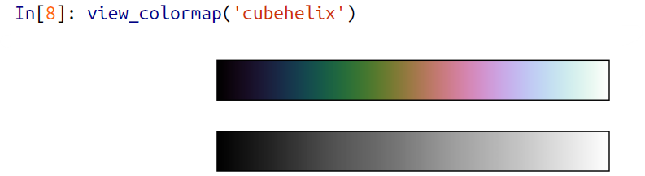

🡪For other situations, such as showing positive and negative deviations from some mean, dual-color colorbars such as RdBu (short for Red-Blue) can be useful. However, as you can see in Figure below, it’s important to note that the positive-negative information will be lost upon translation to grayscale!

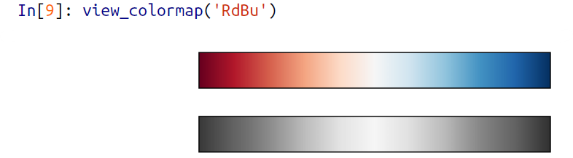

🡪We’ll see examples of using some of these color maps as we continue.

🡪There are a large number of colormaps available in Matplotlib; to see a list of them, you can use IPython to explore the plt.cm submodule. For a more principled approach to colors in Python, you can refer to the tools and documentation within the Seaborn library.

**🡺Color limits and extensions**

🡪Matplotlib allows for a large range of colorbar customization. The colorbar itself is simply an instance of plt.Axes, so all of the axes and tick formatting tricks we’ve learned are applicable. The colorbar has some interesting flexibility; for example, we can narrow the color limits and indicate the out-of-bounds values with a triangular arrow at the top and bottom by setting the extend property. This might come in handy, for example, if you’re displaying an image that is subject to noise as shown below:

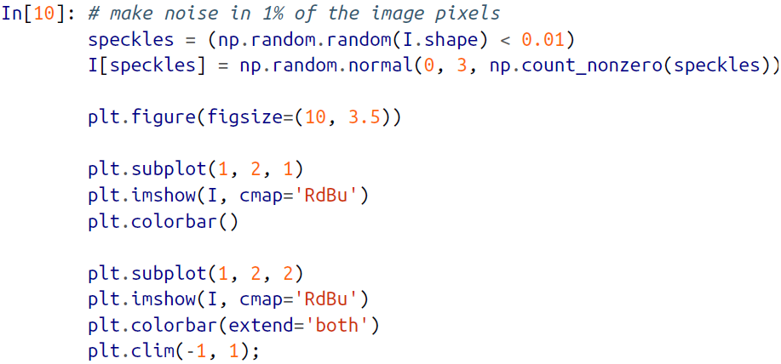

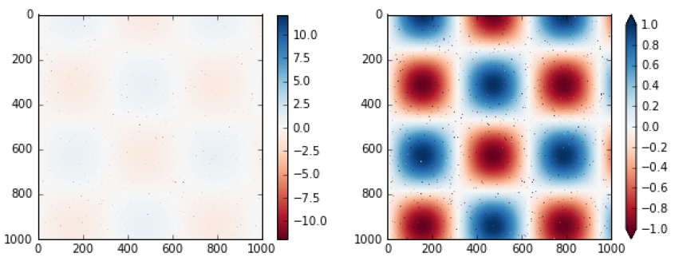

🡪Notice that in the left panel, the default color limits respond to the noisy pixels, and the range of the noise completely washes out the pattern we are interested in. In the right panel, we manually set the color limits, and add extensions to indicate values that are above or below those limits. The result is a much more useful visualization of our data.

**🡺Discrete Colorbars**

🡪Colormaps are by default continuous, but sometimes you’d like to represent discrete values. The easiest way to do this is to use the plt.cm.get_cmap() function, and pass the name of a suitable colormap along with the number of desired bins as shown in figure:

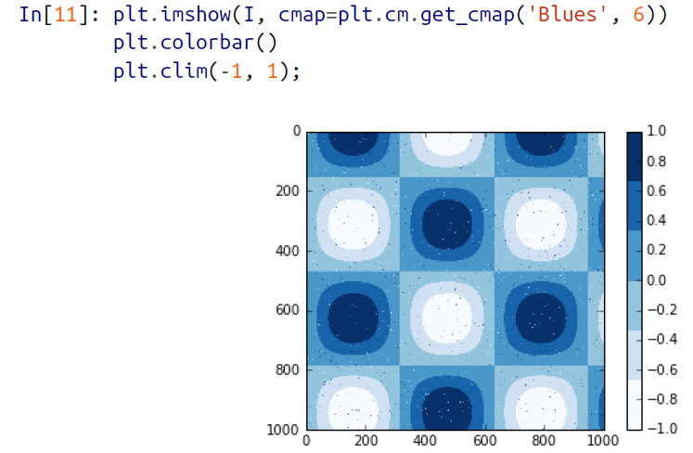

🡪The discrete version of a colormap can be used just like any other colormap.

**🡺Example: Handwritten Digits**

🡪For an example of where this might be useful, let’s look at an interesting visualization of some handwritten digits data. This data is included in Scikit-Learn, and consists of nearly 2,000 8×8 thumbnails showing various handwritten digits.

🡪For now, let’s start by downloading the digits data and visualizing several of the example images with plt.imshow() as shown below:

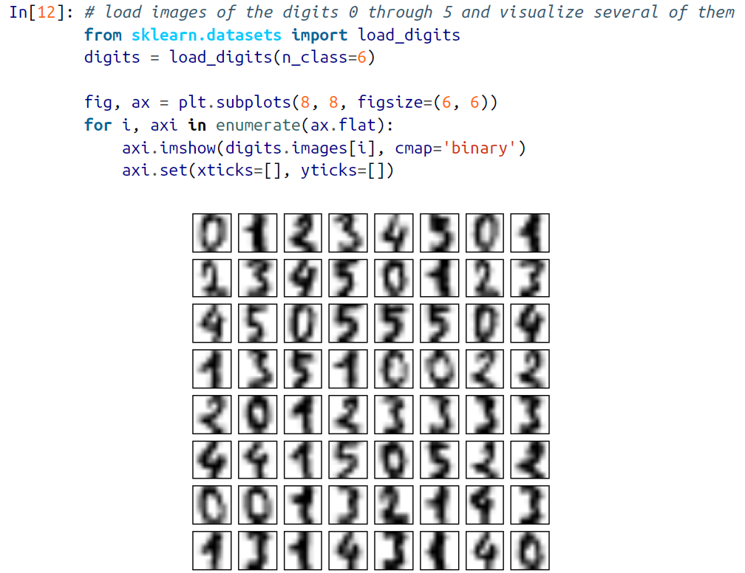

🡪Because each digit is defined by the hue of its 64 pixels, we can consider each digit to be a point lying in 64-dimensional space: each dimension represents the brightness of one pixel. But visualizing relationships in such high-dimensional spaces can be

extremely difficult. One way to approach this is to use a dimensionality reduction technique such as manifold learning to reduce the dimensionality of the data while maintaining the relationships of interest. Dimensionality reduction is an example of unsupervised machine learning, and we will discuss it in more detail later.

🡪Deferring the discussion of these details, let’s take a look at a two-dimensional manifold learning projection of this digits data

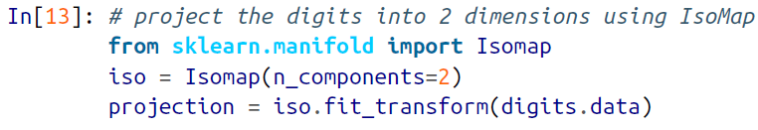

🡪We’ll use our discrete colormap to view the results, setting the ticks and clim to improve the aesthetics of the resulting colorbar as shown in figure below:

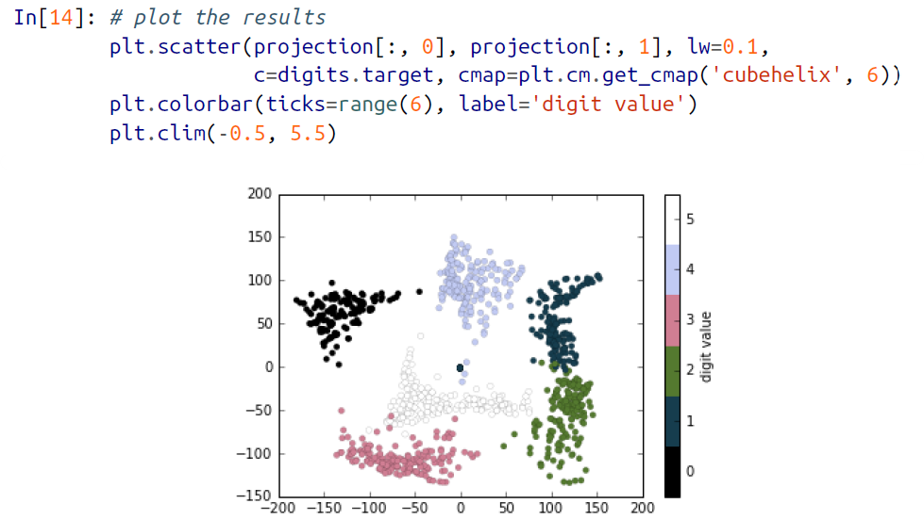

🡪The projection also gives us some interesting insights on the relationships within the dataset: for example, the ranges of 5 and 3 nearly overlap in this projection, indicating that some handwritten fives and threes are difficult to distinguish, and therefore more likely to be confused by an automated classification algorithm. Other values, like 0 and 1, are more distantly separated, and therefore much less likely to be confused.

This observation agrees with our intuition, because 5 and 3 look much more similar than do 0 and 1.

1. **Multiple Subplots**

🡪Sometimes it is helpful to compare different views of data side by side. To this end, Matplotlib has the concept of subplots: groups of smaller axes that can exist together within a single figure. These subplots might be insets, grids of plots, or other more complicated layouts. In this section, we’ll explore four routines for creating subplots in Matplotlib. We’ll start by setting up the notebook for plotting and importing the functions we will use:

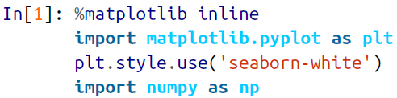

**🡺plt.axes: Subplots by Hand**

🡪The most basic method of creating an axes is to use the plt.axes function. As we’ve seen previously, by default this creates a standard axes object that fills the entire figure. plt.axes also takes an optional argument that is a list of four numbers in the figure coordinate system. These numbers represent [bottom, left, width, height] in the figure coordinate system, which ranges from 0 at the bottom left of the figure to 1 at the top right of the figure.

🡪For example, we might create an inset axes at the top-right corner of another axes by setting the x and y position to 0.65 (that is, starting at 65% of the width and 65% of the height of the figure) and the x and y extents to 0.2 (that is, the size of the axes is

20% of the width and 20% of the height of the figure). Figure below shows the result of this code:

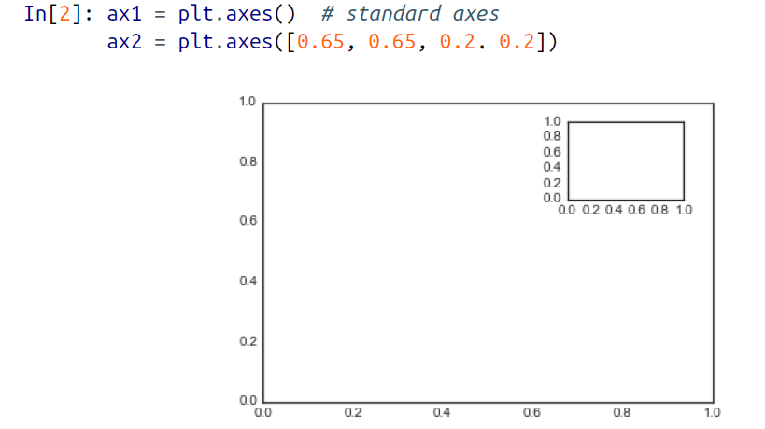

🡪The equivalent of this command within the object-oriented interface is fig.add_axes(). Let’s use this to create two vertically stacked axes is as shown below:

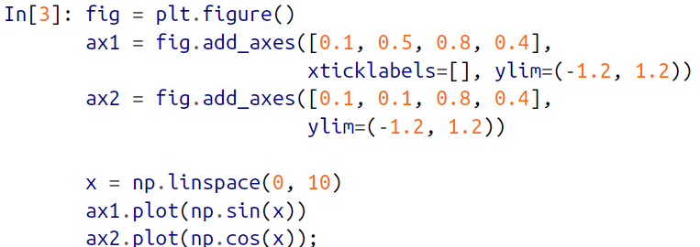

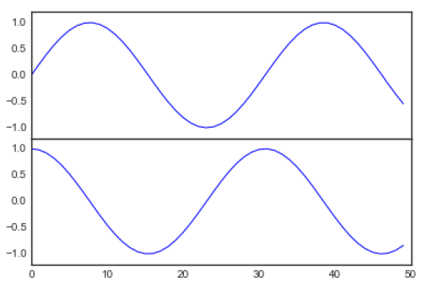

**🡺plt.subplot: Simple Grids of Subplots**

🡪Aligned columns or rows of subplots are a common enough need that Matplotlib has several convenience routines that make them easy to create. The lowest level of these is plt.subplot(), which creates a single subplot within a grid. As you can see, this command takes three integer arguments—the number of rows, the number of columns, and the index of the plot to be created in this scheme, which runs from the upper left to the bottom right as shown in figure:

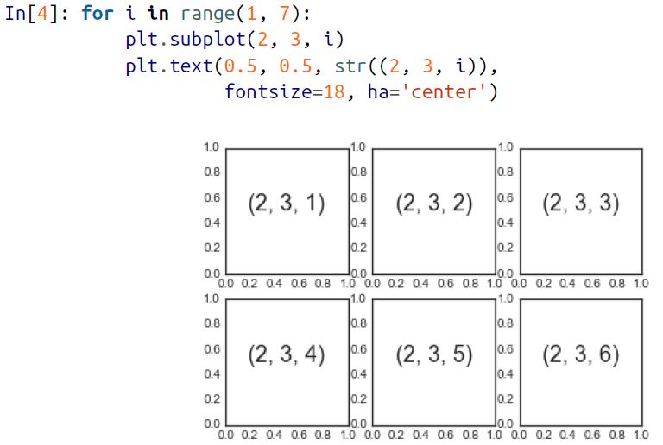

🡪The command plt.subplots_adjust can be used to adjust the spacing between these plots. The following code (the result of which is shown in Figure below) uses the equivalent object-oriented command, fig.add_subplot():

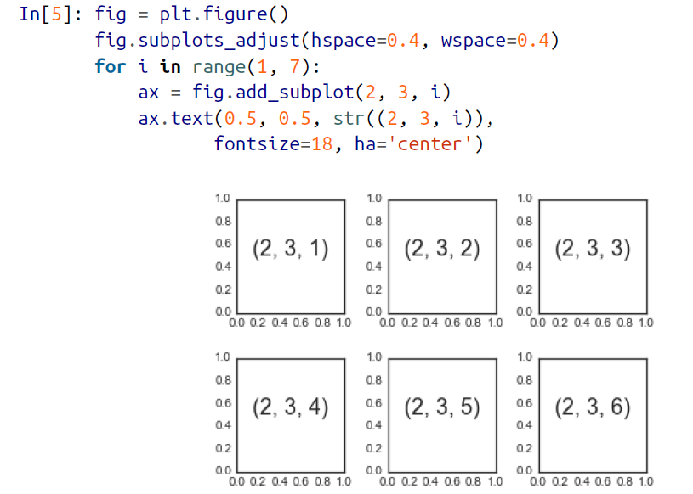

🡪We’ve used the hspace and wspace arguments of plt.subplots_adjust, which specify the spacing along the height and width of the figure, in units of the subplot size (in this case, the space is 40% of the subplot width and height).

**🡺plt.subplots: The Whole Grid in One Go**

🡪The approach just described can become quite tedious when you’re creating a large grid of subplots, especially if you’d like to hide the x- and y-axis labels on the inner plots. For this purpose, plt.subplots() is the easier tool to use (note the s at the end of subplots). Rather than creating a single subplot, this function creates a full grid of subplots in a single line, returning them in a NumPy array. The arguments are the number of rows and number of columns, along with optional keywords sharex and sharey, which allow you to specify the relationships between different axes.

🡪The approach just described can become quite tedious when you’re creating a large grid of subplots, especially if you’d like to hide the x- and y-axis labels on the inner plots. For this purpose, plt.subplots() is the easier tool to use (note the s at the end of subplots). Rather than creating a single subplot, this function creates a full grid of subplots in a single line, returning them in a NumPy array. The arguments are the number of rows and number of columns, along with optional keywords sharex and sharey, which allow you to specify the relationships between different axes.



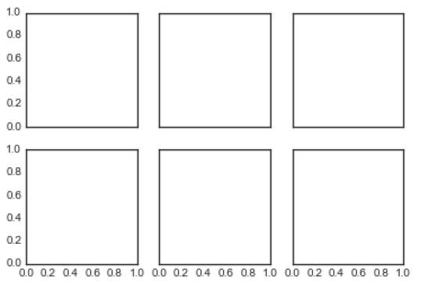

🡪Note that by specifying sharex and sharey, we’ve automatically removed inner labels on the grid to make the plot cleaner. The resulting grid of axes instances is returned within a NumPy array, allowing for convenient specification of the desired axes using standard array indexing notation as shown in figure below:

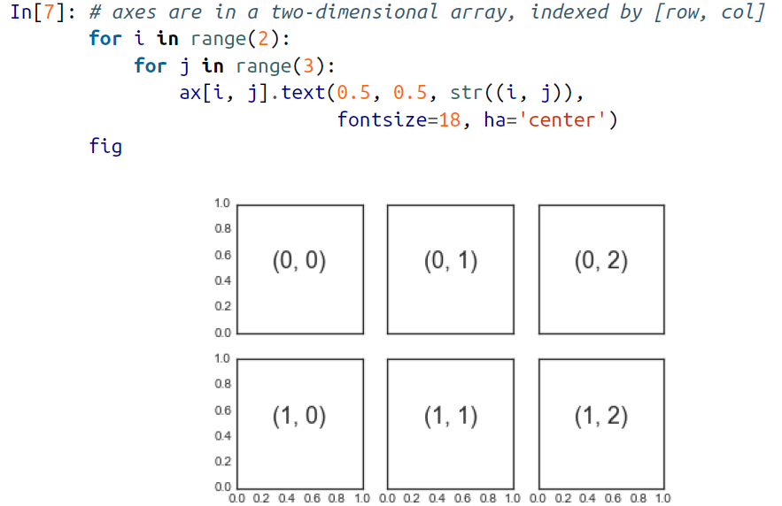

**🡪In comparison to plt.subplot(), plt.subplots() is more consistent with Python’s conventional 0-based indexing.**

**🡺plt.GridSpec: More Complicated Arrangements**

🡪To go beyond a regular grid to subplots that span multiple rows and columns,vplt.GridSpec() is the best tool. The plt.GridSpec() object does not create a plot by itself; it is simply a convenient interface that is recognized by the plt.subplot() command. For example, a gridspec for a grid of two rows and three columns with

some specified width and height space looks like this:



🡪From this we can specify subplot locations and extents using the familiar Python slicing syntax as shown in figure below:

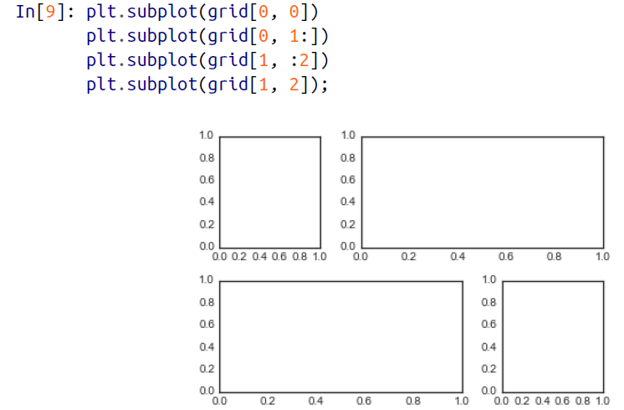

🡪This type of flexible grid alignment has a wide range of uses. I most often use it when creating multi-axes histogram plots like the one shown here in figure below:

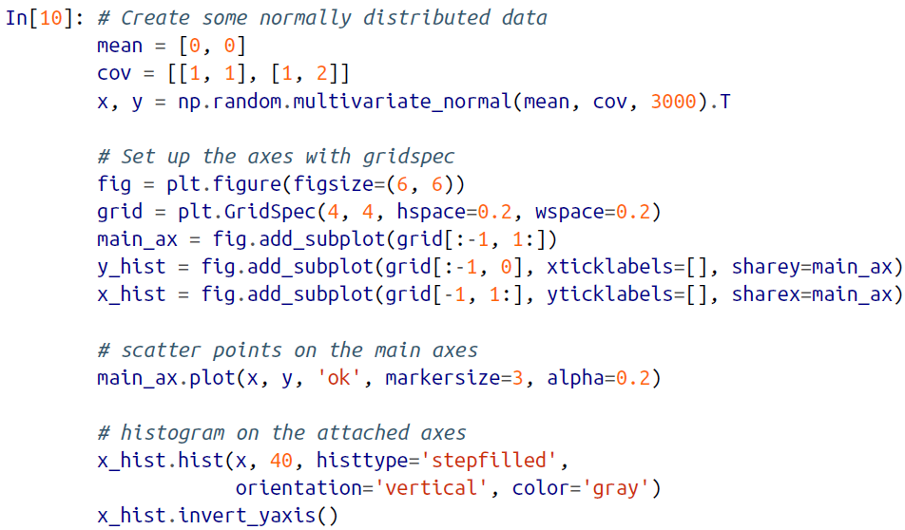

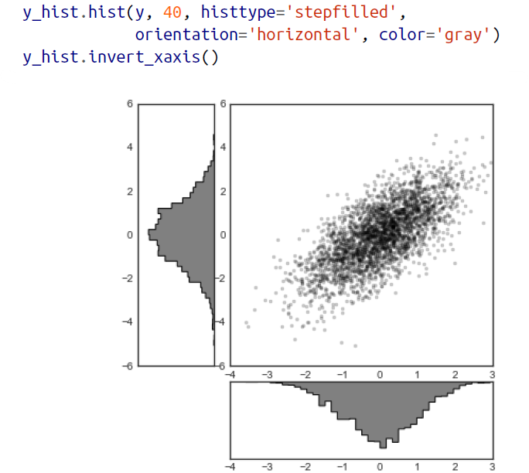

🡪This type of distribution plotted alongside its margins is common enough that it has its own plotting API in the Seaborn package.

1. **Text and Annotation**

🡪Creating a good visualization involves guiding the reader so that the figure tells a story. In some cases, this story can be told in an entirely visual manner, without the need for added text, but in others, small textual cues and labels are necessary. Perhaps the most basic types of annotations you will use are axes labels and titles, but the options go beyond this. Let’s take a look at some data and how we might visualize and annotate it to help convey interesting information. We’ll start by setting up the notebook for plotting and importing the functions we will use:

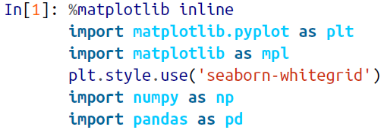

**🡺Example: Effect Of Holidays On Us Births**

🡪Let’s return to some data we worked with earlier in “Example: Birthrate Data” on page 174, where we generated a plot of average births over the course of the calendar year; as already mentioned, this data can be downloaded at https://raw.githubusercontent.com/jakevdp/data-CDCbirths/master/births.csv.

🡪We’ll start with the same cleaning procedure we used there, and plot the results as shown below:

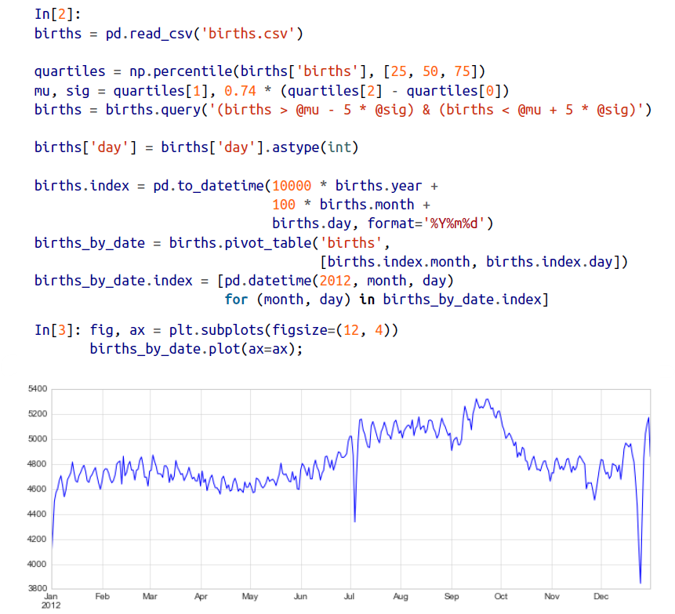

🡪When we’re communicating data like this, it is often useful to annotate certain features of the plot to draw the reader’ attention. This can be done manually with the plt.text/ax.text command, which will place text at a particular x/y value as shown in figure below:

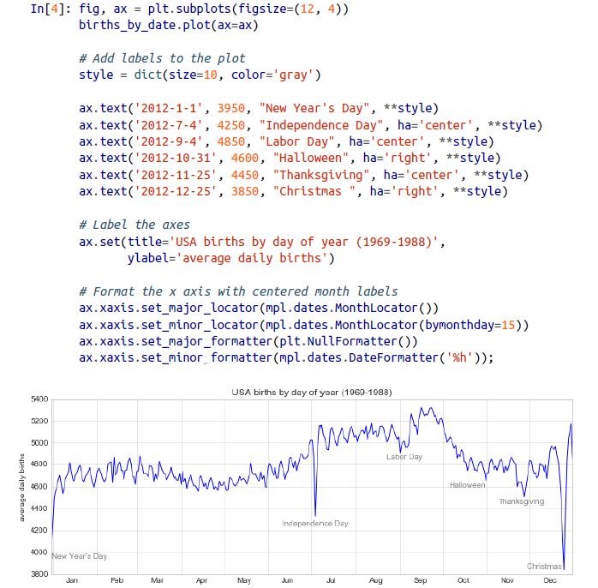

🡪The ax.text method takes an x position, a y position, a string, and then optional keywords specifying the color, size, style, alignment, and other properties of the text. Here we used ha='right' and ha='center', where ha is short for horizonal alignment. See the docstring of plt.text() and of mpl.text.Text() for more information on available options.

**🡺Transform and Text Position**

🡪In the previous example, we anchored our text annotations to data locations. Sometimes it’s preferable to anchor the text to a position on the axes or figure, independent of the data. In Matplotlib, we do this by modifying the transform.

🡪Any graphics display framework needs some scheme for translating between coordinate systems. For example, a data point at x, y = 1, 1 needs to somehow be represented at a certain location on the figure, which in turn needs to be represented in pixels on the screen. Mathematically, such coordinate transformations are relatively straightforward, and Matplotlib has a well-developed set of tools that it uses internally to perform them (the tools can be explored in the matplotlib.transforms submodule).

🡪The average user rarely needs to worry about the details of these transforms, but it is helpful knowledge to have when considering the placement of text on a figure. There are three predefined transforms that can be useful in this situation:

**🡺ax.transData**

🡪Transform associated with data coordinates

**🡺ax.transAxes**

🡪Transform associated with the axes (in units of axes dimensiona)

**🡺fig.transFigure**

🡪Transform associated with the figure (in units of figure dimensions)

🡪Here let’s look at an example of drawing text at various locations using these transforms in figure below:

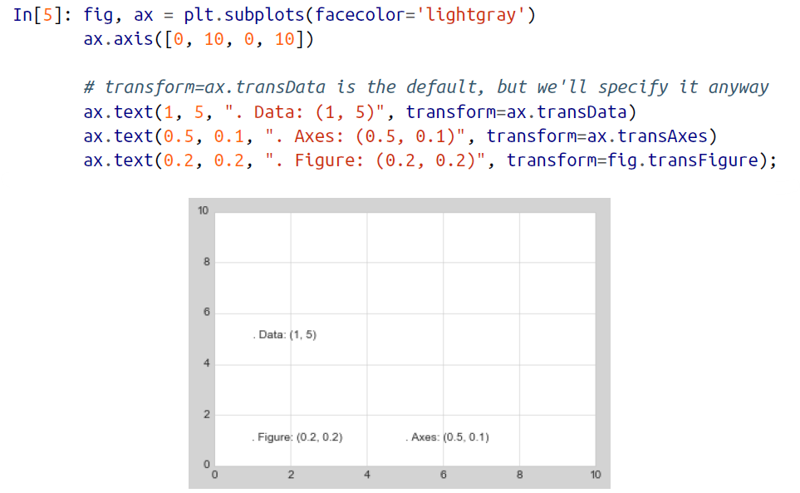

🡪Note that by default, the text is aligned above and to the left of the specified coordinates; here the “.” at the beginning of each string will approximately mark the given coordinate location.

🡪The transData coordinates give the usual data coordinates associated with the x- and y-axis labels. The transAxes coordinates give the location from the bottom-left corner of the axes (here the white box) as a fraction of the axes size. The transfigure coordinates are similar, but specify the position from the bottom left of the figure (here the gray box) as a fraction of the figure size.

**🡪Notice now that if we change the axes limits, it is only the transData coordinates that will be affected, while the others remain stationary as shown in figure below:**

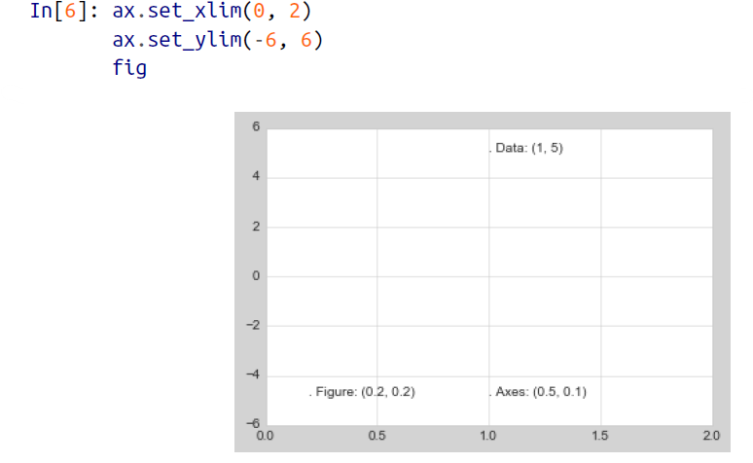

🡪You can see this behavior more clearly by changing the axes limits interactively; if you are executing this code in a notebook, you can make that happen by changing %mat plotlib inline to %matplotlib notebook and using each plot’s menu to interact

with the plot.

**🡺Arrows and Annotation**

🡪Along with tick marks and text, another useful annotation mark is the simple arrow.

🡪Drawing arrows in Matplotlib is often much harder than you might hope. While there is a plt.arrow() function available, **I wouldn’t suggest using it; the arrows it creates are SVG objects that will be subject to the varying aspect ratio of your plots, and the result is rarely what the user intended**. **Instead, I’d suggest using the plt.annotate() function**. This function creates some text and an arrow, and the arrows can be very flexibly specified.

🡪Here we will use annotate with several of its options as shown in the figure below:

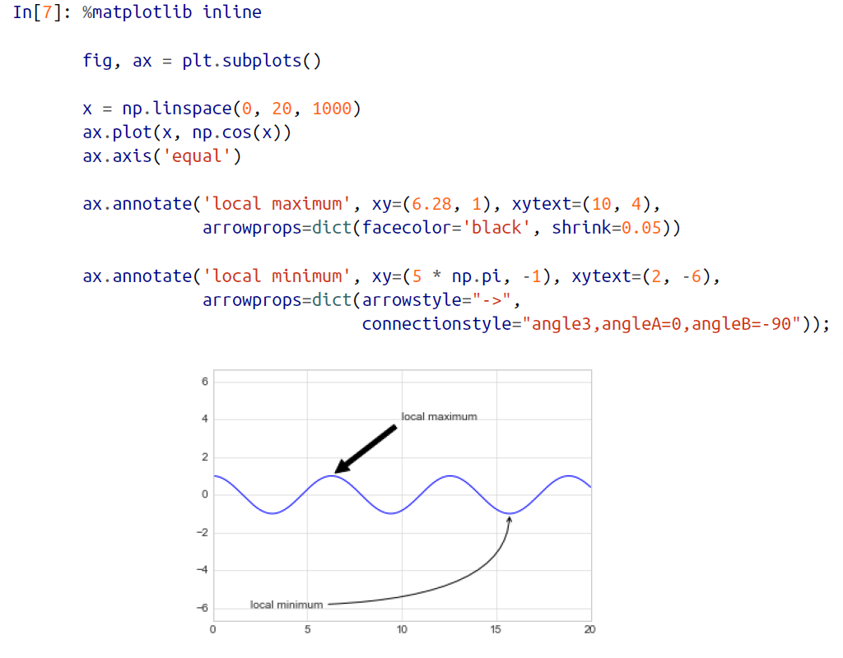

🡪The arrow style is controlled through the arrowprops dictionary, which has numerous options available. These options are fairly well documented in Matplotlib’s online documentation, so rather than repeating them here I’ll quickly show some of the possibilities. Let’s demonstrate several of the possible options using the birth rate plot from before as shown in figure below:

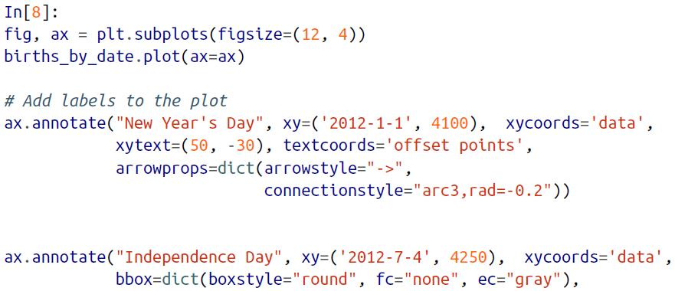

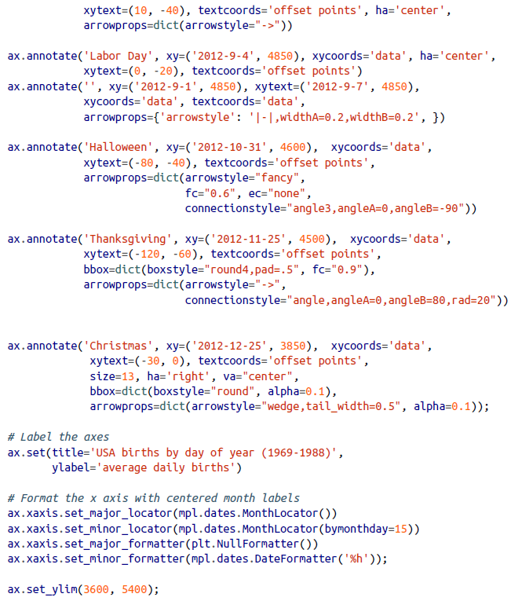

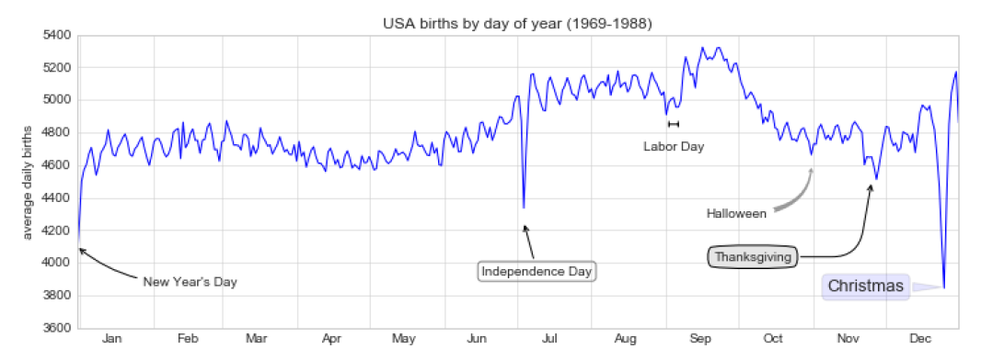

🡪You’ll notice that the specifications of the arrows and text boxes are very detailed: this gives you the power to create nearly any arrow style you wish. Unfortunately, it also means that these sorts of features often must be manually tweaked, a process that can be very time-consuming when one is producing publication quality graphics! Finally, I’ll note that the preceding mix of styles is by no means best practice for presenting data, but rather included as a demonstration of some of the available options.

1. Customizing Ticks

🡪Matplotlib’s default tick locators and formatters are designed to be generally sufficient in many common situations, but are in no way optimal for every plot. This section will give several examples of adjusting the tick locations and formatting for the particular plot type you’re interested in.

🡪Before we go into examples, it will be best for us to understand further the object hierarchy of Matplotlib plots. Matplotlib aims to have a Python object representing everything that appears on the plot: for example, recall that the figure is the bounding box within which plot elements appear. Each Matplotlib object can also act as a container of sub-objects; for example, each figure can contain one or more axes objects, each of which in turn contain other objects representing plot contents.

🡪The tick marks are no exception. Each axes has attributes xaxis and yaxis, which in turn have attributes that contain all the properties of the lines, ticks, and labels that make up the axes.

**🡺Major and Minor Ticks**

🡪Within each axis, there is the concept of a major tick mark and a minor tick mark. As the names would imply, major ticks are usually bigger or more pronounced, while minor ticks are usually smaller. By default, Matplotlib rarely makes use of minor ticks, but one place you can see them is within logarithmic plots as shown in figure below:

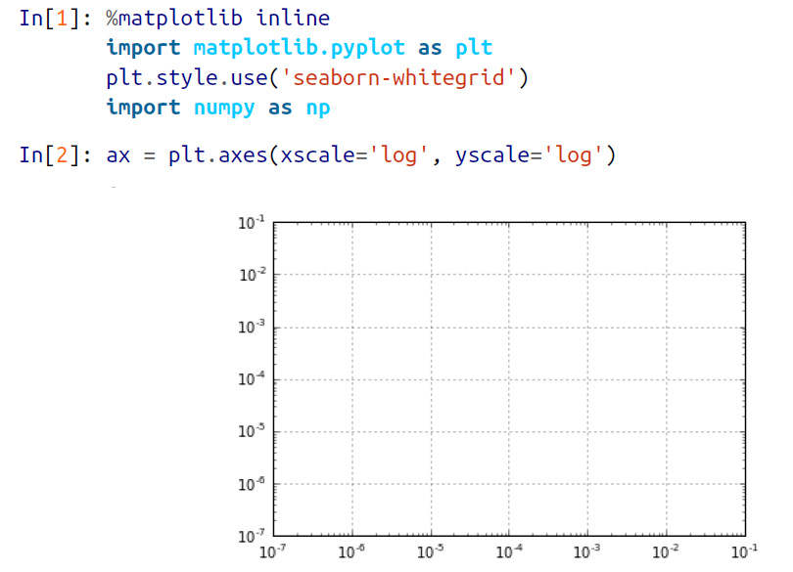

🡪We see here that each major tick shows a large tick mark and a label, while each minor tick shows a smaller tick mark with no label.

🡪We can customize these tick properties—that is, locations and labels—by setting the formatter and locator objects of each axis. Let’s examine these for the x axis of the plot just shown:

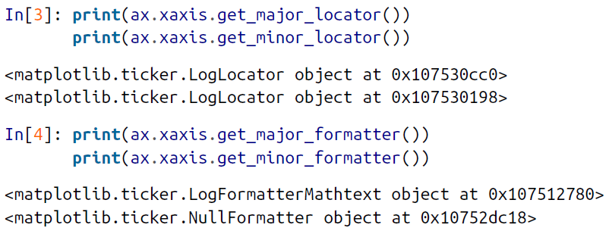

🡪We see that both major and minor tick labels have their locations specified by a LogLocator (which makes sense for a logarithmic plot). Minor ticks, though, have their labels formatted by a NullFormatter; this says that no labels will be shown.

🡪We’ll now show a few examples of setting these locators and formatters for various plots.

**🡺Hiding Ticks or Labels**

🡪Perhaps the most common tick/label formatting operation is the act of hiding ticks or labels. We can do this using plt.NullLocator() and plt.NullFormatter(), as shown in figure below:

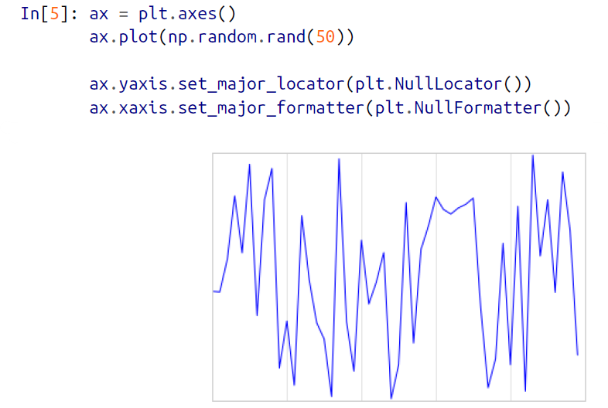

🡪**Notice that we’ve removed the labels (but kept the ticks/gridlines) from the x axis, and removed the ticks (and thus the labels as well) from the y axis**. Having no ticks at all can be useful in many situations—for example, when you want to show a grid of images. For instance, consider Figure below, which includes images of different faces, an example often used in supervised machine learning problems.

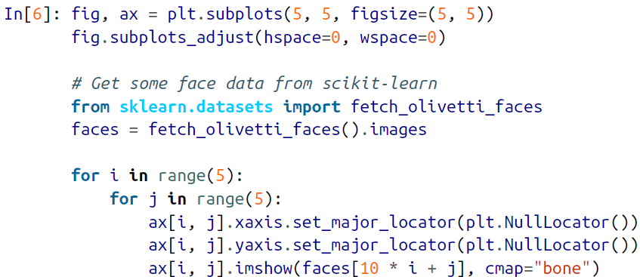

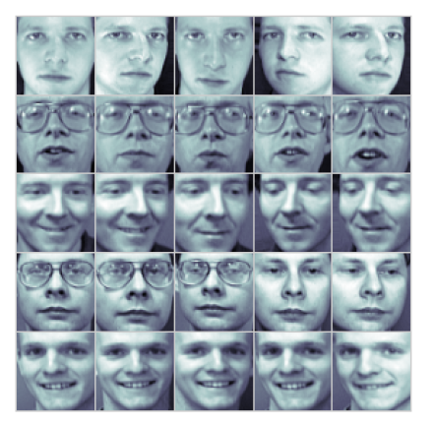

🡪Notice that each image has its own axes, and we’ve set the locators to null because the tick values (pixel number in this case) do not convey relevant information for this particular visualization.

**🡺Reducing or Increasing the Number of ticks**

🡪One common problem with the default settings is that smaller subplots can end up with the crowded labels. We can see this in the plot grid as shown in the figure below:

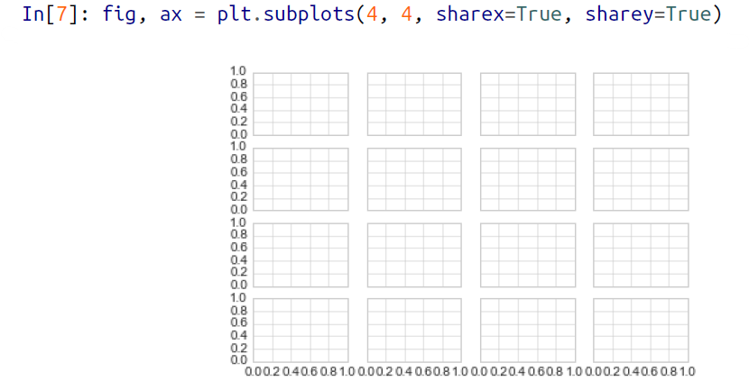

🡪**Particularly for the x ticks, the numbers nearly overlap, making them quite difficult to decipher. We can fix this with the plt.MaxNLocator(), which allows us to specify the maximum number of ticks that will be displayed**. Given this maximum number, Matplotlib will use internal logic to choose the particular tick locations as shown in figure below:

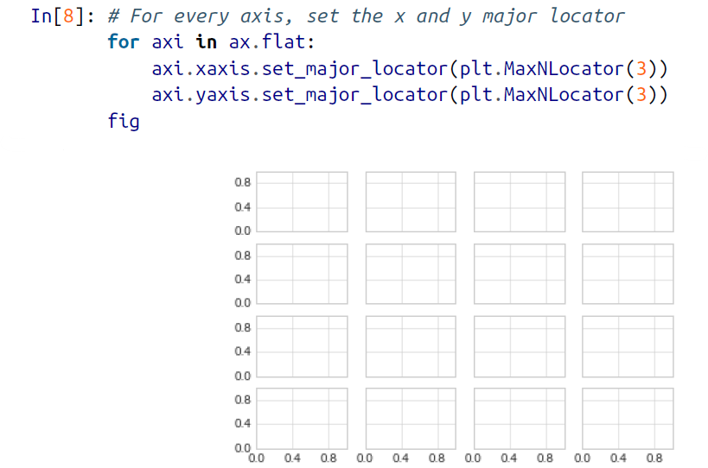

🡪This makes things much cleaner. If you want even more control over the locations of regularly spaced ticks, you might also use plt.MultipleLocator, which we’ll discuss in the following section.

**🡺Fancy Tick Formats**

🡪Matplotlib’s default tick formatting can leave a lot to be desired; it works well as a broad default, but sometimes you’d like to do something more. Consider the plot shown in figure below, a sine and a cosine:

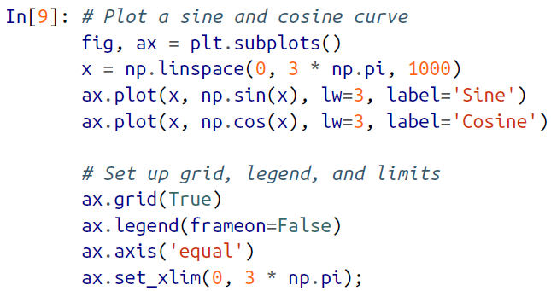

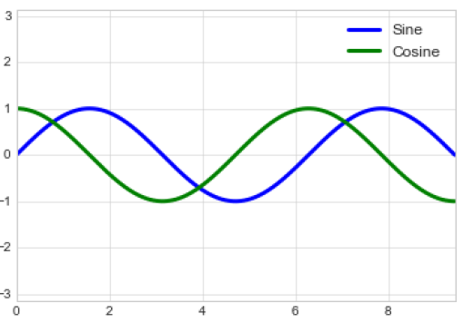

🡪There are a couple changes we might like to make. First, it’s more natural for this data to space the ticks and grid lines in multiples of π. We can do this by setting a Multi pleLocator, which locates ticks at a multiple of the number you provide. For good measure, we’ll add both major and minor ticks in multiples of π/4 as shown in figure below:

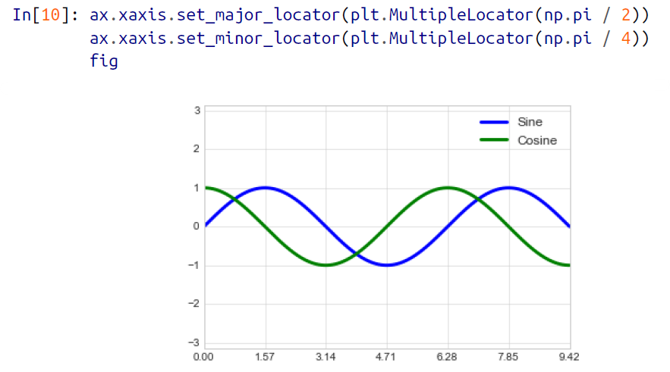

🡪But now these tick labels look a little bit silly: we can see that they are multiples of π, but the decimal representation does not immediately convey this. To fix this, we can change the tick formatter. There’s no built-in formatter for what we want to do, so we’ll instead use plt.FuncFormatter, which accepts a user-defined function giving fine-grained control over the tick outputs as shown in figure below:

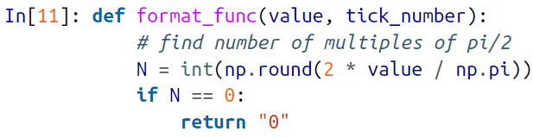

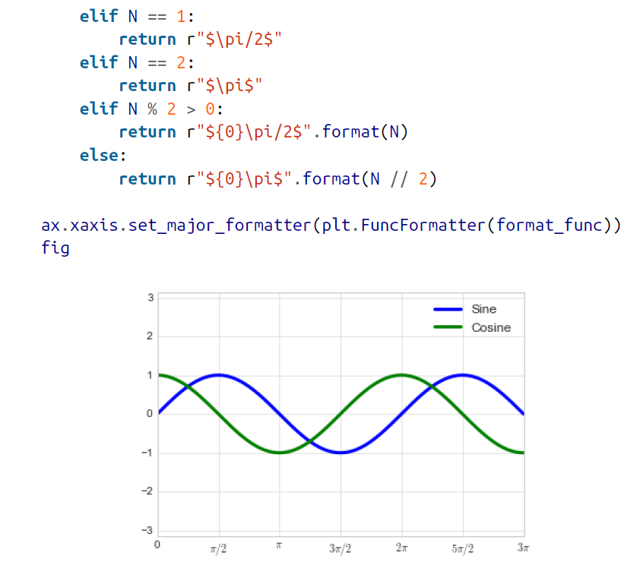

🡪**This is much better! Notice that we’ve made use of Matplotlib’s LaTeX support**, **specified by enclosing the string within dollar signs. This is very convenient for display of mathematical symbols and formulae; in this case, "$\pi$" is rendered as the Greek character π.**

🡪The plt.FuncFormatter() offers extremely fine-grained control over the appearance of your plot ticks, and comes in very handy when you’re preparing plots for presentation or publication.

**🡺Summary Of Formators and Locators**

🡪We’ve mentioned a couple of the available formatters and locators. We’ll conclude this section by briefly listing all the built-in locator and formatter options. For more information on any of these, refer to the docstrings or to the Matplotlib online documentation. Each of the following is available in the plt namespace:

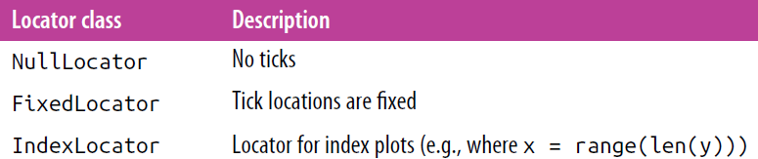

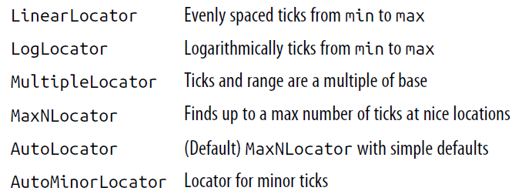

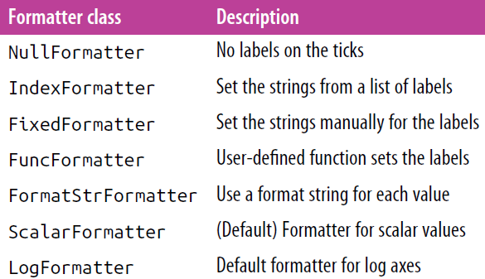

1. Customizing Matplotlib: Configuration and Stylesheet

🡪Matplotlib’s default plot settings are often the subject of complaint among its users. While much is slated to change in the 2.0 Matplotlib release, the ability to customize default settings helps bring the package in line with your own aesthetic preferences.

🡪Here we’ll walk through some of Matplotlib’s runtime configuration (rc) options, and take a look at the newer stylesheets feature, which contains some nice sets of default configurations.

**🡺Plot Customization by Hand**

🡪Throughout this chapter, we’ve seen how it is possible to tweak individual plot settings to end up with something that looks a little bit nicer than the default. It’s possible to do these customizations for each individual plot. For example, here is a fairly drab default histogram as shown in figure below:

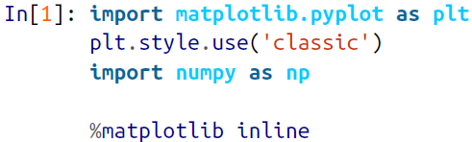

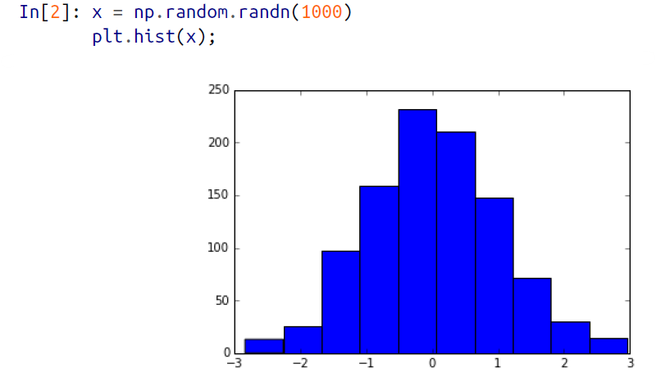

🡪We can adjust this by hand to make it a much more visually pleasing plot, shown in figure below:

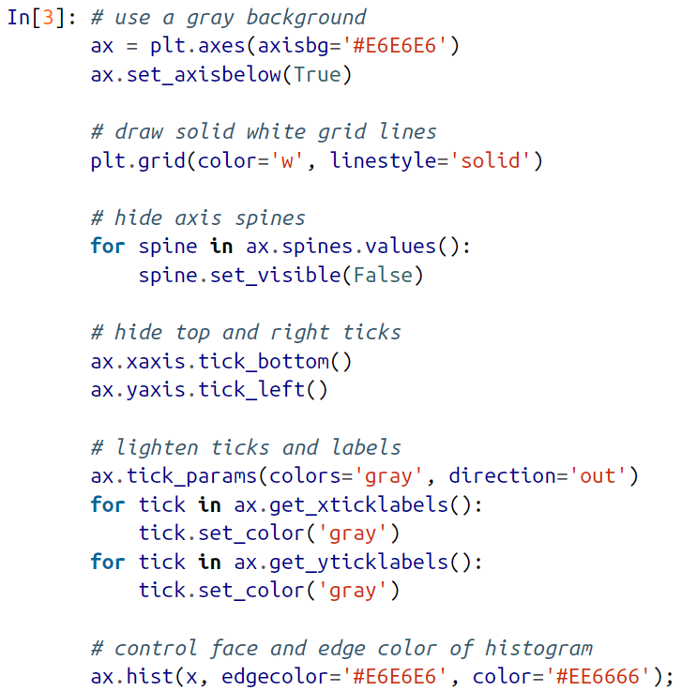

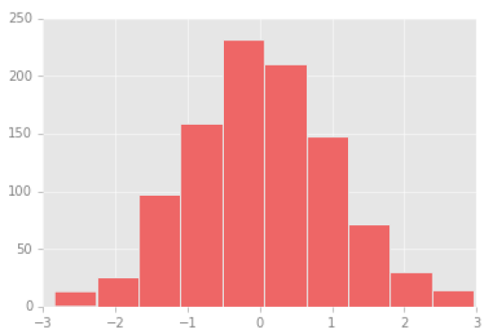

🡪This looks better, and you may recognize the look as inspired by the look of the R language’s ggplot visualization package. But this took a whole lot of effort! We definitely do not want to have to do all that tweaking each time we create a plot. Fortunately, there is a way to adjust these defaults once in a way that will work for all plots.

**🡺Changing the Defaults: rcparams**

🡪**Each time Matplotlib loads, it defines a runtime configuration (rc) containing the default styles for every plot element you create.** **You can adjust this configuration at any time using the plt.rc convenience routine**. Let’s see what it looks like to modify the rc parameters so that our default plot will look similar to what we did before.

🡪We’ll start by saving a copy of the current rcParams dictionary, so we can easily reset these changes in the current session:



🡪Now we can use the plt.rc function to change some of these settings:

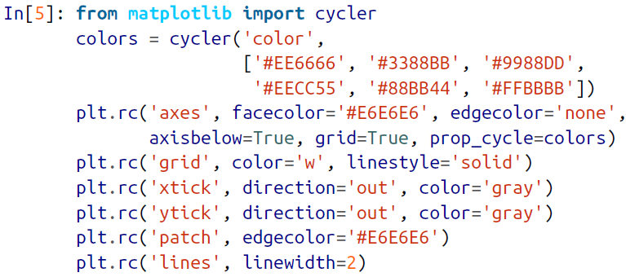

🡪With these settings defined, we can now create a plot and see our settings in action as shown in figure below:

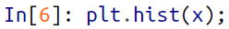

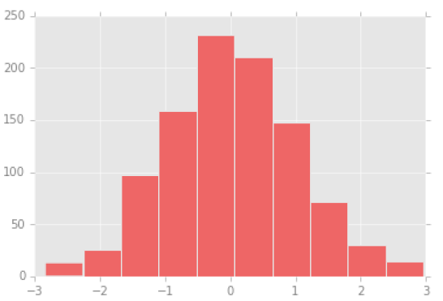

🡪Let’s see what simple line plots look like with these rc parameters as shown in figure below:

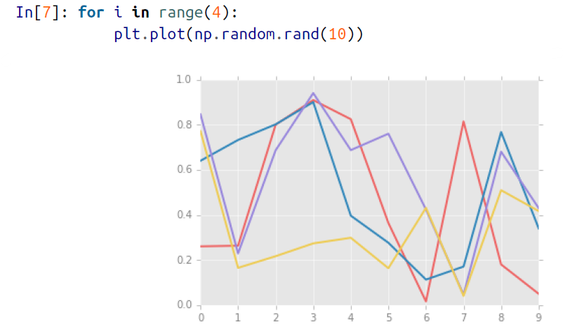

🡪I find this much more aesthetically pleasing than the default styling. If you disagree with my aesthetic sense, the good news is that you can adjust the rc parameters to suit your own tastes! These settings can be saved in a .matplotlibrc file, which you can read about in the Matplotlib documentation. That said, I prefer to customize Matplotlib using its stylesheets instead.

**🡺Stylesheets**

🡪Even if you don’t create your own style, the stylesheets included by default are extremely useful. The available styles are listed in plt.style.available—here I’ll list only the first five for brevity:

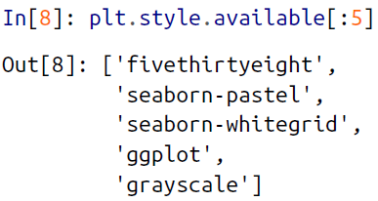

🡪The basic way to switch to a stylesheet is to call:

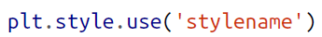

🡪**But keep in mind that this will change the style for the rest of the session! Alternatively, you can use the style context manager, which sets a style temporarily**:

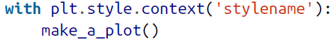

🡪Let’s create a function that will make two basic types of plot:

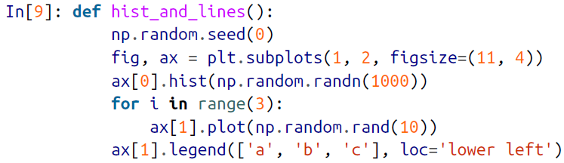

🡪We’ll use this to explore how these plots look using the various built-in styles.

**🡺Default Style**

🡪The default style is what we’ve been seeing so far throughout

the book; we’ll start with that. First, let’s reset our runtime configuration to the notebook default:

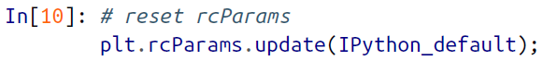

🡪Now lets see how it works in figure below:



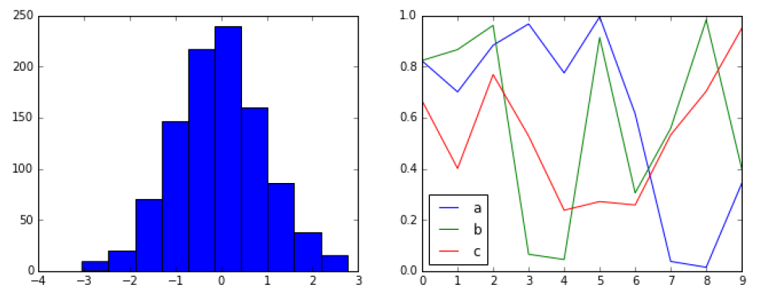

**🡺FiveThirtyEight Style**

🡪The FiveThirtyEight style mimics the graphics found on the popular FiveThirtyEight website. As you can see in Figure below, it is typified by bold colors, thick lines, and transparent axes.

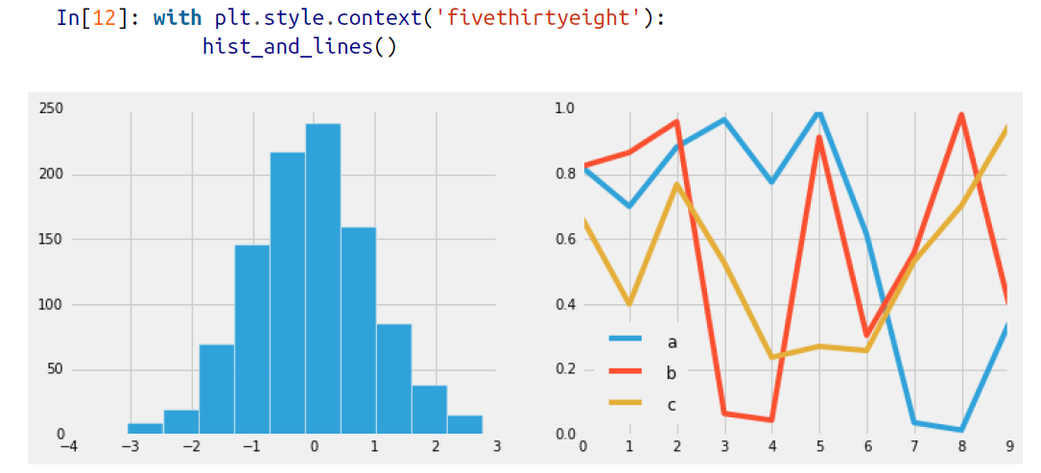

**🡺ggplot**

🡪The ggplot package in the R language is a very popular visualization tool. Matplotlib’s ggplot style mimics the default styles from that package as shown in figure below:

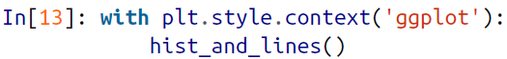

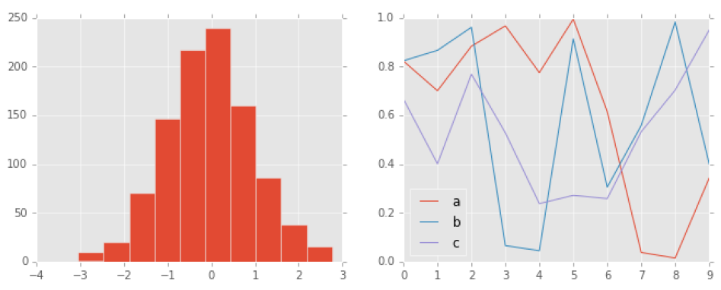

**🡺Bayesian Methods for Hackers style**

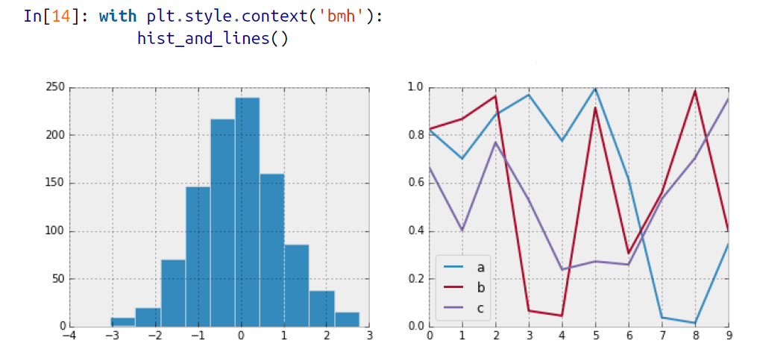

**🡺Dark Background**

🡪For figures used within presentations, it is often useful to have a dark rather than light background. The dark_background style provides this as shown in figure below:



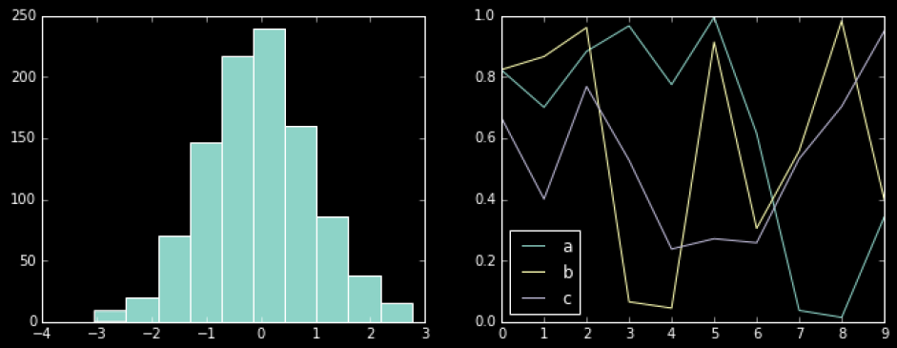

**🡺Grayscale**

🡪Sometimes you might find yourself preparing figures for a print publication that does not accept color figures. For this, the grayscale style, shown in figure below, can be very useful:

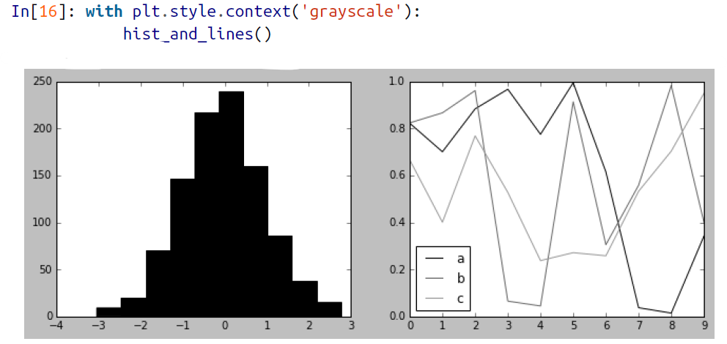

**🡺Seaborn**

🡪Matplotlib also has stylesheets inspired by the Seaborn library (discussed more fully in “Visualization with Seaborn” in below section). As we will see, these styles are loaded automatically when Seaborn is imported into a notebook. I’ve found these settings to be very nice, and tend to use them as defaults in my own data exploration as shown in figure below:

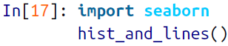

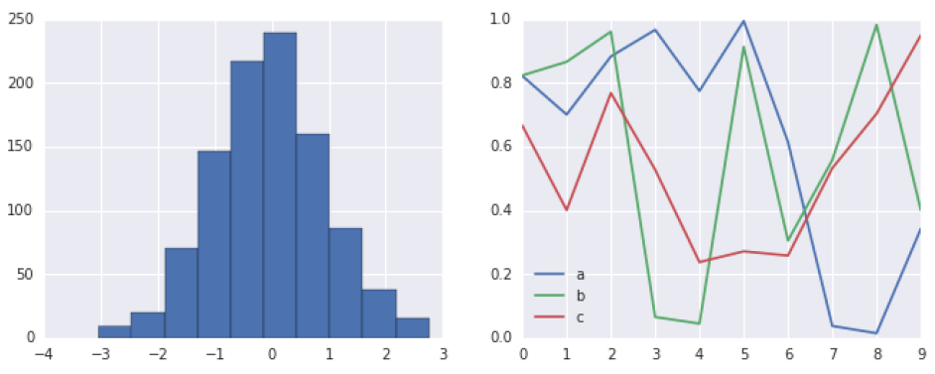

🡪With all of these built-in options for various plot styles, Matplotlib becomes much more useful for both interactive visualization and creation of figures for publication. Throughout this book, I will generally use one or more of these style conventions when creating plots.

1. **Three-Dimensional Plotting in Matplotlib**

🡪Matplotlib was initially designed with only two-dimensional plotting in mind. Around the time of the 1.0 release, some three-dimensional plotting utilities were built on top of Matplotlib’s two-dimensional display, and the result is a convenient (if somewhat limited) set of tools for three-dimensional data visualization. We enable three-dimensional plots by importing the mplot3d toolkit, included with the main Matplotlib installation as shown in figure bellow:



🡪Once this submodule is imported, we can create a three-dimensional axes by passing the keyword projection='3d' to any of the normal axes creation routines:

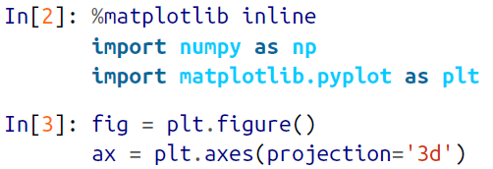

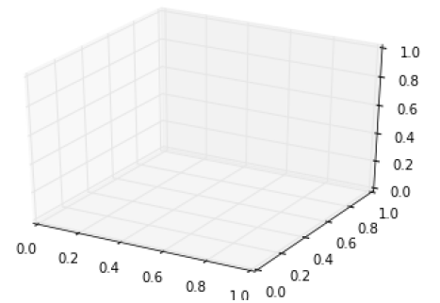

🡪With this 3D axes enabled, we can now plot a variety of three-dimensional plot types. Three-dimensional plotting is one of the functionalities that benefits immensely from viewing figures interactively rather than statically in the notebook; recall that to use interactive figures, you can use **%matplotlib notebook** rather than **%matplotlib inline** when running this code.

🡺**Three-Dimensional Points and Lines**

🡪The most basic three-dimensional plot is a line or scatter plot created from sets of (x, y, z) triples. In analogy with the more common two-dimensional plots discussed earlier, we can create these using the **ax.plot3D** and **ax.scatter3D** functions. The call signature for these is nearly identical to that of their two-dimensional counterparts. Here we’ll plot a trigonometric spiral, along with some points drawn randomly near the line.

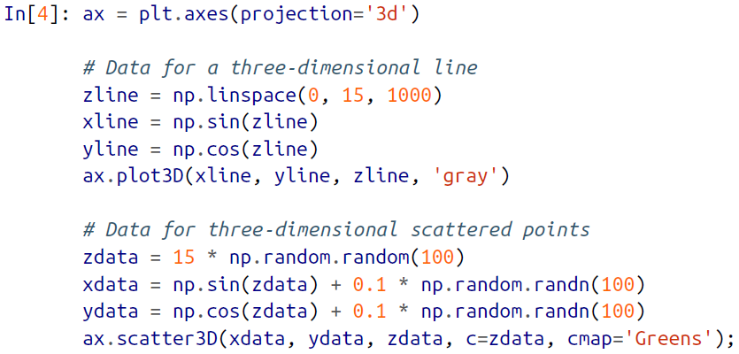

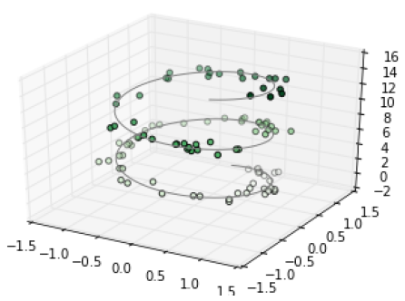

🡪Notice that by default, the scatter points have their transparency adjust to give a sense of depth on the page. While the three-dimensional effect is some times difficult to see within the static image, an interactive view can lead to some nice intuition about the layout of the points.

**🡺Three-Dimensional counter plots**

🡪**mplot3d** contains tools to create three-dimensional relief plots using the same inputs. Like two-dimensional **ax.contour plots, ax.contour3D** requires all the input data to be in the form of two-dimensional regular grids, with the Z data evaluated at each point. Here we’ll show a three-dimensional contour diagram of a three-dimensional sinusoidal function as shown in figure below:

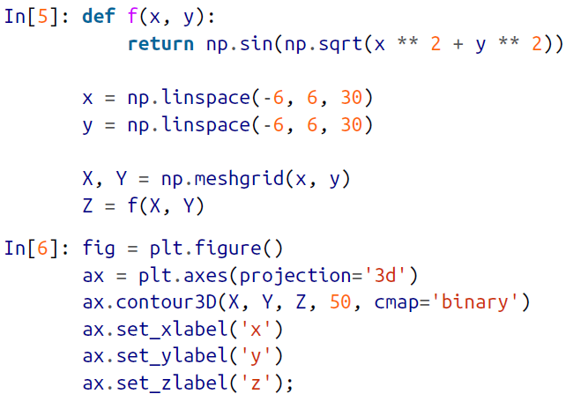

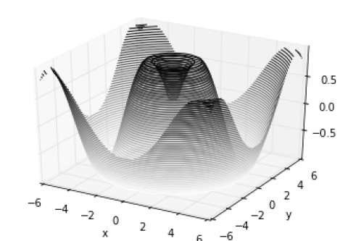

🡪Sometimes the default viewing angle is not optimal, in which case we can use the **view_init method** to set the elevation and azimuthal angles.

, we’ll use **an elevation of 60 degrees** (that is, 60 degrees above the x-y plane) and **an azimuth of 35 degrees** (that is, rotated 35 degrees counter-clockwise about the z-axis):

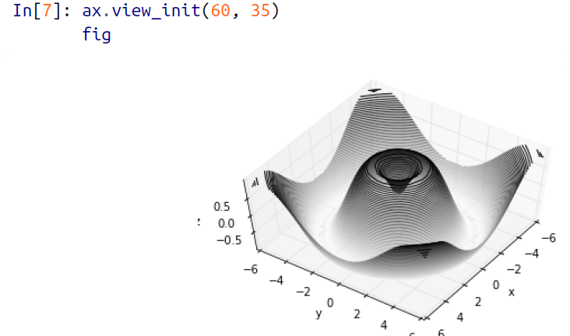

🡪Again note that we have performed this type of the rotations by clicking and dragging when using one Matplotlib’s interactive backends.

**🡺Wireframes and Surface Plots**

🡪**Two other types of three-dimensional plots that work on gridded data are wireframes and surface plots**. These take a grid of values and project it onto the specified three dimensional surface, and can make the resulting three-dimensional forms quite easy to visualize. Here’s an example using a wireframe as shown in figure below:

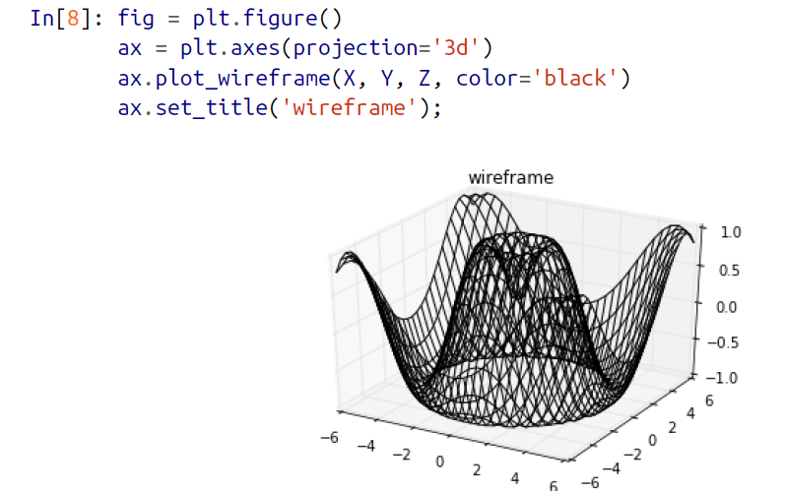

🡪**A surface plot is like a wireframe plot, but each face of the wireframe is a filled polygon**. Adding a colormap to the filled polygons can aid perception of the topology of the surface being visualized as shown in the figure below:

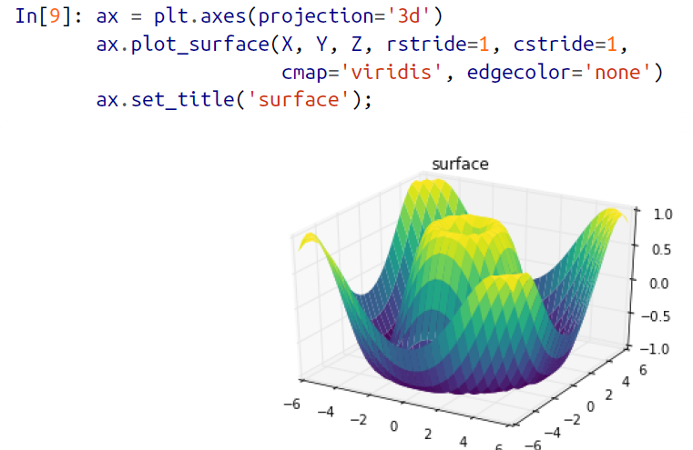

🡪**Note that though the grid of values for a surface plot needs to be two-dimensional, it need not be rectilinear**. Here is an example of creating a **partial polar grid**, which when used with the surface3D plot can give us a slice into the function we’re visualizing as shown in the figure below:

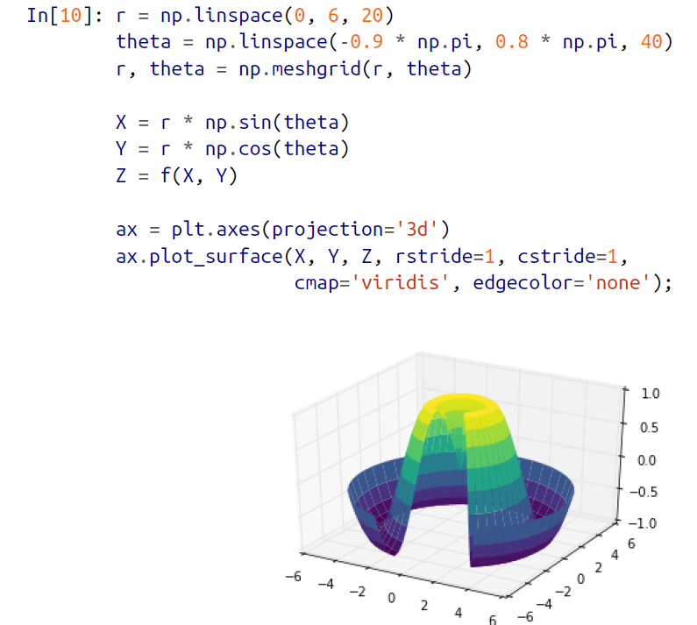

**🡺Surface Triangulation**

🡪For some applications, the evenly sampled grids required by the preceding routines are overly restrictive and inconvenient. In these situations, the triangulation-based plots can be very useful. What if rather than an even draw from a Cartesian or a polar grid, we instead have a set of random draws?

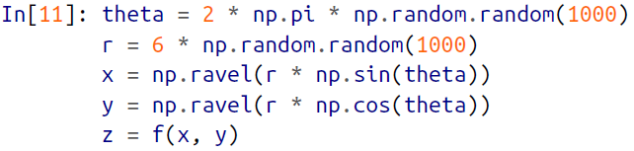

🡪We could create a scatter plot of the points to get an idea of the surface we’re sampling from as shown in the figure:



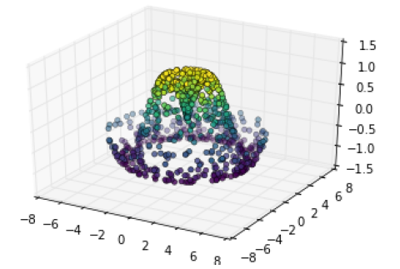

🡪This leaves a lot to be desired. **The function that will help us in this case is ax.plot_trisurf, which creates a surface by first finding a set of triangles formed between adjacent points** (the result is shown in Figure below; remember that x, y, and z here are one-dimensional arrays):

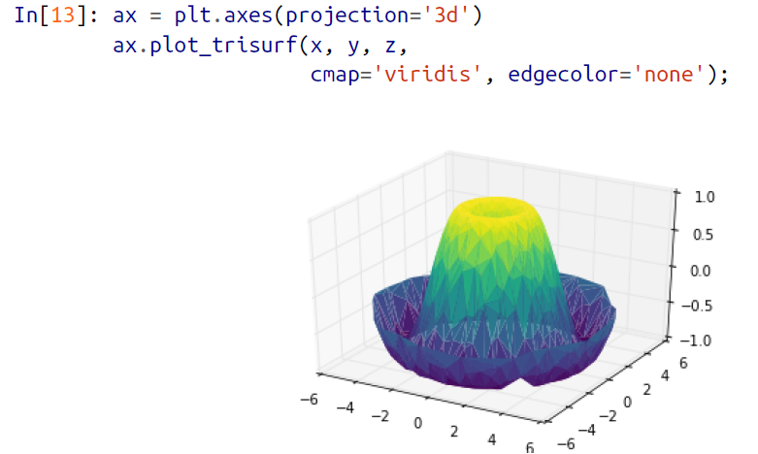

🡪The result is certainly not as clean as when it is plotted with a grid, but the flexibility of such a triangulation allows for some really interesting three-dimensional plots. For example, it is actually possible to plot a three-dimensional Möbius strip using this, as we’ll see next.

**🡺Example: Visualizing a Mobius strip**

🡪**A Möbius strip is similar to a strip of paper glued into a loop with a half-twist. Topologically, it’s quite interesting because despite appearances it has only a single side!** Here we will visualize such an object using Matplotlib’s three-dimensional tools. The key to creating the Möbius strip is to think about its parameterization: it’s a two dimensional strip, so we need two intrinsic dimensions. Let’s call them θ, which ranges from 0 to 2π around the loop, and w which ranges from –1 to 1 across the width of the strip:

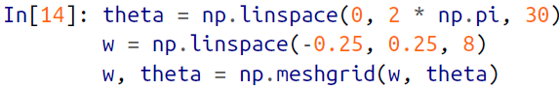

🡪Now from this parameterization, we must determine the (x, y, z) positions of the embedded strip.

🡪Thinking about it, we might realize that there are two rotations happening: one is the position of the loop about its center (what we’ve called θ), while the other is the twisting of the strip about its axis (we’ll call this ϕ). For a Möbius strip, we must have the strip make half a twist during a full loop, or Δϕ = Δθ/2.



🡪Now we use our recollection of trigonometry to derive the three-dimensional embedding. We’ll define r, the distance of each point from the center, and use this to find the embedded x, y, z coordinates:

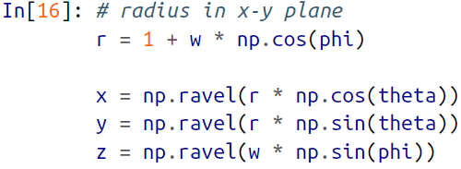

🡪Finally, to plot the object, we must make sure the triangulation is correct. The best way to do this is to define the triangulation within the underlying parameterization, and then let Matplotlib project this triangulation into the three-dimensional space of the Möbius strip. This can be accomplished as follows as shown in figure below:

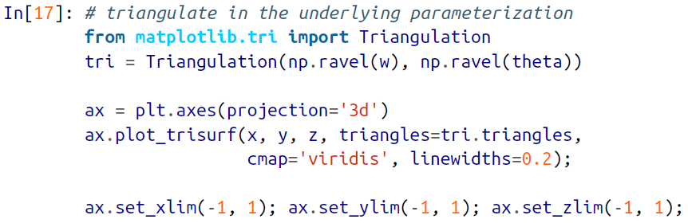

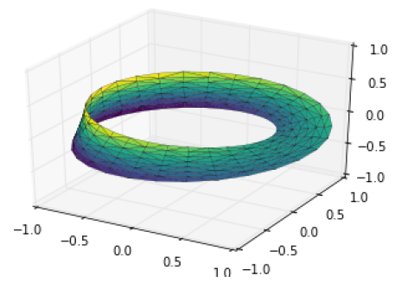

🡪Combining all of these techniques, it is possible to create and display a wide variety of three-dimensional objects and patterns in Matplotlib.

1. Geographic Data with Basemap

🡪One common type of visualization in data science is that of geographic data. Matplotlib’s main tool for this type of visualization is the **Basemap** toolkit, **which is one of several Matplotlib toolkits that live under the mpl_toolkits namespace**. Admittedly, Basemap feels a bit clunky to use, and often even simple visualizations take much longer to render than you might hope. More modern solutions, such as leaflet or the Google Maps API, may be a better choice for more intensive map visualizations. Still, Basemap is a useful tool for Python users to have in their virtual toolbelts. In this section, we’ll show several examples of the type of map visualization that is possible with this toolkit.

🡪Installation of Basemap is straightforward; if you’re using conda you can type this and the package will be downloaded:

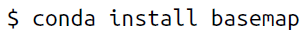

🡪We add just a single new import to our standard boilerplate:

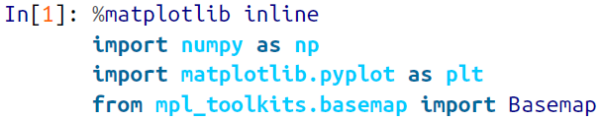

🡪Once you have the Basemap toolkit installed and imported, geographic plots are just a few lines away (the graphics in Figure in below figure also require the **PIL package in Python 2, or the pillow package in Python 3**):



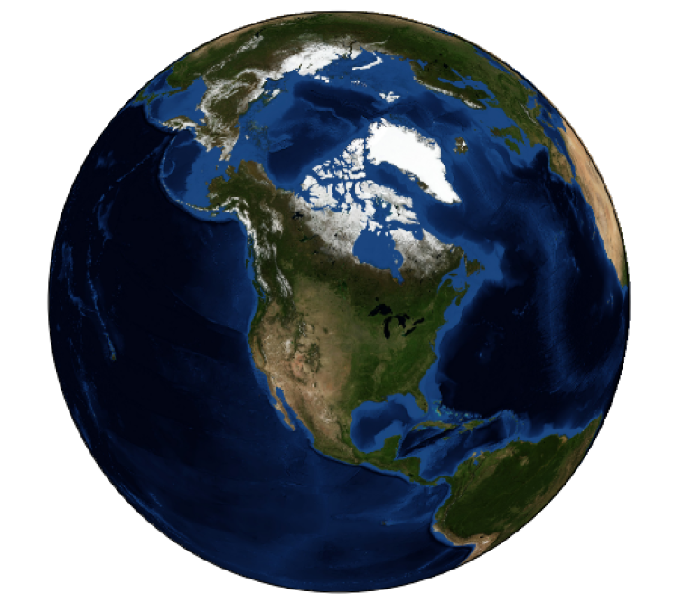

🡪The meaning of the arguments to Basemap will be discussed momentarily.

🡪The useful thing is that the globe shown here is not a mere image; it is a fully functioning Matplotlib axes that understands spherical coordinates and allows us to easily over-plot data on the map! For example, we can use a different map projection, zoom in to North America, and plot the location of Seattle. We’ll use an etopo image (which shows topographical features both on land and under the ocean) as the map background as shown in the figure below:

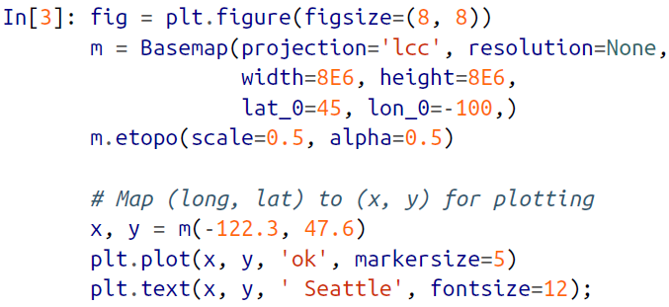

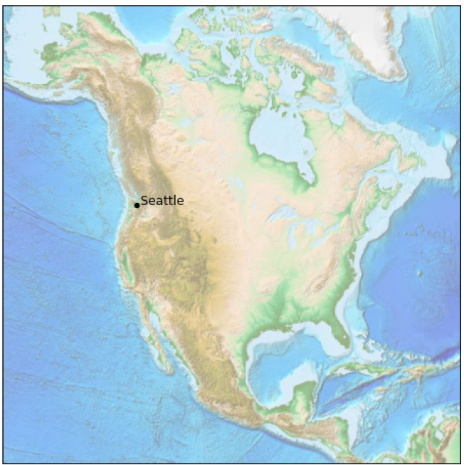

🡪This gives you a brief glimpse into the sort of geographic visualizations that are possible with just a few lines of Python. We’ll now discuss the features of Basemap in more depth, and provide several examples of visualizing map data. Using these brief examples as building blocks, you should be able to create nearly any map visualization that you desire.

**🡺Map Projections**

🡪The first thing to decide when you are using maps is which projection to use. You’re probably familiar with the fact that it is impossible to project a spherical map, such as that of the Earth, onto a flat surface without somehow distorting it or breaking its continuity. These projections have been developed over the course of human history, and there are a lot of choices! Depending on the intended use of the map projection, there are certain map features (e.g., direction, area, distance, shape, or other considerations) that are useful to maintain.

🡪The Basemap package implements several dozen such projections, all referenced by a short format code. Here we’ll briefly demonstrate some of the more common ones.

🡪We’ll start by defining a convenience routine to draw our world map along with the longitude and latitude lines:

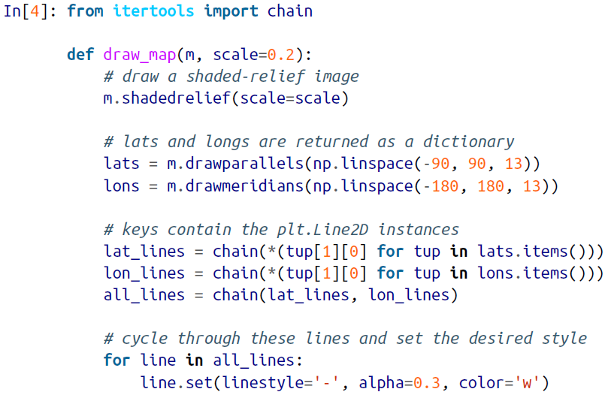

**🡺Cylindrical Projections**

🡪**The simplest of map projections are cylindrical projections**, in which lines of constant latitude and longitude are mapped to horizontal and vertical lines, respectively. This type of mapping represents equatorial regions quite well, **but results in extreme distortions near the poles**. The spacing of latitude lines varies between different cylindrical projections, leading to different conservation properties, and different distortion near the poles. In Figure below, we show an example of the equidistant cylindrical projection, which chooses a latitude scaling that preserves distances along meridians. Other cylindrical projections are the **Mercator (projection='merc')** and the **cylindrical equal-area (projection='cea')** projections.

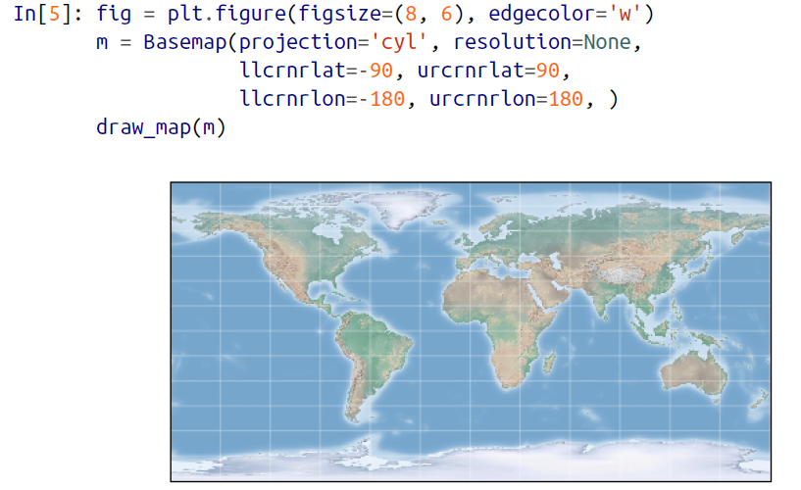

🡪The additional arguments to Basemap for this view specify the **latitude (lat)** and **longitude (lon)** of the **lower-left corner (llcrnr)** and **upper-right corner (urcrnr)** for the desired map, in units of degrees.

**🡺Pseudo-Cylindrical Projections**

🡪Pseudo-cylindrical projections relax the requirement that meridians (lines of constant longitude) remain vertical; this can give better properties near the poles of the projection. The Mollweide projection (projection='moll') is one common example of this, in which all meridians are elliptical arcs as shown in figure below.

🡪It is constructed so as to preserve area across the map: though there are distortions near the poles, the area of small patches reflects the true area. Other pseud-cylindrical projections are the sinusoidal (projection='sinu') and Robinson (projection='robin') projections.

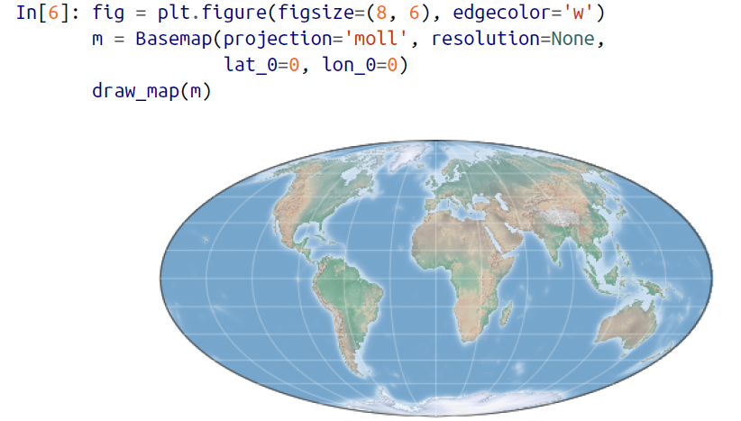

🡪The extra arguments to Basemap here refer to the central latitude (lat_0) and longitude (lon_0) for the desired map.

**🡺Perspective Projections**

🡪**Perspective projections are constructed using a particular choice of perspective point, similar to if you photographed the Earth from a particular point in space (a point which, for some projections, technically lies within the Earth!).** One common example is the orthographic projection **(projection='ortho')**, **which shows one side of the globe as seen from a viewer at a very long distance.** Thus, it can show only half the globe at a time. Other perspective-based projections include the **gnomonic projection (projection='gnom')** and **stereographic projection (projection='stere')**. These are often the most useful for showing small portions of the map.

🡪Here is an example of the orthographic projection as shown in the figure below:

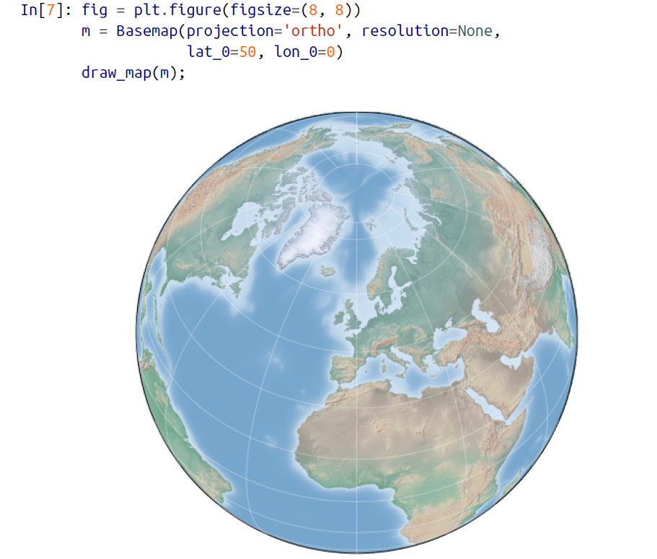

**🡺Conic Projections**

🡪**A conic projection projects the map onto a single cone, which is then unrolled**. **This can lead to very good local properties, but regions far from the focus point of the cone may become very distorted**. One example of this is the Lambert conformal conic projection (projection='lcc'), which we saw earlier in the map of North America. It projects the map onto a cone arranged in such a way that two standard parallels (specified in Basemap by lat_1 and lat_2) have well-represented distances, with scale decreasing between them and increasing outside of them. Other useful conic projections are the **equidistant conic (projection='eqdc')** and the **Albers equal-area (projection='aea')**. Conic projections, like perspective projections, tend to be good choices for representing small to medium patches of the globe.

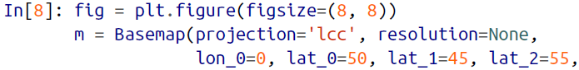

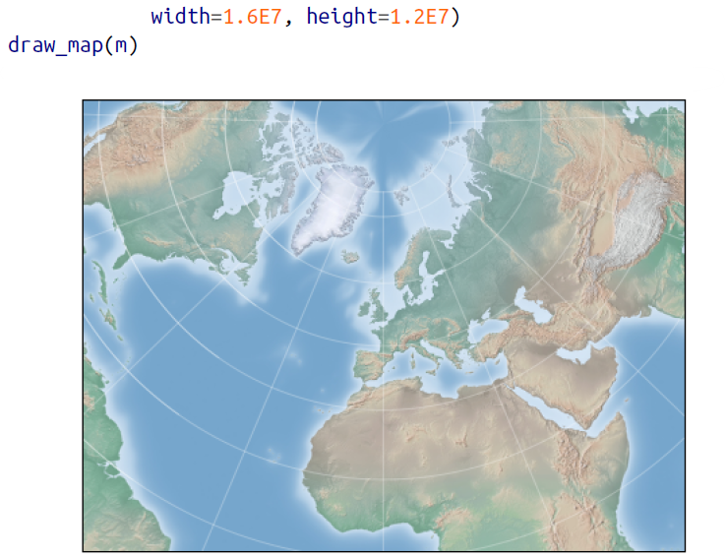

**🡺Other Projections**

🡪If you’re going to do much with map-based visualizations, I encourage you to read up on other available projections, along with their properties, advantages, and disadvantages. Most likely, they are available in the Basemap package.

**🡺Drawing a map background**

🡪Earlier we saw the **bluemarble()** and **shadedrelief()** methods for projecting global images on the map, as well as the **drawparallels()** and **drawmeridians()** methods for drawing lines of constant latitude and longitude. **The Basemap package contains a range of useful functions for drawing borders of physical features like continents, oceans, lakes, and rivers, as well as political boundaries such as countries and US states and counties**. The following are some of the available drawing functions that you may wish to explore using IPython’s help features:

* + Physical boundaries and bodies of water
* drawcoastlines() : Draws continental coast lines
* drawlsmask() : Draw a musk between the land and sea, for use with projecting images on one or the other
* drawmapboundary() : Draw the map boundary, including the fill colour for oceans
* drawrivers() : Draws rivers on the map
* fillcontinents() : Fill the continents with a given colour; optionally fill lakes with another coloue
  + Political boundaries
* drawcountries() : Draw country boundaries
* drawstates() : Draw US state boundaries
* drawcountries() : Draw US country boundaries
  + Map Features
* drawgreatcircle() : Draw a great circle between two points
* drawparalles() : Draw lines of constant latitude
* drawmeridians() : Draw lines of constant longitude
* drawmapscale() : Draw a linear scale on the map
  + Whole-globe images
* bluemarbel() : Projects NASA’s blue marble image onto the map
* shadedrelief() : Projects a shaded relief image onto map
* etopo() : Draw an etopo relief image onto the map
* wrapimage() : Project a user-provided image onto the map

🡪For the boundary-based features, you must set the desired resolution when creating a Basemap image. The resolution argument of the Basemap class sets the level of detail in boundaries, either 'c' (crude), 'l' (low), 'i' (intermediate), 'h' (high), 'f' (full), or None if no boundaries will be used. This choice is important: setting high-resolution boundaries on a global map, for example, can be very slow.

🡪Here’s an example of drawing land/sea boundaries, and the effect of the resolution parameter. We’ll create both a low- and high-resolution map of Scotland’s beautiful Isle of Skye. It’s located at 57.3°N, 6.2°W, and a map of 90,000×120,000 kilometers shows it well as shown in figure below:

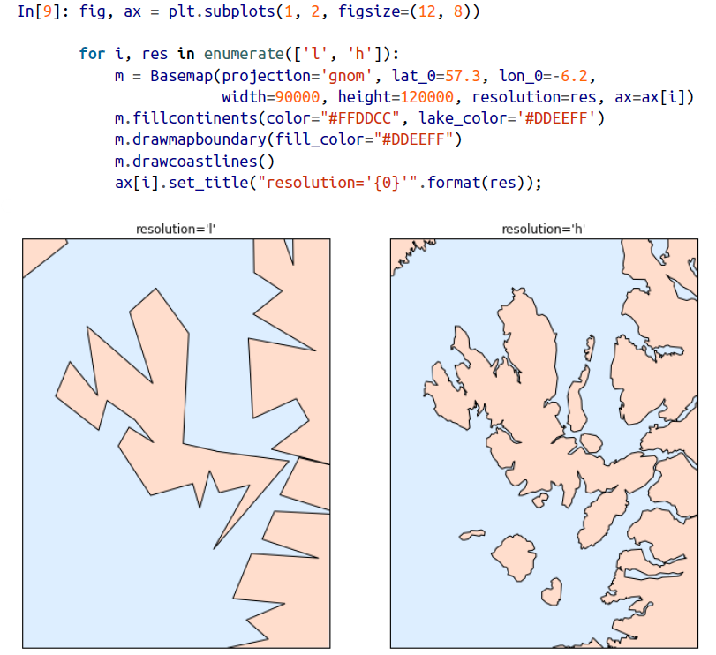

🡪Notice that the low-resolution coastlines are not suitable for this level of zoom, while high-resolution works just fine. The low level would work just fine for a global view, however, and would be much faster than loading the high-resolution border data for the entire globe! It might require some experimentation to find the correct resolution parameter for a given view; the best route is to start with a fast, low-resolution plot and increase the resolution as needed.

**🡺Plotting Data on Maps**

🡪Perhaps the most useful piece of the Basemap toolkit is the ability to over-plot a variety of data onto a map background. For simple plotting and text, any plt function works on the map; you can use the Basemap instance to project latitude and longitude coordinates to (x, y) coordinates for plotting with plt, as we saw earlier in the Seattle example.

🡪In addition to this, there are many map-specific functions available as methods of the Basemap instance. These work very similarly to their standard Matplotlib counterparts, but have an additional Boolean argument latlon, which if set to True allows you to pass raw latitudes and longitudes to the method, rather than projected (x, y) coordinates.

🡪Some of these map-specific methods are:

* contour()/contourf() : Draw contour lines or filled contours
* imshow() : Draw an image
* pcolor()/pcolormesh() : Draw a pseudo colour plot for irregular/regular meshes
* plot() : Draw lines and/or markers
* scatter() : Draw points with markers
* quiver() : Draw vectors
* barbs() : Draw wind barbs
* drawgreatcircle() : Draw a great circle

🡪We’ll see examples of a few of these as we continue. For more information on these functions, including several example plots, see the online Basemap documentation.

**🡺Example: California Cities**

🡪Recall that in “Customizing Plot Legends”, we demonstrated the use of size and color in a scatter plot to convey information about the location, size, and population of California cities. Here, we’ll create this plot again, but using Basemap to put the data in context.

🡪We start with loading the data, as we did before:

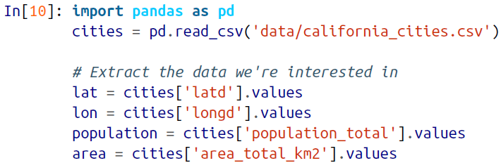

🡪Next, we set up the map projection, scatter the data, and then create a colorbar and legend as shown in figure below:

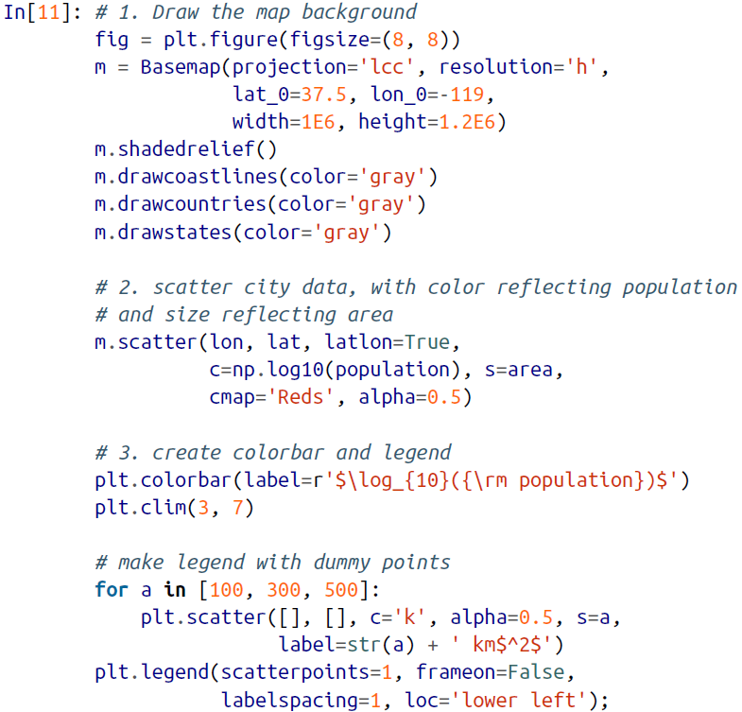

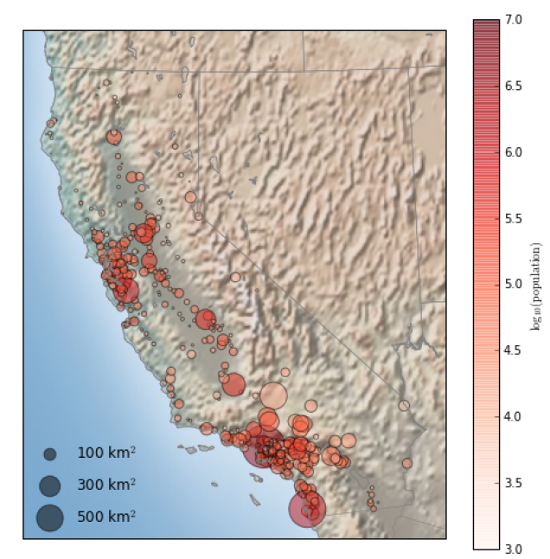

🡪This shows us roughly where larger populations of people have settled in California: they are clustered near the coast in the Los Angeles and San Francisco areas, stretched along the highways in the flat central valley, and avoiding almost completely the mountainous regions along the borders of the state.

**🡺Example: Surface Temperature Data**

🡪As an example of visualizing some more continuous geographic data, let’s consider the “polar vortex” that hit the eastern half of the United States in January 2014. A great source for any sort of climatic data is NASA’s Goddard Institute for Space Studies. Here we’ll use the GIS 250 temperature data, which we can download using shell commands (these commands may have to be modified on Windows machines). The data used here was downloaded on 6/12/2016, and the file size is approximately 9 MB:



🡪The data comes in NetCDF format, which can be read in Python by the netCDF4 library. You can install this library as shown here:

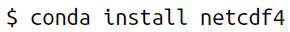

🡪We read the data as follows:

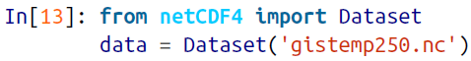

🡪The file contains many global temperature readings on a variety of dates; we need to select the index of the date we’re interested in—in this case, January 15, 2014:

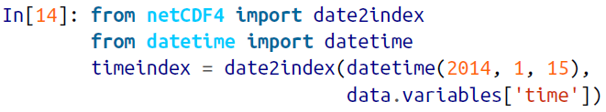

🡪Now we can load the latitude and longitude data, as well as the temperature anomaly for this index:

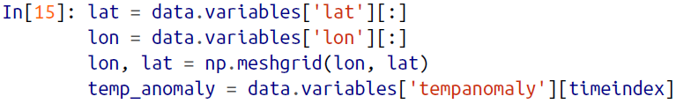

🡪Finally, we’ll use the pcolormesh() method to draw a color mesh of the data. We’ll look at North America, and use a shaded relief map in the background. Note that for this data we specifically chose a divergent colormap, which has a neutral color at zero and two contrasting colors at negative and positive values. We’ll also

lightly draw the coastlines over the colors for reference:

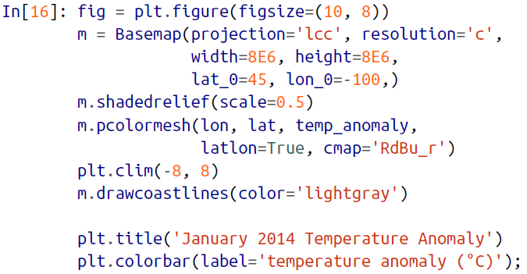

🡪The data paints a picture of the localized, extreme temperature anomalies that happened during that month. The eastern half of the United States was much colder than normal, while the western half and Alaska were much warmer. Regions with no recorded temperature show the map background.

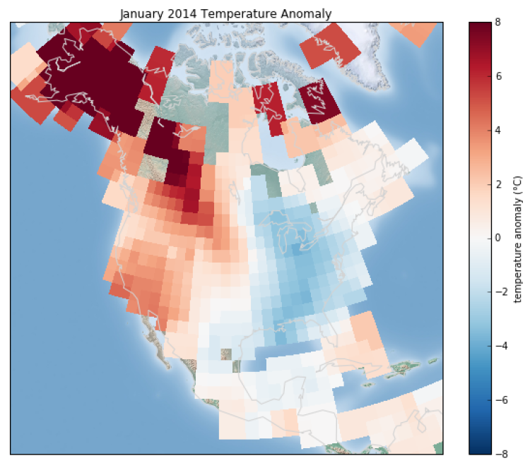

1. Visualization with Seaborn

🡪Matplotlib has proven to be an incredibly useful and popular visualization tool, but even avid users will admit it often leaves much to be desired. There are several valid complaints about Matplotlib that often come up:

* Matplotlib’s API is relatively low level. Doing sophisticated statistical visualization is possible, but often requires a lot of boilerplate code.
* Matplotlib predated Pandas by more than a decade, and thus is not designed for use with Pandas DataFrames. In order to visualize data from a Pandas DataFrame, you must extract each Series and often concatenate them together into the right format. It would be nicer to have a plotting library that can intelligently use the DataFrame labels in a plot.

🡪**An answer to these problems is Seaborn. Seaborn provides an API on top of Matplotlib that offers sane choices for plot style and color defaults, defines simple high-level functions for common statistical plot types, and integrates with the functionality provided by Pandas DataFrames**.

🡪To be fair, the Matplotlib team is addressing this: it has recently added the plt.style tools, and is starting to handle Pandas data more seamlessly. The 2.0 release of the library will include a new default stylesheet that will improve on the current status quo. But for all the reasons just discussed, Seaborn remains an extremely useful add-on.

**🡺Seaborn Versus Matplotlib**

🡪Here is an example of a simple random-walk plot in Matplotlib, using its classic plot formatting and colors. We start with the typical imports:

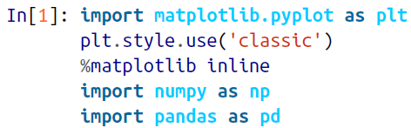

🡪Now we create some random walk data:

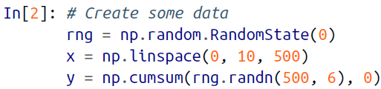

🡪And do a simple plot as shown in figure below:

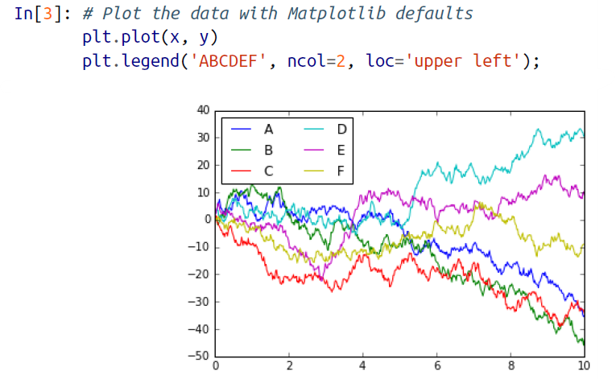

🡪Although the result contains all the information we’d like it to convey, it does so in a way that is not all that aesthetically pleasing, and even looks a bit old-fashioned in the context of 21st-century data visualization.

🡪Now let’s take a look at how it works with Seaborn. As we will see, Seaborn has many of its own high-level plotting routines, but it can also overwrite Matplotlib’s default parameters and in turn get even simple Matplotlib scripts to produce vastly superior output. **We can set the style by calling Seaborn’s set() method. By convention, Seaborn is imported as sns**:

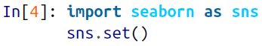

🡪Now let’s rerun the same two lines as before as shown in figure below:

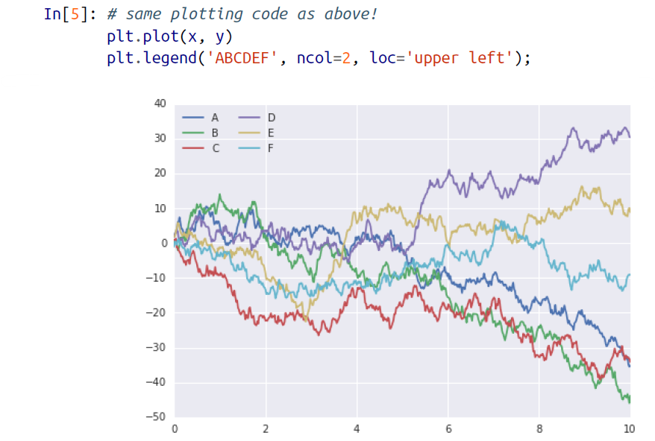

**🡺Exploring Seaborn Plots**

🡪The main idea of Seaborn is that it provides high-level commands to create a variety of plot types useful for statistical data exploration, and even some statistical model fitting.

🡪Let’s take a look at a few of the datasets and plot types available in Seaborn. Note that all of the following could be done using raw Matplotlib commands (this is, in fact, what Seaborn does under the hood), but the Seaborn API is much more convenient.

**🡺Histograms, KDE, and densities**

🡪Often in statistical data visualization, all you want is to plot histograms and joint distributions of variables. We have seen that this is relatively straightforward in Matplotlib as shown in figure below:

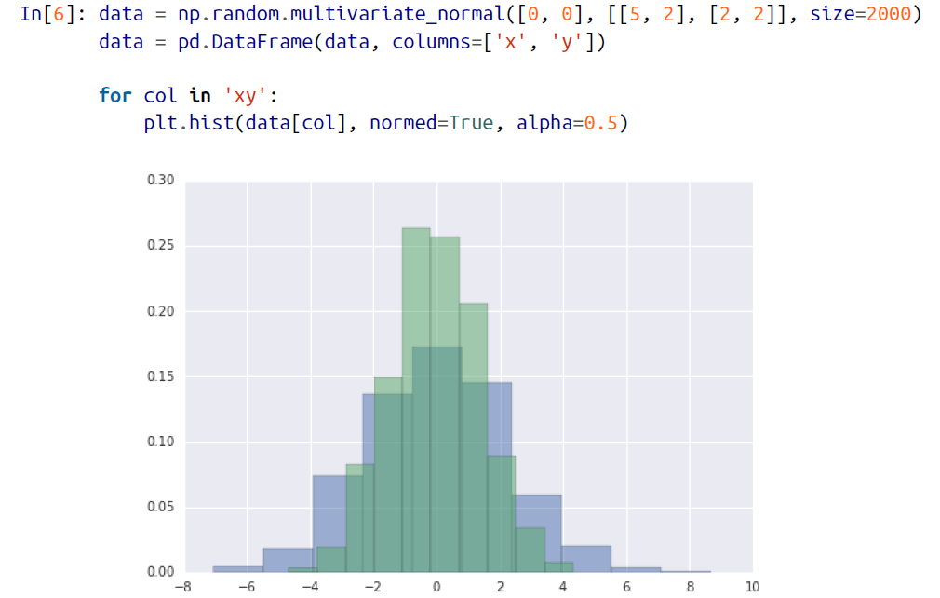

🡪Rather than a histogram, we can get a smooth estimate of the distribution using a kernel density estimation, which Seaborn does with sns.kdeplot as shown in figure below:

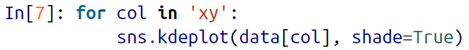

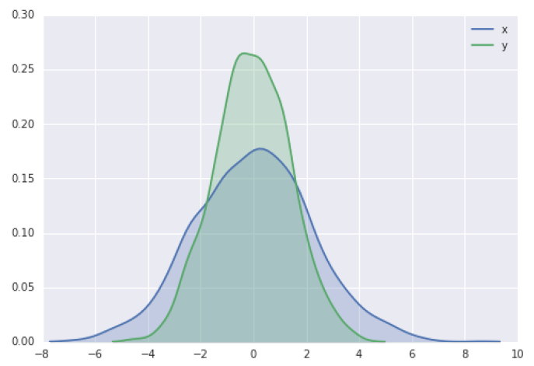

🡪Histograms and KDE can be combined using distplot is as shown in figure below:

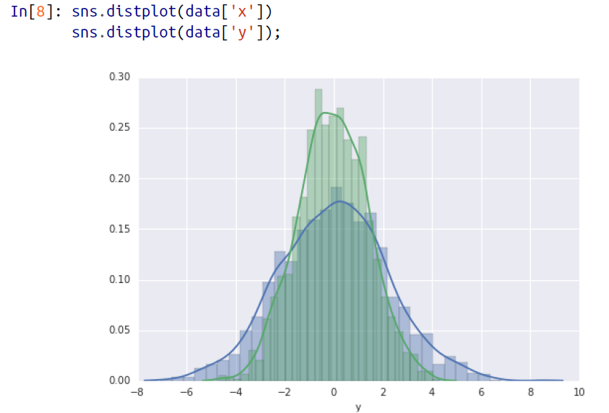

🡪If we pass the full two-dimensional dataset to kdeplot, we will get a two-dimensional visualization of the data as shown in figure below:

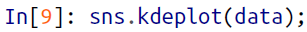

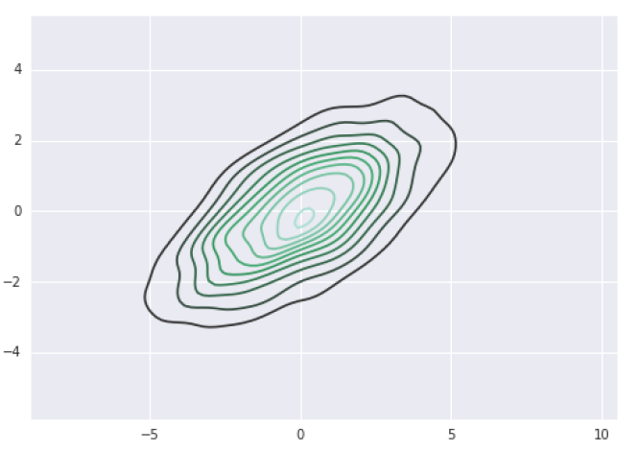

🡪We can see the joint distribution and the marginal distributions together using sns.jointplot. For this plot, we’ll set the style to a white background as shown in figure below:

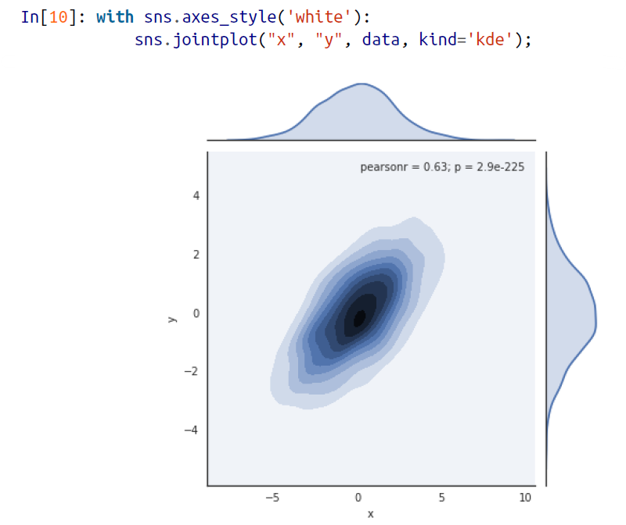

🡪There are other parameters that can be passed to jointplot—for example, we can use a hexagonally based histogram instead as shown in figure below:

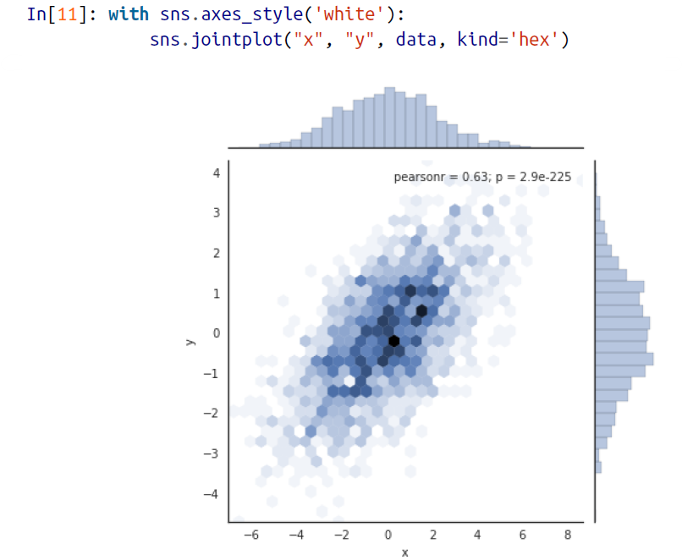

**🡺Pair Plots**

🡪When you generalize joint plots to datasets of larger dimensions, you end up with pair plots. This is very useful for exploring correlations between multidimensional data, when you’d like to plot all pairs of values against each other.

🡪We’ll demo this with the well-known Iris dataset, which lists measurements of petals and sepals of three iris species:

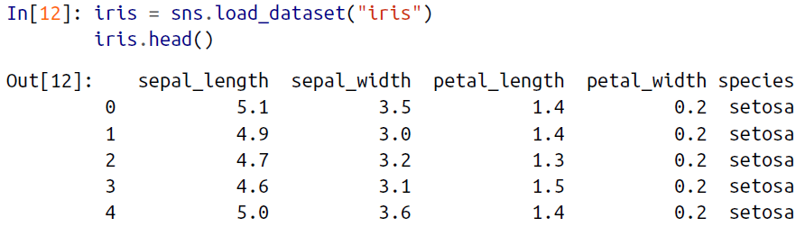

🡪Visualizing the multidimensional relationships among the samples is as easy as calling sns.pairplot as shown below:

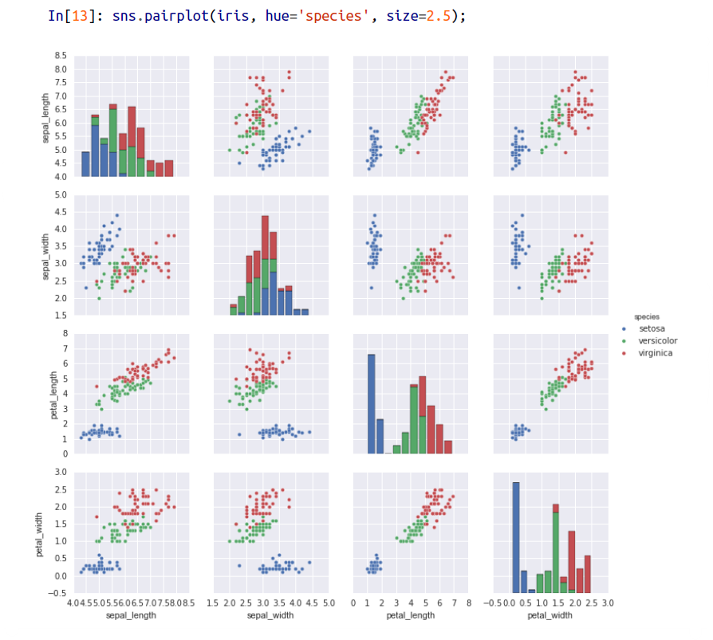

**🡺Faceted Histograms**

🡪Sometimes the best way to view data is via histograms of subsets. Seaborn’s FacetGrid makes this extremely simple. We’ll take a look at some data that shows the amount that restaurant staff receive in tips based on various indicator data as shown in figure below:

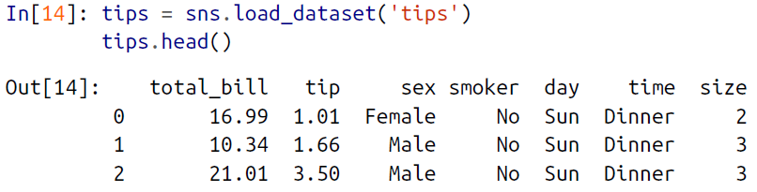

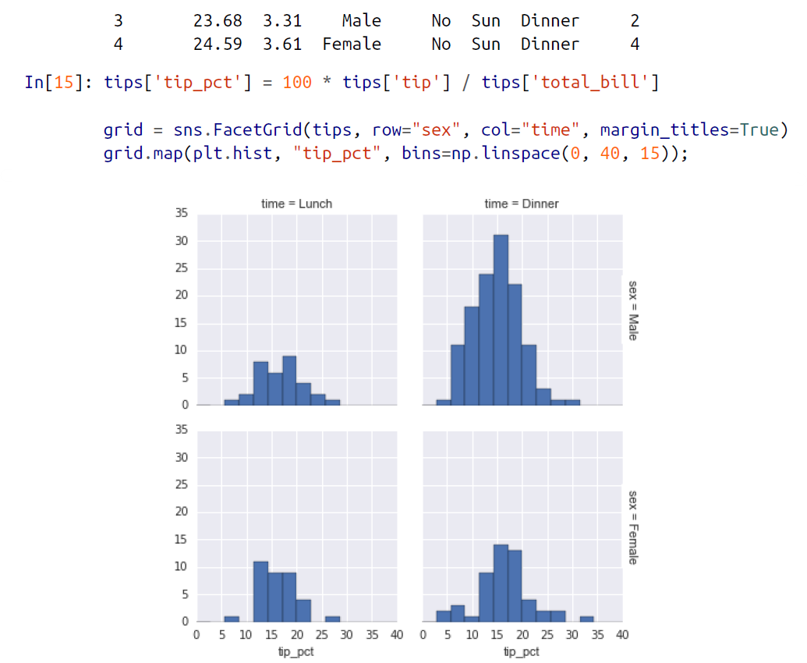

**🡺Factor Plots**

🡪Factor plots can be useful for this kind of visualization as well. This allows you to view the distribution of a parameter within bins defined by any other parameter as shown in figure below:

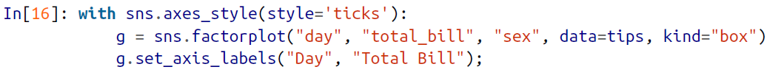

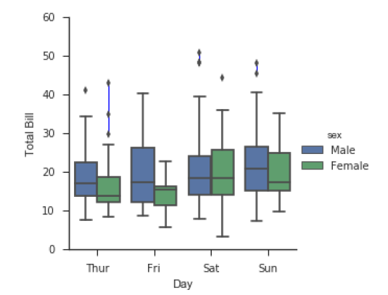

**🡺Joint Distribution**

🡪Similar to the pair plot we saw earlier, we can use sns.jointplot to show the joint distribution between different datasets, along with the associated marginal distributions as shown in figure below:

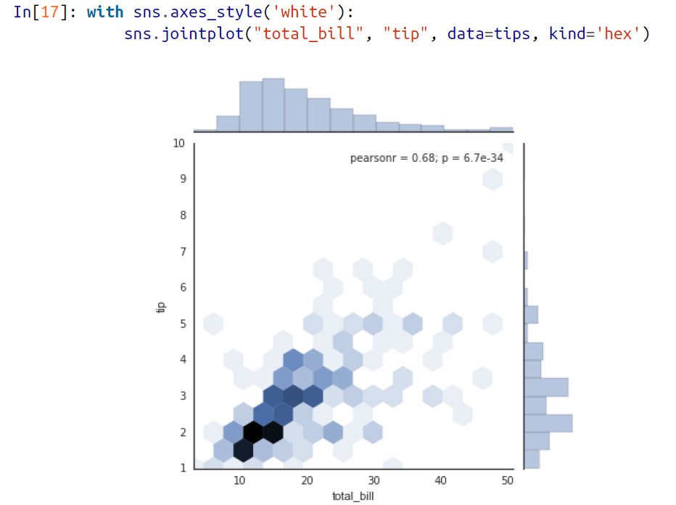

🡪The joint plot can even do some automatic kernel density estimation and regression as shown in figure below:

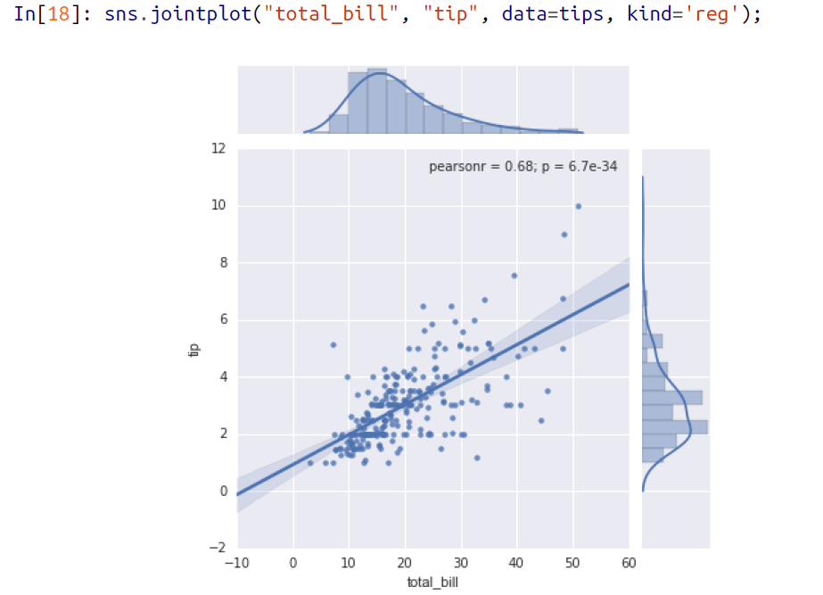

**🡺Bar Plots**

🡪**Time series can be plotted with sns.factorplot**. In this section we will use the planets data that we first saw in “Aggregation and Grouping”

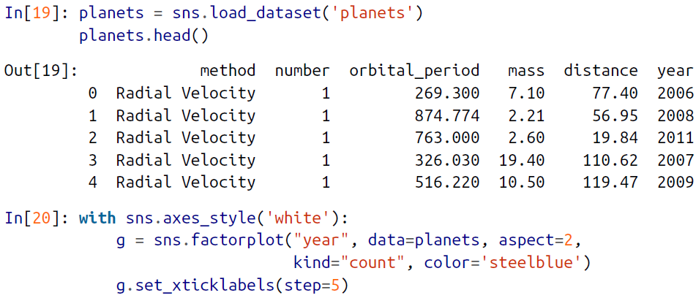

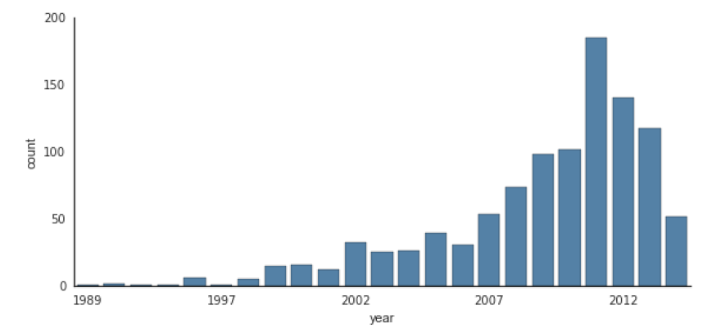

🡪We can learn more by looking at the method of discovery of each of these planets, as illustrated in figure below:

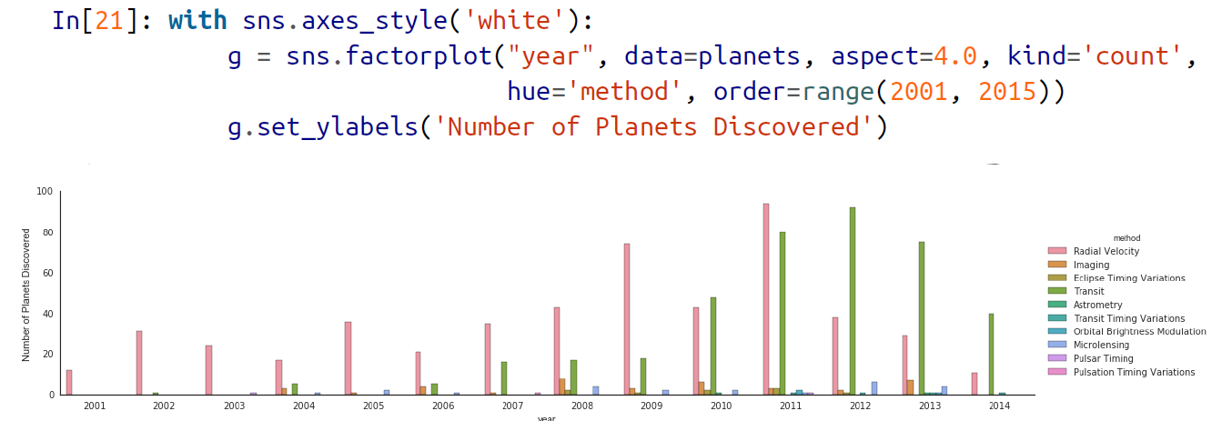

**🡺Example: Exploring Marathon Fishing Times**

🡪Here we’ll look at using Seaborn to help visualize and understand finishing results from a marathon. I’ve scraped the data from sources on the Web, aggregated it and removed any identifying information, and put it on GitHub where it can be downloaded (if you are interested in using Python for web scraping, I would recommend Web Scraping with Python by Ryan Mitchell). We will start by downloading the data from the Web, and loading it into Pandas:

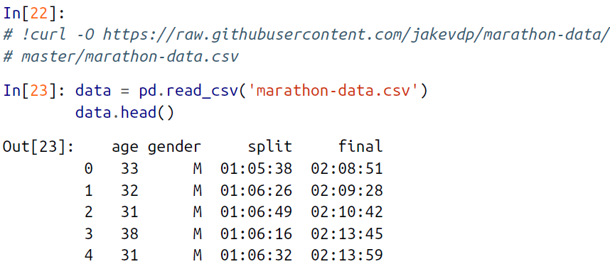

🡪By default, Pandas loaded the time columns as Python strings (type object); we can see this by looking at the dtypes attribute of the DataFrame:

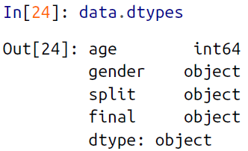

🡪Let’s fix this by providing a converter for the times:

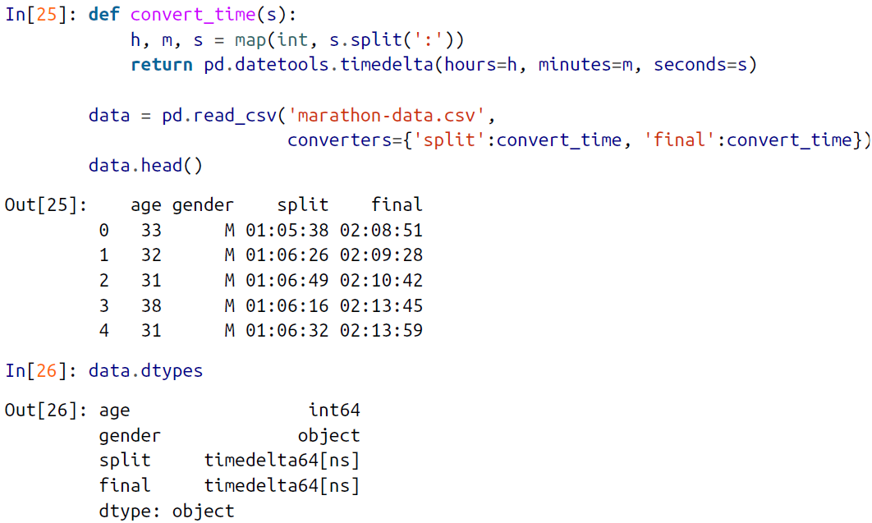

🡪That looks much better. For the purpose of our Seaborn plotting utilities, let’s next add columns that give the times in seconds:

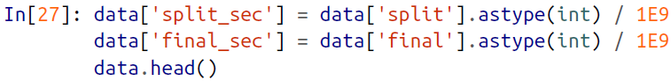

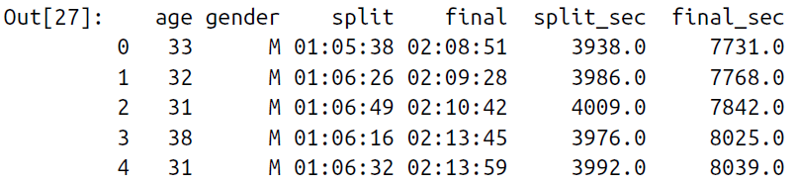

🡪To get an idea of what the data looks like, we can plot a jointplot over the data as shown in figure:

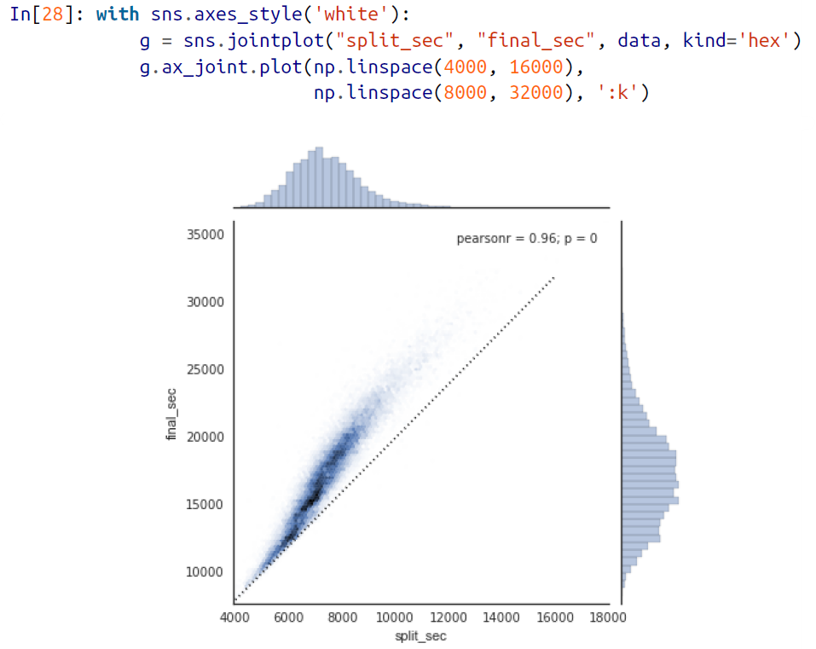

🡪The dotted line shows where someone’s time would lie if they ran the marathon at a perfectly steady pace. The fact that the distribution lies above this indicates (as you might expect) that most people slow down over the course of the marathon. If you have run competitively, you’ll know that those who do the opposite—run faster during the second half of the race—are said to have “negative-split” the race.

🡪Let’s create another column in the data, the split fraction, which measures the degree to which each runner negative-splits or positive-splits the race:



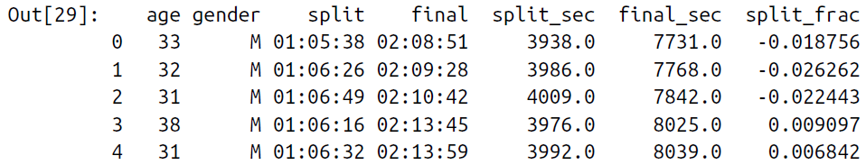

🡪Where this split difference is less than zero, the person negative-split the race by that fraction. Let’s do a distribution plot of this split fraction as shown in figure below:

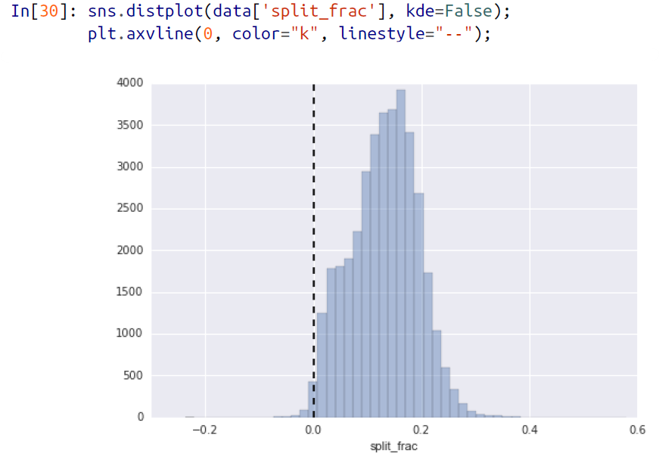

🡪The distribution of split fractions; 0.0 indicates a runner who completed the first and second halves in identical times.

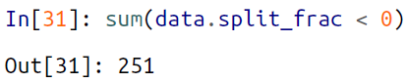

🡪Out of nearly 40,000 participants, there were only 250 people who negative-split their marathon.

🡪Let’s see whether there is any correlation between this split fraction and other variables. We’ll do this using a pairgrid, which draws plots of all these correlations as shown in figure below:

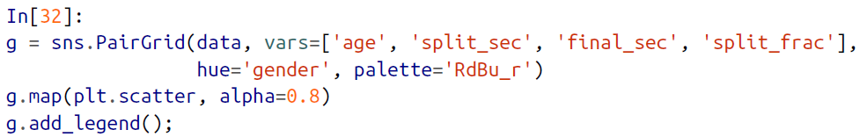

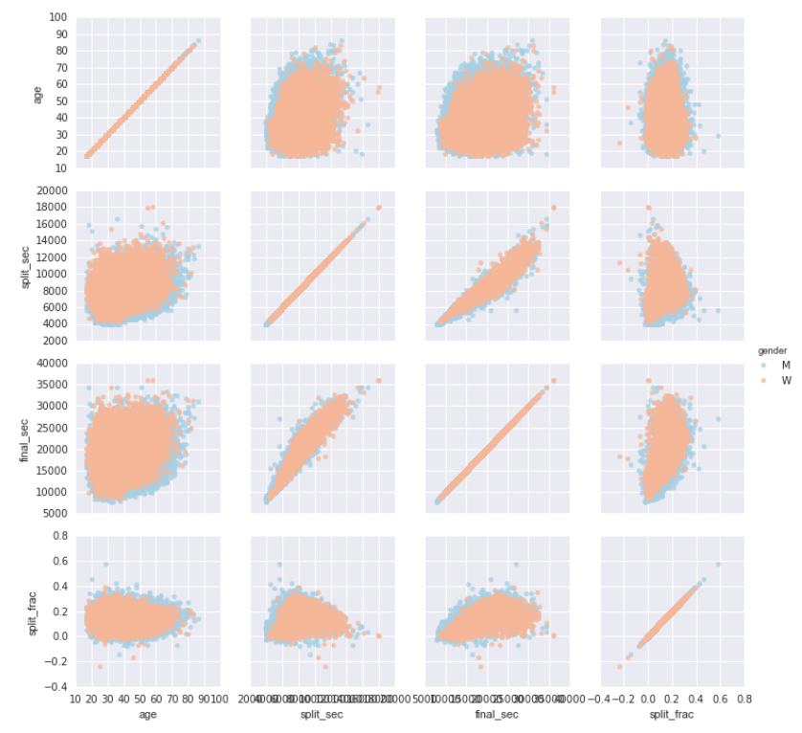

🡪It looks like the split fraction does not correlate particularly with age, but does correlate with the final time: faster runners tend to have closer to even splits on their marathon time.

🡪The difference between men and women here is interesting. Let’s look at the histogram of split fractions for these two groups as shown in figure below:



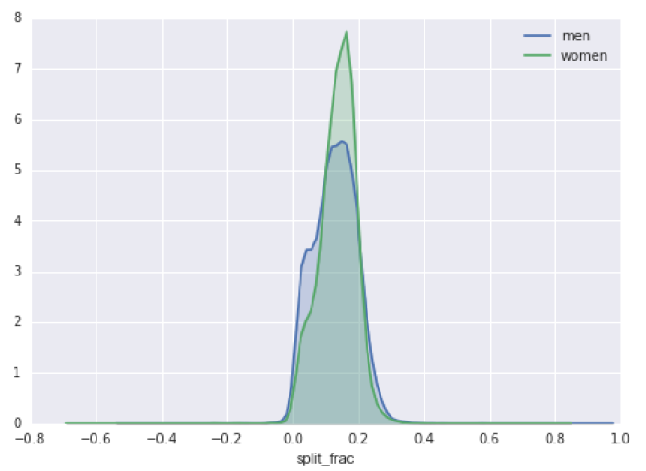

🡪The interesting thing here is that there are many more men than women who are running close to an even split! This almost looks like some kind of bimodal distribution

among the men and women. Let’s see if we can suss out what’s going on by looking at the distributions as a function of age.

🡪A nice way to compare distributions is to use a violin plot as shown in figure below:

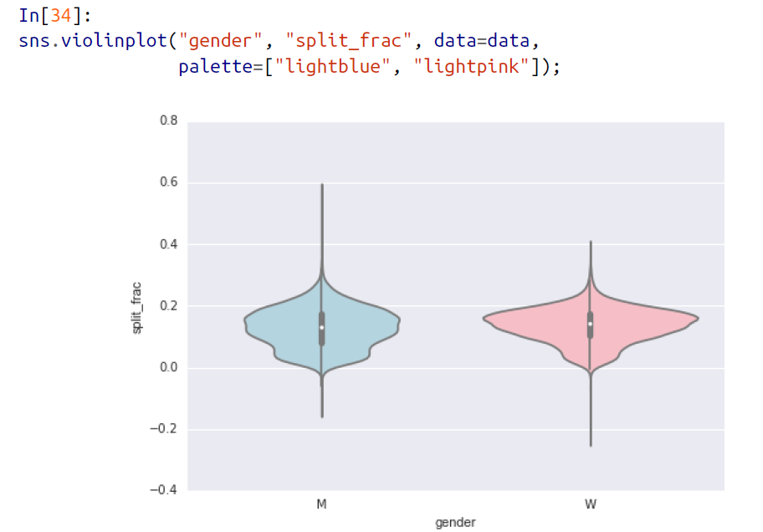

🡪This is yet another way to compare the distributions between men and women.

🡪Let’s look a little deeper, and compare these violin plots as a function of age. We’ll start by creating a new column in the array that specifies the decade of age that each person is in figure below:

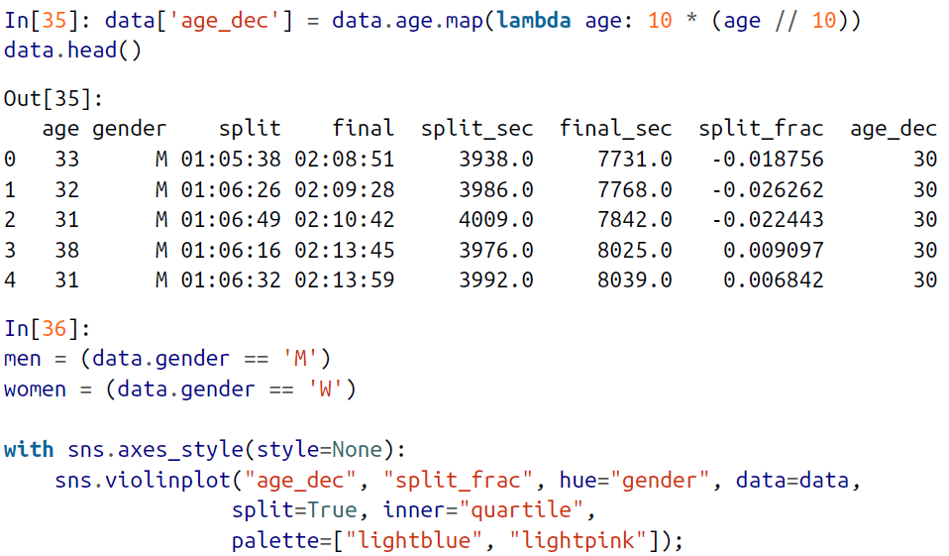

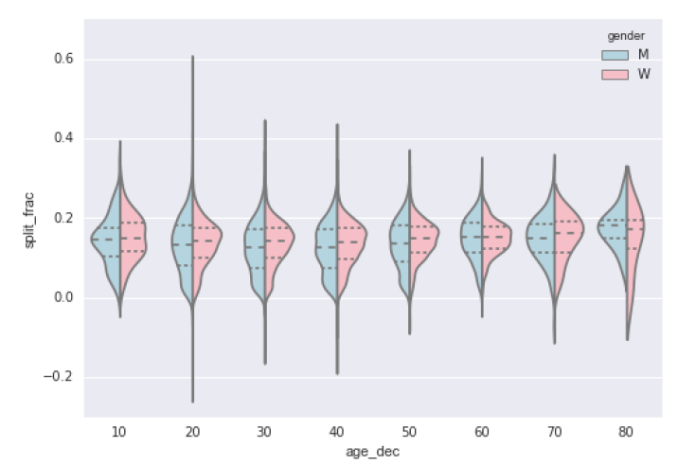

🡪Looking at this, we can see where the distributions of men and women differ: the split distributions of men in their 20s to 50s show a pronounced over-density toward

lower splits when compared to women of the same age (or of any age, for that matter).

🡪Also surprisingly, the 80-year-old women seem to outperform everyone in terms of their split time. This is probably due to the fact that we’re estimating the distribution from small numbers, as there are only a handful of runners in that range:

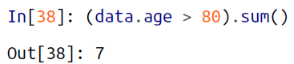

🡪Back to the men with negative splits: who are these runners? Does this split fraction correlate with finishing quickly? We can plot this very easily. We’ll use regplot,

which will automatically fit a linear regression to the data as shown in figure below:

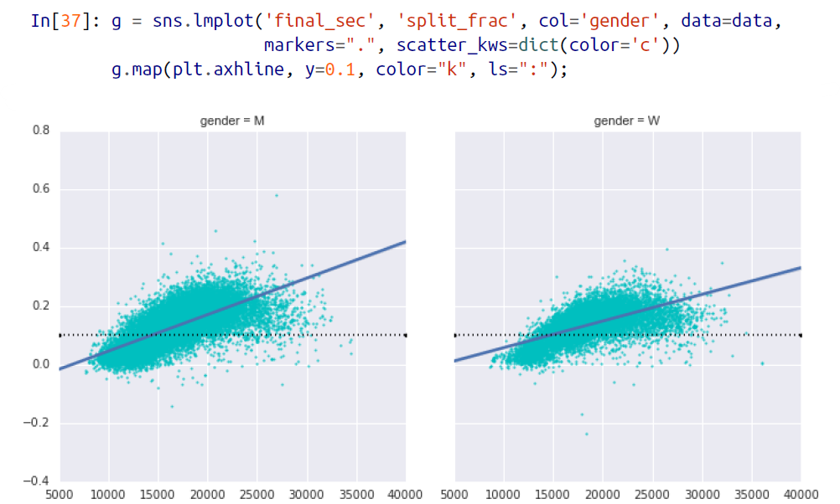

🡪Apparently the people with fast splits are the elite runners who are finishing within ~15,000 seconds, or about 4 hours. People slower than that are much less likely to have a fast second split.